

GROUP ASSIGNMENT
(GROUP WORK)

CT108-3-1-DGTIN

Digital Thinking and Innovation

APD1F2309SE-APU1F2309SE

HAND OUT DATE: WEEK 2 (09/102023)

HAND IN DATE: WEEK 12 (22/12/2023)

WEIGHTAGE: 50%
LECTURER’S NAME: PALVINDERJIT KAUR A/P HARNEK SINGH

MADE BY:
Name | TP Number
WONG LIK HONG | TP070142
ABHAY RANA PRATAP BEEDASEE | TP077261
LEE KA SHING | TP070837
LEE WAN CHIEN | TP070220
RAKHMATULLAYEVA AMINA | TP069997
TANG KIEN HWA | TP069321
VALERIE ANNABELLA | TP071725
TAN QIAOQIAN | TP070860
YAP HUEY SHIN | TP070470
YEE KA HOE | TP071671

Contents
1. Introduction 3
2. Issues and Proposed Solution 4
2.1 Bad Customer Service 4
2.2 Bad Aftercare 5
2.3 Insufficient Information on Delivery 5
2.4 Bad Management System 5
2.5 Low Quality Control 5
3. Existing Systems Review 6
4. Conclusion 7
5. References 8
6. Appendices 9
6.1 Appendix A: System Prototype 9
6.2 Appendix B: Work Breakdown Structure 9

Introduction

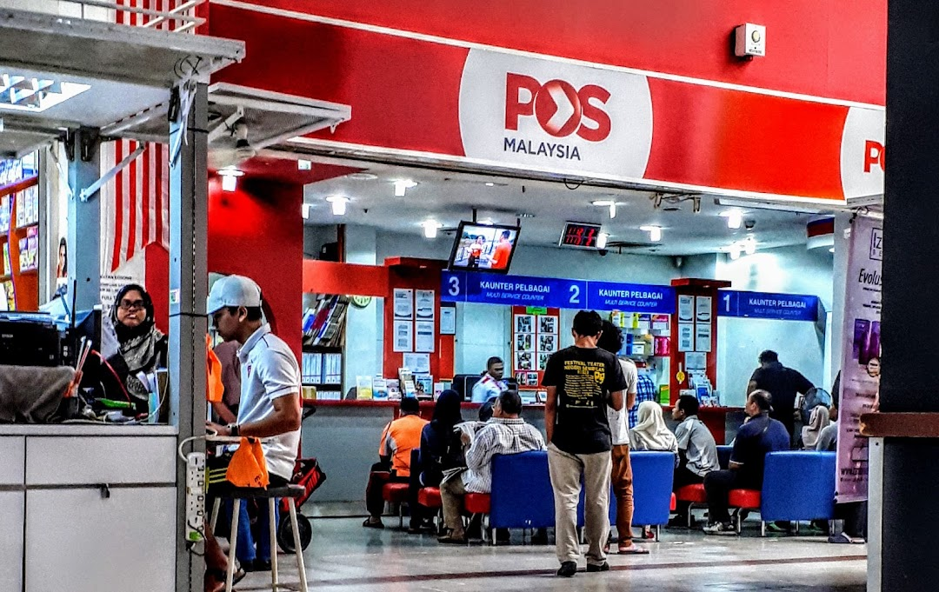

Pos Malaysia is a Malaysian company, which dated back to the early 1800s, which mainly focuses on offering delivery services. But over the years, it has expanded its services, into a more diverse range of services, from express parcel delivery, logistics, freight forwarding to e-commerce solutions, and network, which has reached over 1000 touchpoints, which includes branches, authorized agents, kiosks and drop boxes, which provides accessibility to customers across Malaysia.

Currently, Pos Malaysia has an overall bad reputation in the logistics industry, with a 1.7-star rating based on 1123 customer reviews which can be seen in Pissed Consumer, which is due to the reason that its consumer always had a problem with their parcel delivery or customer service. Additionally, there is a total of 967 complaints, on one side which is called complaints board, only 7 were resolved and the rest were left to be unresolved and most of the complaints were regarding parcel delivery or parcel’s information or customer service.

Issues and Proposed Solution

Bad Customer Service


Customer service is an act of assisting, on behalf of the organizations, clients, or customers in the time of pre-procurement and post-procurement. It consists of offering product suggestions, troubleshooting issues, and responding to general questions.

Hence, regarding customer service, Pos Malaysia has a terrible reputation for customer service. This can be seen from various reviews from various sites, such as Trustpilot and Glassdoor, which states that Pos Malaysia has unhelpful customer service and has given their customers a long wait time for customer service, which is often regarding delays in delivery or information on the current status of the packages, which is often not shown to be very detailed on the website or app of Pos Malaysia, or regarding stolen or damaged packets.



Thus, we have come up with a feature which would be implemented in the solution, which is that we would make a ticket system. So, to further elaborate on the solutions, firstly, a client, which could be a receiver or sender, would open a ticket and this ticket, which would then be sent to Pos Malaysia, which would consist of the current problem. Secondly, a customer service representative of Pos Malaysia would open the ticket and try to chat towards the client and try to resolve the issue, through chatting, and in the case that it would need further actions, such as needing members from other departments, they could try to do various things, such as adding a new member, which could be a member from another department, to the ticket to discuss about further details regarding the issue, which the new ticket member could help in resolving the issue faster, without needing to open a new ticket or have the client be transferred into another ticket, which could be very annoying for the client. Thirdly, if the issue has been resolved, the customer can give a rating and a review to the customer service representative on how they handled the issue.

Furthermore, with this feature, we could have a system where it checks the worker’s customer review and judge on whether they need customer service training. If they do need training, they would automatically be enrolled into a 4-weeks of intense training, which would consist of videos, regarding customer service, would be sent to their account and they must do a report on what they have learnt to ensure that they have learnt something, from the training, and is becoming a better customer service representative.

Hence, with this proposed solution feature, it would result in a more efficient and less confusing way of handling issues, which are given by the customers of Pos Malaysia, and it would also help in increase worker’s skills in customer service, if they lack of it.

The proposed solution is as follows:
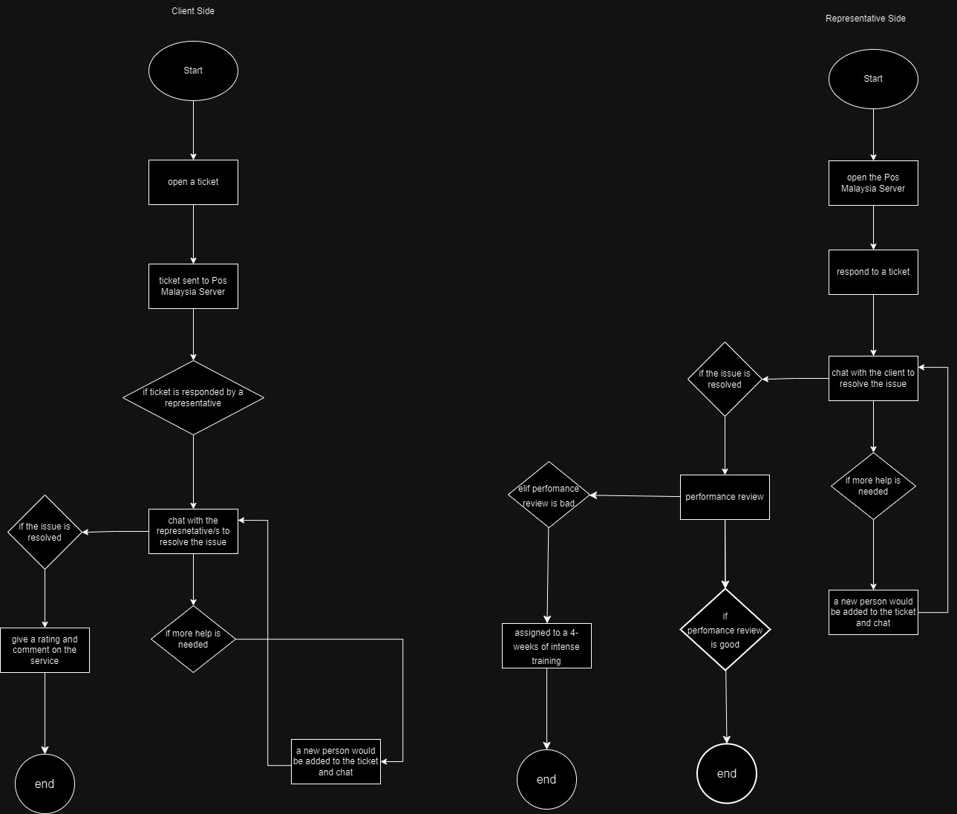

Bad Aftercare

The support given after the customer uses the service from a company called customer aftercare, which includes issue solving and getting feedback from customers. All of this is to ensure that the customers are satisfied with their service and continue to use that service again and again in the future. However, nowadays Pos Malaysia aftercare should be improved due to not achieving the goal they set out to do with providing continued support towards customers even after the job is done. Their customer service often makes customers feel frustrated due to the late responses, pushing the responsibilities among the departments and keep ignoring customers complaints.

Firstly, Pos Malaysia often provides late response to the customers through their customer service chat or email. This may be caused by factors like the low staff level and the low efficiency of the customer service system. Besides, the hurdle in effective task management like pushing responsibilities among the departments is presented because of the bad organizational structure within Pos Malaysia. Lack of clear communication between the departments result the responsibility being shuffled among the departments. For the next notable issue that Pos Malaysia’s aftercare service faced is the ignorance from the departments regarding the complaints of the customers. This might cause by the low sufficiency of the system that help to track customers’ complaints and lack of problem handling abilities among the departments of Pos Malaysia.

To deal with these issues, we have decided to utilize the automated acknowledgment system in our customer service system by making an “AI Chatbot System”. This chat box will be provided on our official website, and it will function for 24/7, which will provide immediate assistance and helps customers to deal with the issues in real-time. This will help a lot in increasing customer satisfaction. For some of the general issues that are often faced by customers, the AI will help to track and address with the customers’ complaints. For those special issues.

The proposed solution’s flowchart is as follows:

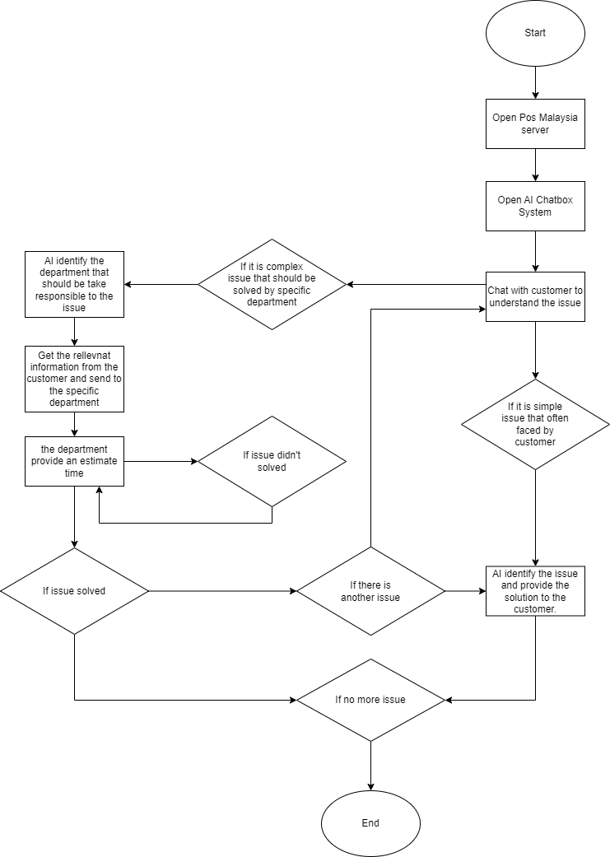

Insufficient Information on Delivery



Most customers want to track their packages to confirm the location and estimated time of delivery of their parcels. When customers do not receive timely information about the location, delivery status, or estimated arrival time of their parcels, they may feel inconvenienced and uncertain. When the parcel does not appear in the customer's tracking information for an extended period, the customer is left without any up-to-date information on the status of the parcel. It is unclear where the parcel is or why it has not arrived on time. When customers contact Pos Malaysia for more information, they often receive unclear or unhelpful responses, which prevents them from resolving the issue or getting help. Communication problems lead to customer dissatisfaction and complicated problem solving.



Pos Malaysia can overcome insufficient information on delivery by implementing some solutions to improve their delivery process. First, they can implement a real- time tracking system. This system can provide real-time updates about their shipment’s status and location to the customers. The parcel information also will mention the details of the driver such as name, ID, location, and the estimate time taken to deliver the parcel. The driver will update the information at various stages of the delivery process and then offer the messages alert to inform customers about the parcel’s status. After the parcel is delivered, the customer can leave the feedback on the delivery process.

Second, Pos Malaysia can implement a driver training program. The driver that has been trained can be more responsibility and punctual. Every driver will be allocated at different branches. They will know their own area responsible and the location to deliver the parcel.

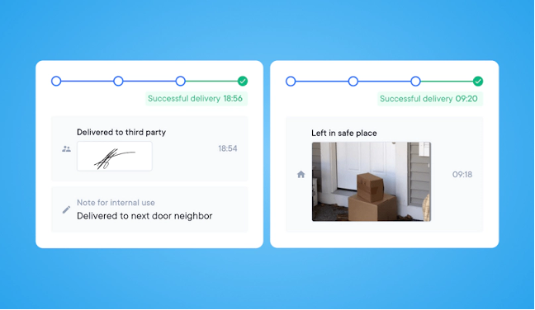

Last, they can invest technology in their Pos Malaysia app. They can use electronic proof of delivery on the Pos Malaysia app to prevent the parcel from being stolen or lost. For example, they can get the electronic signature from the customers while the parcel is delivered. The electronic signature will become the proof of delivery. If the driver arrives and nobody is at home, they can use the app to take photos of where the parcel was left. This proof of delivery information is kept in the cloud and is easily accessible, making it possible to track down the location and pick up the parcel.

The proposed solution’s flowchart is as follow

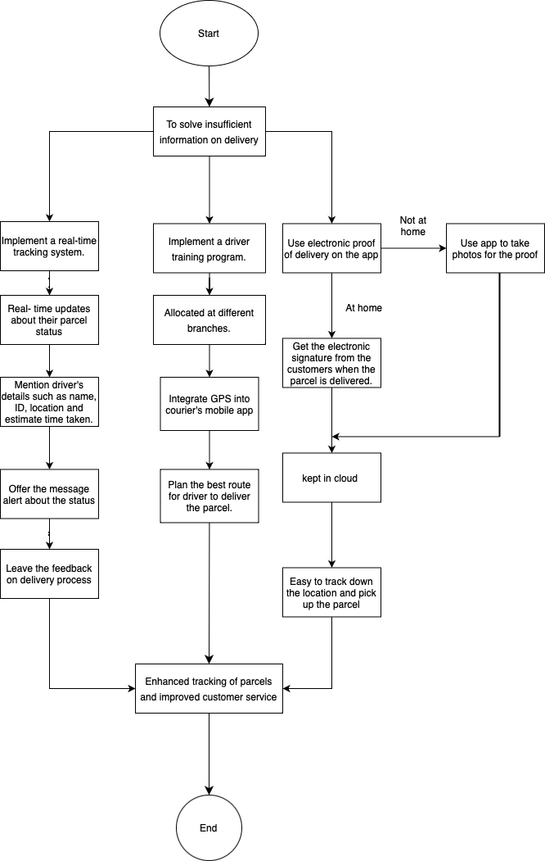

Bad Management System

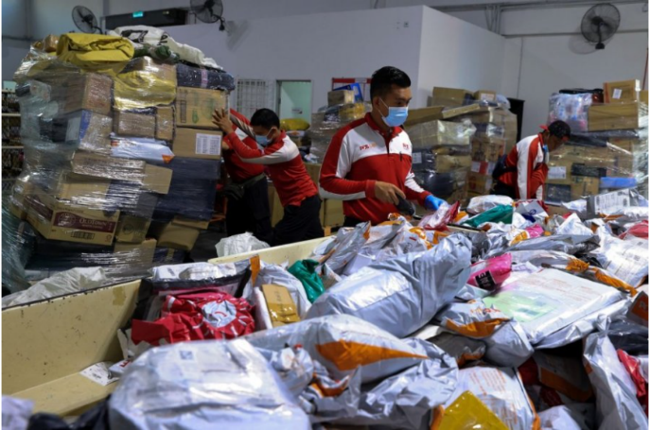

The management department plays a vital role in every organization in ensuring the smooth operations of the company as a whole. An incompetent management team will lead to problems regarding the main workforce of any company in the world, which is the employees of the company.

Pos Malaysia has always been burdened by the fact that managerial roles are filled with underqualified individuals contributing to bad decisions are made on the daily. With the implementation of a management system that is inadequate in dealing with employees has led to employees losing motivation to perform their duties efficiently.

We propose the implementation of a more efficient and employee-friendly system to assist the employees in performing their daily tasks with ease. With a plethora of features that help employees to keep track of their job, it has proven to be more efficient for the management department to manage their employees with a well-made system compared to one that is lacking in features.

First and foremost, the biggest cause of employees losing motivation in doing their work is due to work monotony. Performing repetitive tasks for a long period of time would cause employees to lose motivation and cause them to perform worse than normal. To combat this issue, we have added a system to automate work position rotation for employees to allow them to cycle through tasks that need to be completed. This would not only provide fresh and new challenges for employees but also remove the repetitive task that they had to endure every day. Coupled with a system that allows documentation of work done, employees can complete different tasks as a team without missing out on anything.

Other than that, there is also a feature that allows employees to provide feedback to the management for any complaint or review. Employees can report incompetent colleagues or incidents anonymously to the management team in hope of it getting solved as soon as possible. Compared to the old system where there is insufficient communication between the employees and the management team, this one provides a direct channel for employees to communicate with the management team. This occurrence brings us to the next issues.

The lack of communication between different departments will also lead to confusion and also unmet expectations from the higher-ups. The system allows seamless cooperation between departments because it allows exchange of important information between multiple parties. Tasks and duties can be overcome cooperatively and smoothly due to efficient communication between departments in the company.
Lastly, a performance-based yearly assessment included in the system can also further motivate employees to complete their duties. Incentives or benefits which are provided to employees that are good performing year-round will increase their morale and also motivate them to make a special effort in achieving their goals will surely benefit the company in the long run.

The proposed solution’s flowchart is as follows:

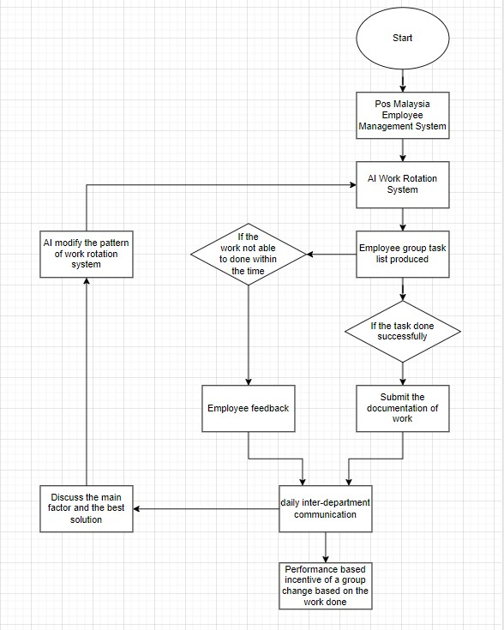

Low Quality Control



Quality management plays a big role in any business and why is that? Quality management is the process of supervising all operations and tasks to ensure the optimal degree of performance is maintained. Quality management also helps covers aspects such as quality strategy, quality planning and quality assurance, quality management and quality improvement.

POS Malaysia is a company that specialized in postal and related services such as receiving and sending email. However, POS Malaysia is suffering a net loss for 2 years. To start off, the problem of POS Malaysia is customer focus. Certain customers had complained that the delivery for their courier was delayed by a month during the Movement Control Order (MCO) which was enforced on March 2020. Customers were furious about the delay and compared the delivery time with other courier services which provided much quicker services. Here, they have failed the customers in the “customer focus” aspect of the Quality Management System (QMS).

Besides that, POS Malaysia is said to be functioning in a weak system which was implemented in year 2001. This cause Post Malaysia website to be terrible and have over 2 weeks of lagging and it still doesn’t function now. A Facebook seller, has complained that their clients have not receive their package and don't know what happens to it. Another customer remarked that track and trace system updates are not available although her Japanese things are dispatched 8 days ago. In a Declaration to the Malay Mail, POS Malaysia reacted to complaints about delays and apologised to the people impacted.

Moving on, it is said that POS Malaysia have a limited capacity of offices. POS Malaysia only had around 200 branches nationwide whereas its competitor such as J&T Express had more than 600 branches all over Malaysia to make the entire shipping and delivery process smoother. With limited space, POS Malaysia could not store many parcels at once, therefore the new parcels had to wait for the earlier parcels to be delivered. This was one of the factors that made the delivery process lengthy. When parcels are received exceedingly, postmen are expected to work more than they are paid. Eventually, POS Malaysia became understaffed in terms of clerks and postmen which led to inefficiency in their services. They told me they are terribly understaffed, and the top management is yet to investigate this problem. Customers receiving damaged or broken items which involves of POS Malaysia staff in handling items in the warehouse is unskilled until the item in the parcel is damaged or broken. At times, the damage could be also because of the postmen tossing the parcels inside the house compound.

These issues negatively impact customer satisfaction and hinder the company's potential for growth. To improve the customer experience and fortify the company's position in the market, this part of the report offers comprehensive solutions that address these important issues. To solve the issue that Pos Malaysia are facing, customer feedback can be an option as the company need to have a review to improve the company. It is said that Pos Malaysia are still functioning in a weak system with lead the website to crumble. However, with the help of customer feedback the company can learn their mistake from the review provided by the customer. On the other hand, many postmen are quitting Pos Malaysia as the company have a limited capacity of offices. The result of limited capacity offices has caused the company to not store many parcels at once which leaded to delay. However, Artificial Intelligence (Ai) can help identify each parcel and separate the parcels to each postman so that the postmen do not have to delivery too much parcels.

The proposed solution’s flowchart is as follows:
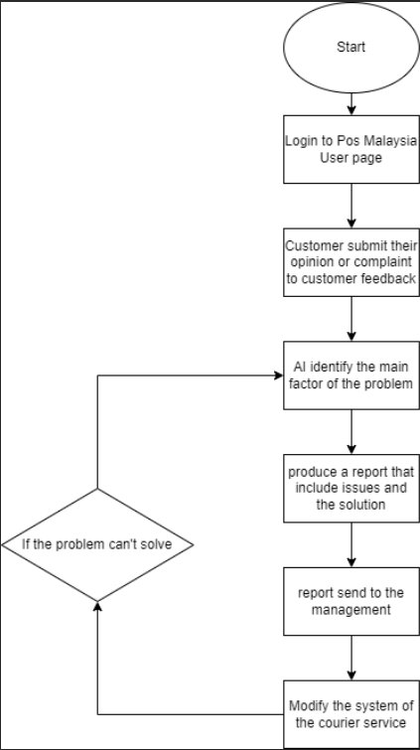

Existing Systems Review

The current delivery system is as follows:
- Package your parcel
- Select a delivery service, which ranges from express courier service to international shipping option
- Visit a Pos Malaysia Outlet
- Complete the necessary documents, which would be provided by the staff
- Pay for the delivery of the parcel
- Obtain a receipt from the store
- Wait for completion of your delivery and track your delivery, which could be tracked by using the provided tracking number of your product on the website or mobile app
- When the parcel has arrived, the receiver can pick up the parcel
- If the parcel goes missing or damaged pretty badly during shipping, the customers can contact Pos Malaysia, regarding this issue

One of the main problems with this system is that sometimes, the products will go missing or damaged in shipping, which could be due to several factors which are bad management system, and low service quality control. Additionally, in the mobile app or website, the information given about the parcel in shipping, which would cause the customers to worry about what will happen to the package which would cause them to call customer service, but Pos Malaysia’s customer service is very slow and unresponsive.

Additionally, in the case that the parcel goes missing or damaged, customers will have to go through a tedious process: of contacting Pos Malaysia, which could consist of calling them and texting them, and sometimes would not get a respond for quite some time, which could be due to bad customer service or bad after customer service or it could be due to the reason that there is an overflowing influx of complaints paired with a bad complains management system, and in the case that they do receive a respond, it would sometimes result in an unhelpful response.

Conclusion

Delivery services have become more important in our daily life nowadays as we are in the era that places greater emphasis on time saving and convenience. Simultaneously, Pos Malaysia also becomes more important for Malaysian due to the development of e-commerce and most of the service platform in Malaysia. Because of the consumers begin to adapt the “new normal”, which is the changes brought by the COVID-19 pandemic, it shows that the demand for this service is strong, not only in Malaysia but throughout the world.

Pos Malaysia has been recognized the surge in e-commerce and the heightened demand for delivery services. They found out that automation, especially in the parcel sorting part, it is a must to increase their efficiency and provide more affordable delivery choices. After the continuous three years transformation plan that launched in 2019, Pos Malaysia has already made substantial progress and play an important role in solving lots of the problem cause by the COVID-19 pandemic. Pos Malaysia able to maintain its position and keep fulfilling the needs of customer in the competitive world of delivery services.

Pos Malaysia has a lot of potential for future growth and a better customer experience as long as it keeps investing in its technology and infrastructure. Pos Malaysia is poised to solve current problems and improve operations because to its strong resources and financial performance.

Pos Malaysia is well-positioned for a bright future because to its commitment to resolving issues and enhancing services in this age of technology. The business can maintain its position and keep up with changing consumer needs in the competitive world of delivery services.


References
- Jules. (n.d.). How to deal with shipping delays (and keep your customers happy). Easyship. https://www.easyship.com/blog/shipping-delays-tips#6-tips-for-dealing-with-shipping-delays
- Redirect notice.(n.d.).
https://www.google.com/url?sa=i&url=https%3A%2F%2Fwww.freepik.com%2Fvectors%2Fdelivery-tracking%2F17&psig=AOvVaw2H58u8-r90mHqD08j7IcJi&ust=1703233973997000&source=images&cd=vfe&opi=89978449&ved=0CBQQjhxqFwoTCPipzJGPoIMDFQAAAAAdAAAAABAI
- Aleixo, C. (2022, February 10). 4 Great ways to improve delivery service. https://getcircuit.com/teams/blog/how-to-improve-delivery-service
- How to prevent late deliveries? (n.d.). eLogii. https://elogii.com/blog/how-to-prevent-late-deliveries/
- POS Laju Reviews and Complaints | pos.com.my @ PissedConsumer Page 3. (2023, December 17). PissedConsumer. https://pos-laju.pissedconsumer.com/reviews/RT-P.html
- Pos Malaysia: Reviews, Complaints, Customer Claims | ComplaintsBoard. (2023, December 16). https://www.complaintsboard.com/pos-malaysia-b120628
- Poslaju Malaysia operating hours, operating days, post offices. (n.d.). Track PosLaju - Tracking PosLaju Delivery Tracker Malaysia & World. https://trackposlaju.com/poslaju-malaysia-operating-hours/
- Figma: The Collaborative Interface Design Tool. (n.d.). Figma. https://www.figma.com/
- draw.io - free flowchart maker and diagrams online. (n.d.). https://app.diagrams.net

Appendices

Appendix A: System Prototype

6.1.1 Flowchart
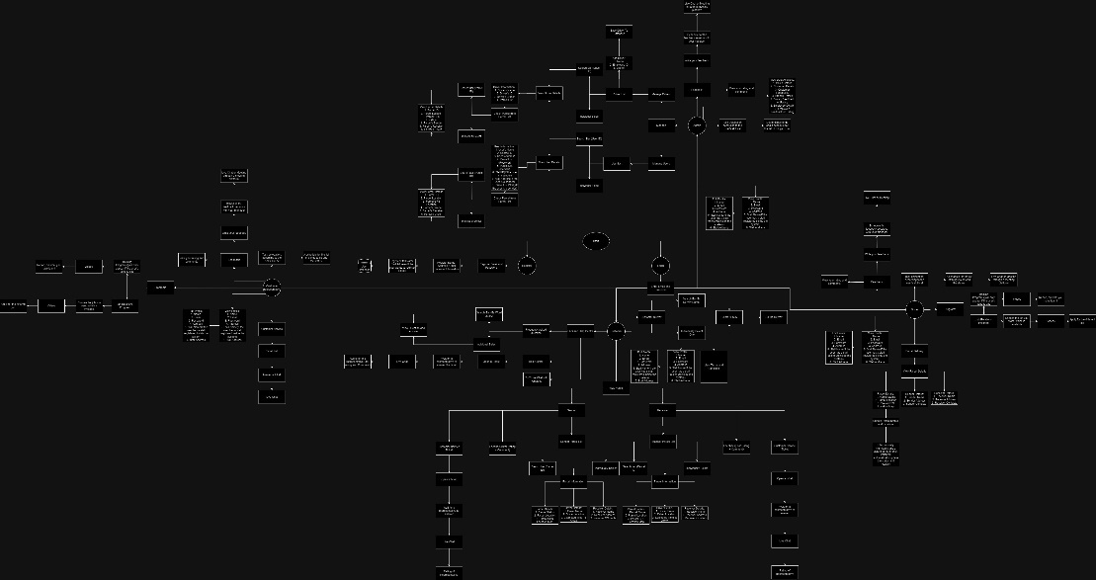
The link to the Flowchart: https://drive.google.com/file/d/1eqImnzUeExRlmmN7r_ofiOa1ByeNSsKL/view?usp=sharing

6.1.2 Prototype
The link to the Figma Site: https://www.figma.com/file/bqxteKqihYpQNI6zx2wqbo/POS-MALAYSIA-PROTOTYPE-(Community)?type=design&node-id=89%3A3&mode=design&t=k7BnvQuNTeXg4Qk0-1

6.1.2.1 Driver

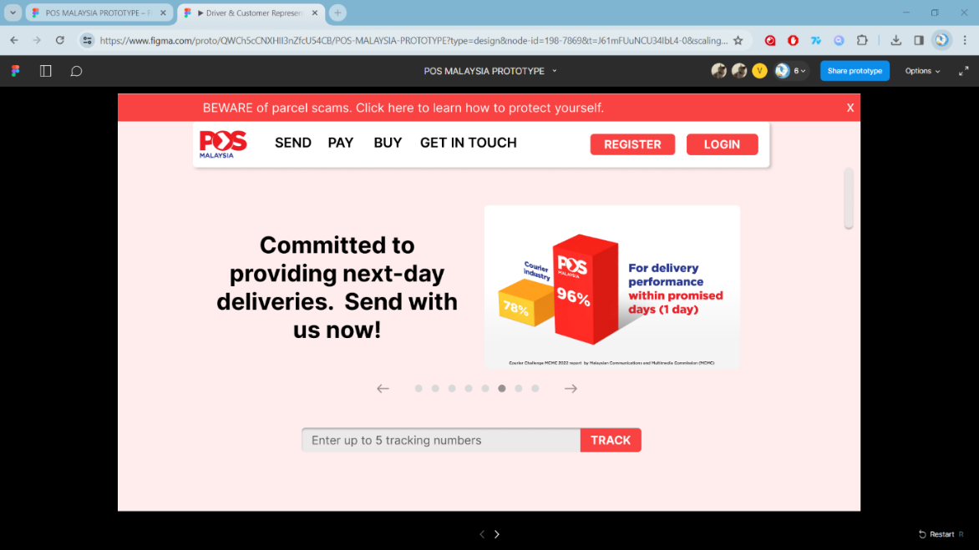
Figure 1:Driver Main Menu
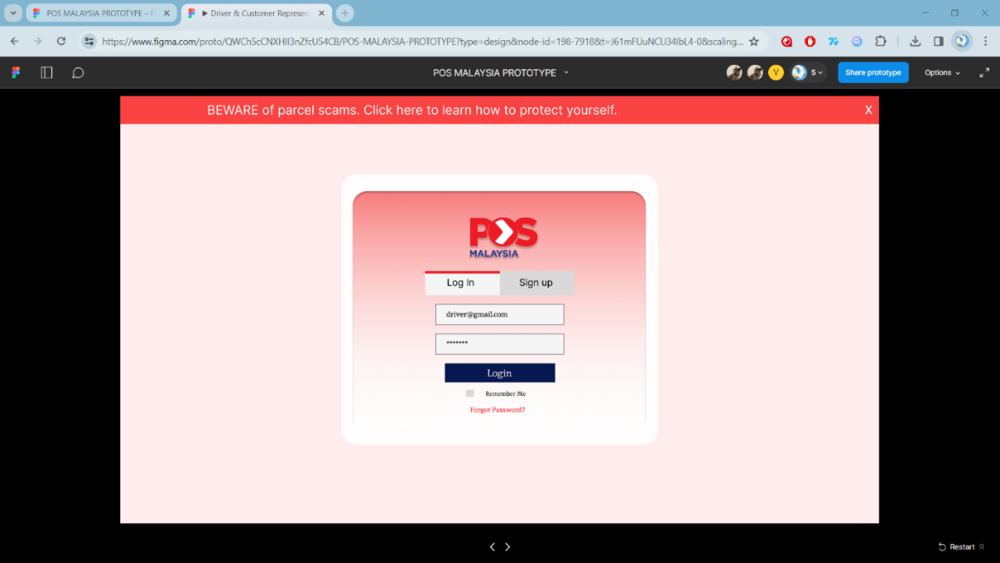
Figure 2:Driver Login Page
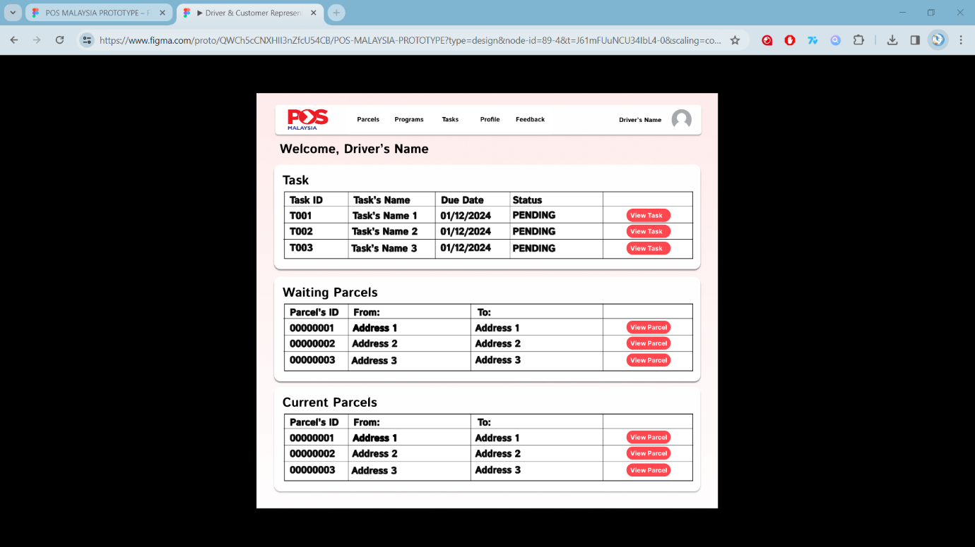
Figure 3:Driver Home Page

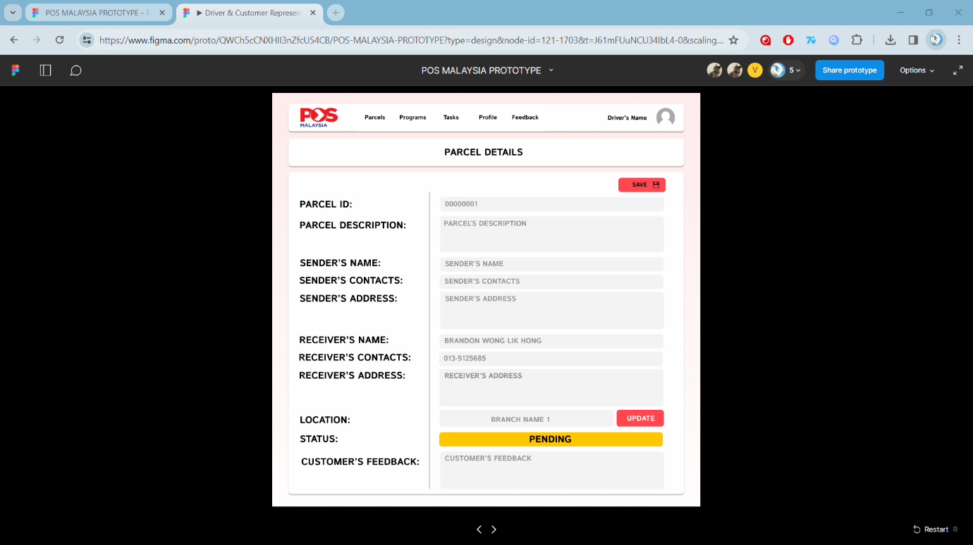
Figure 4:Driver Parcel's Detail
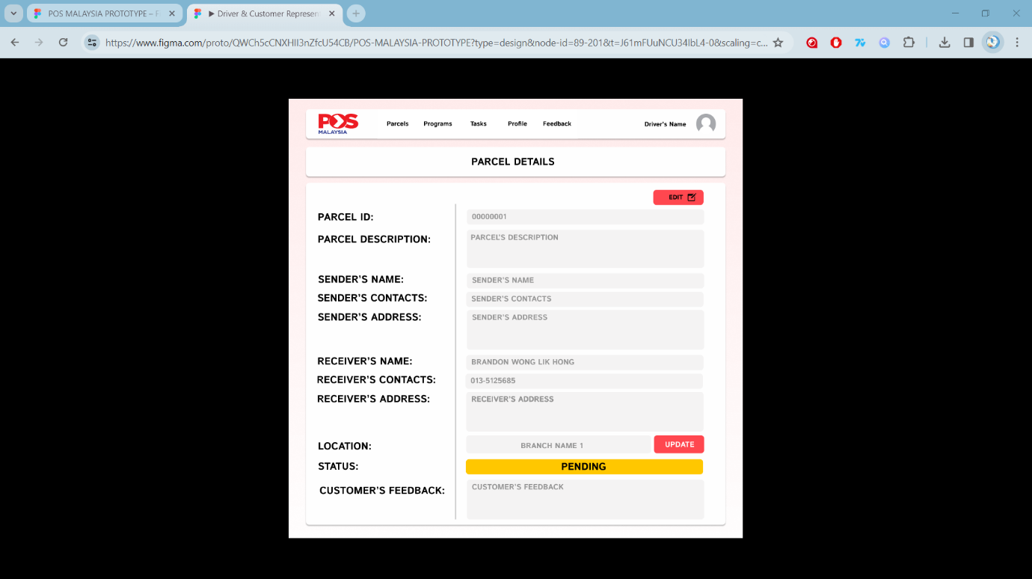
Figure 5:Driver Edit Parcel Detail
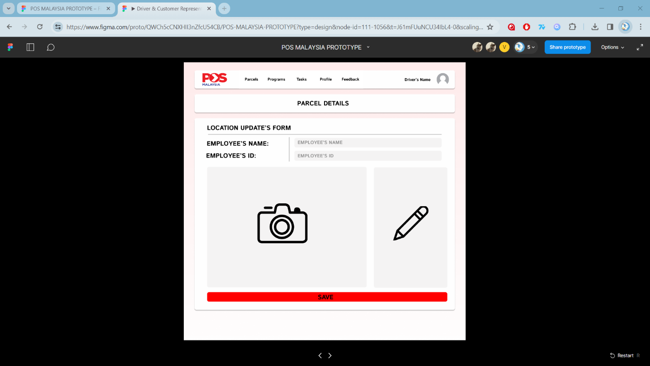
Figure 6:Driver Update Location Form
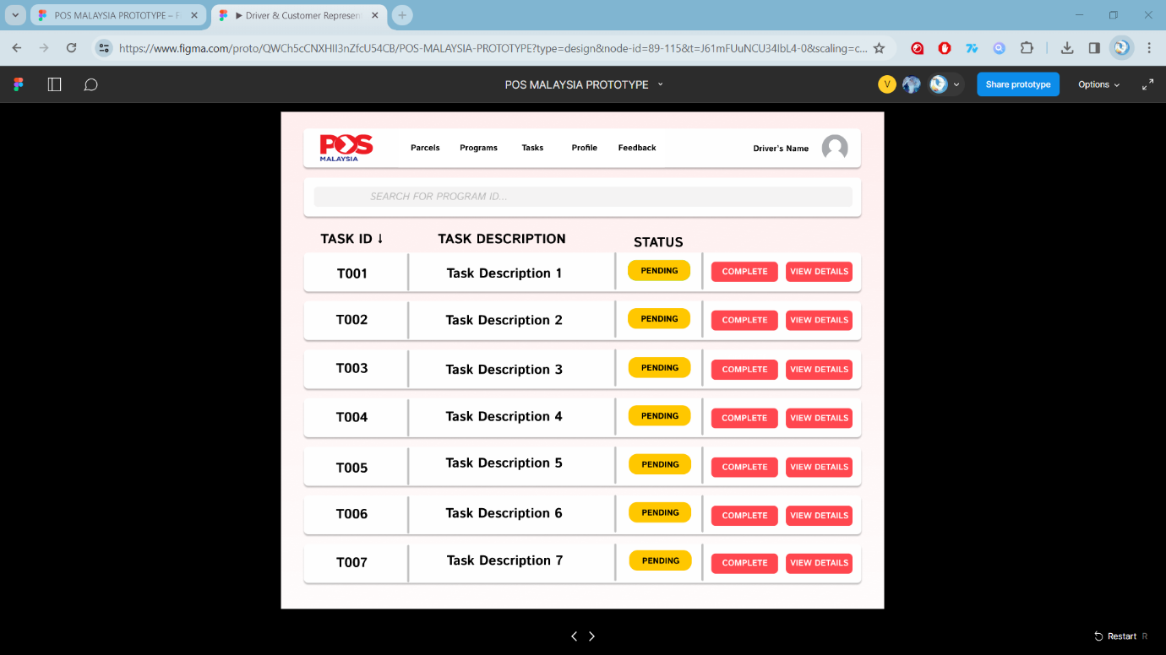
Figure 7:Driver Task Delegation
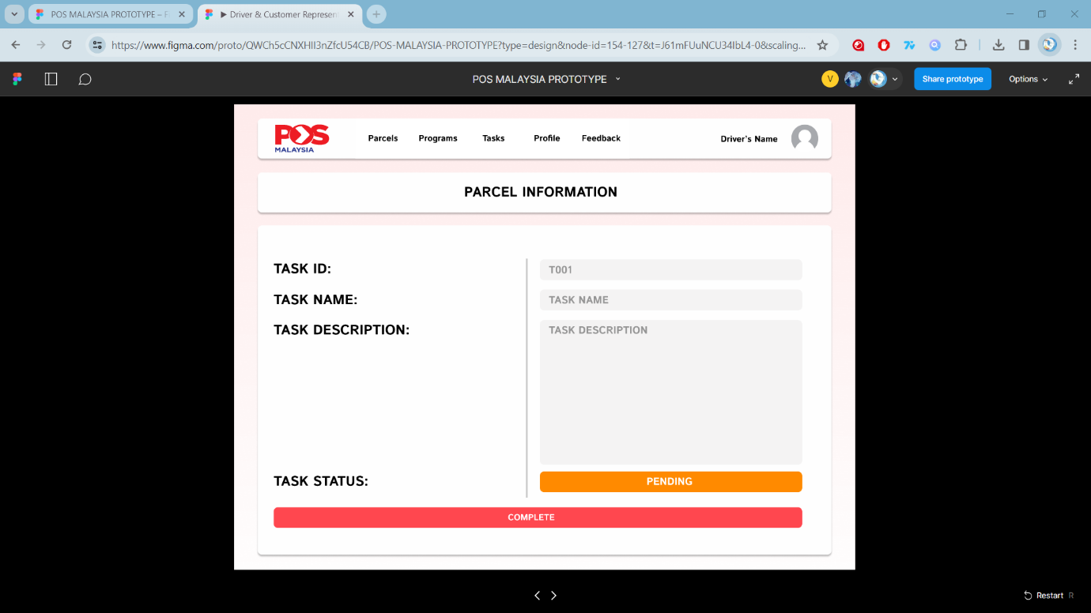
Figure 8:Driver View Task Detail
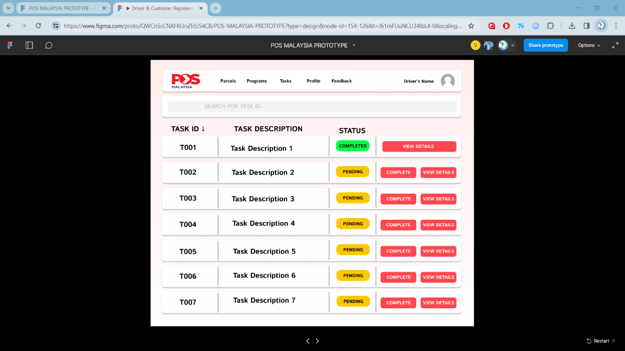
Figure 9:Driver Task Delegation 2

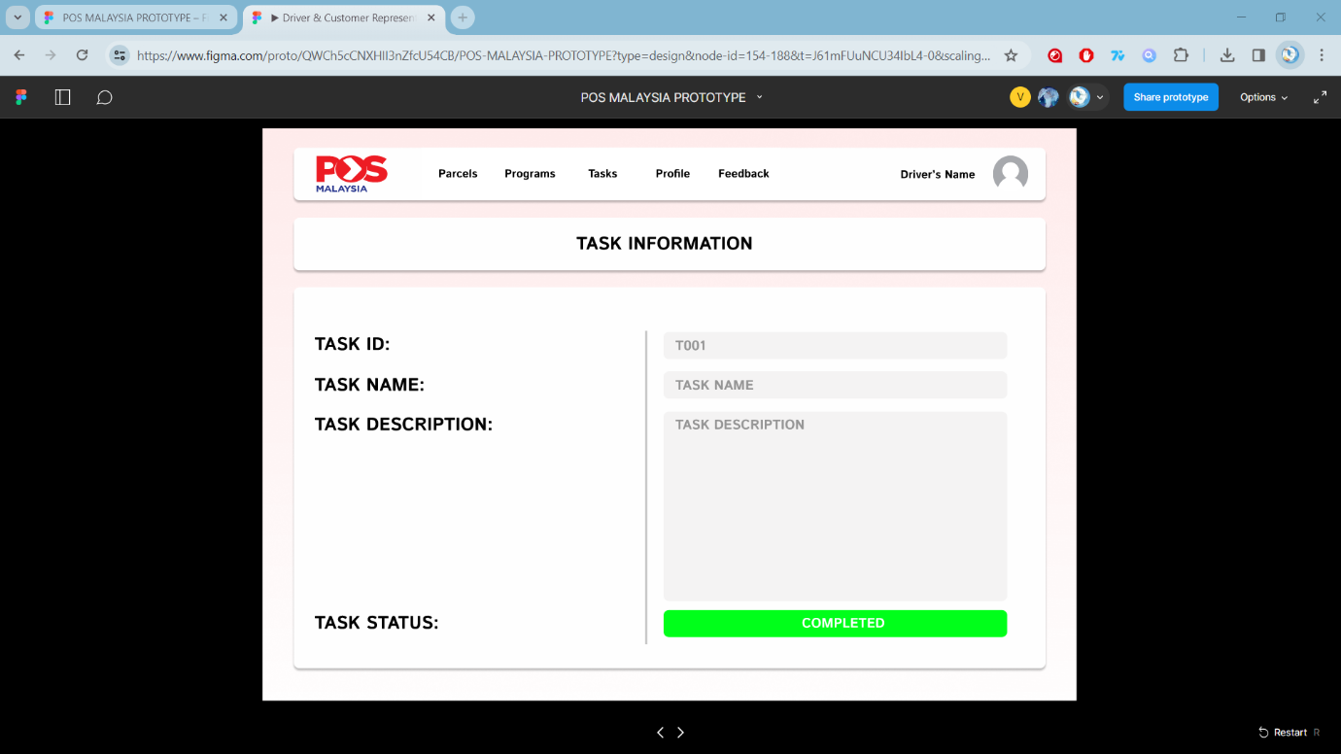
Figure 10:Driver View Task Detail 2
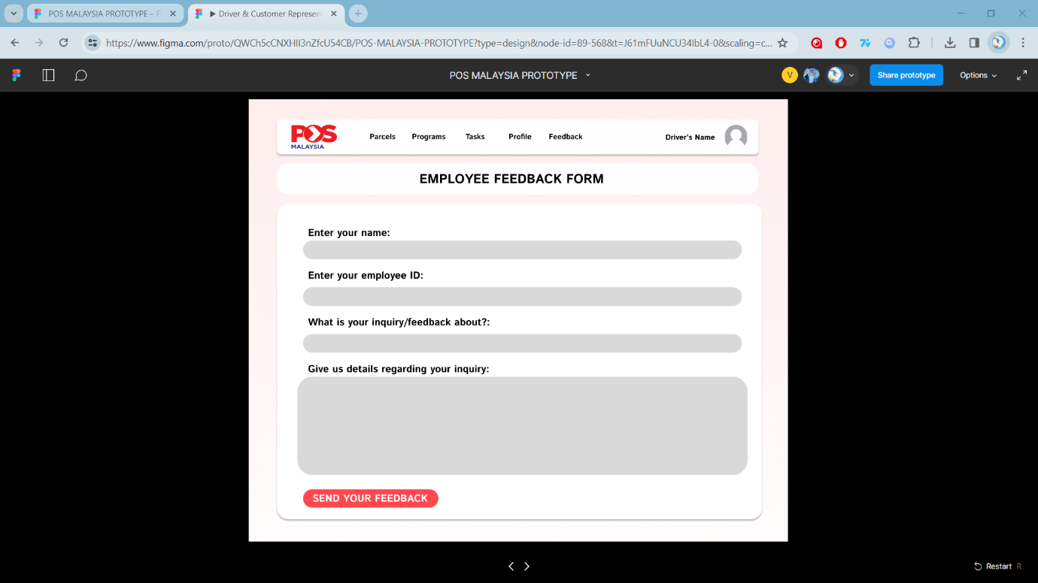
Figure 11:Driver Employee Feedback Form
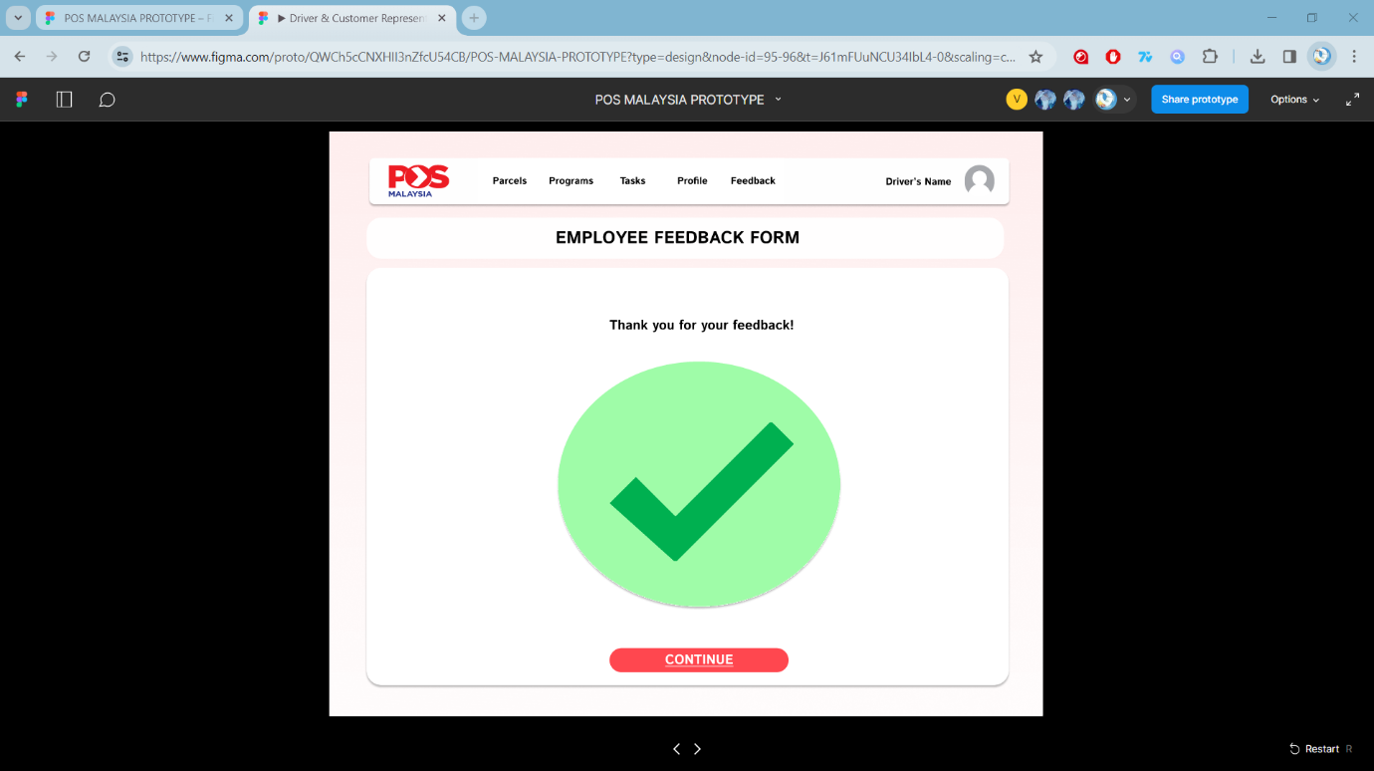
Figure 12:Driver Employee Feedback Form Submitted
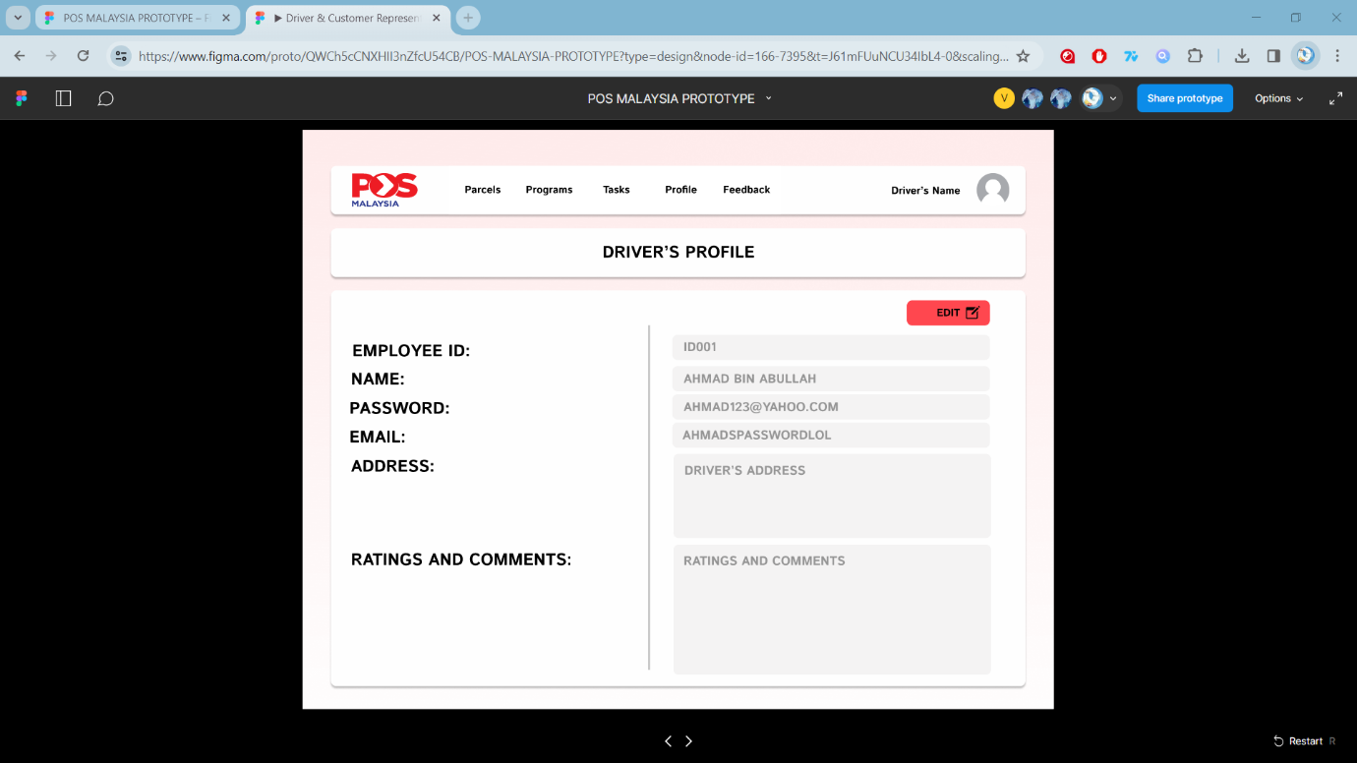
Figure 13:Driver View Profile
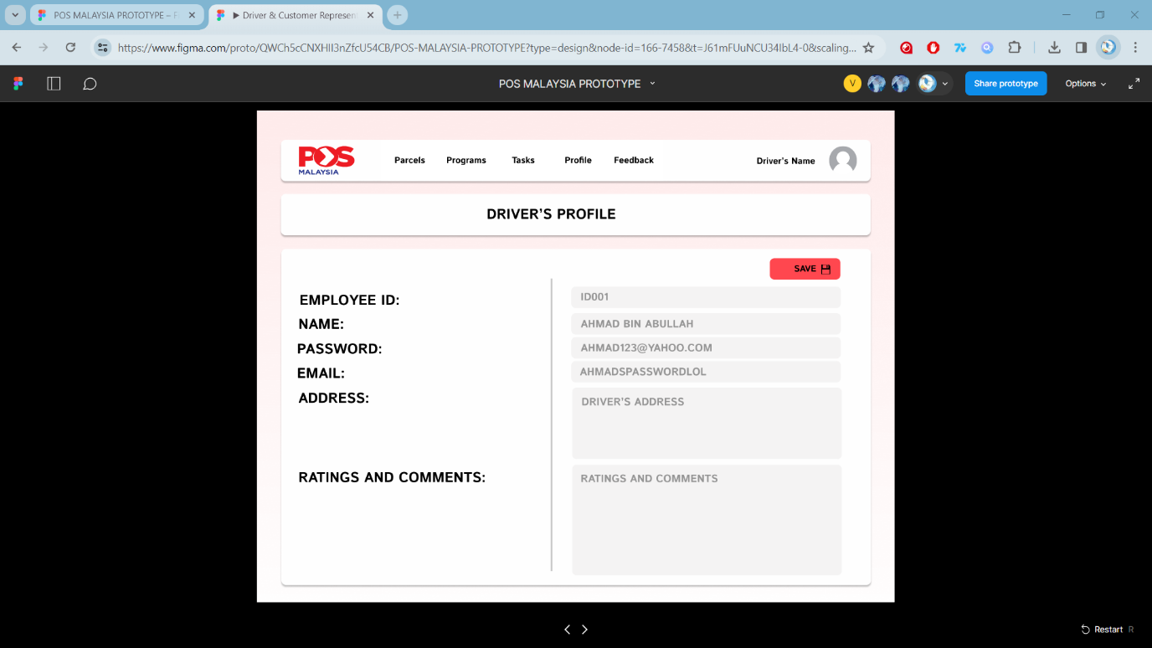
Figure 14:Driver Edit Profile
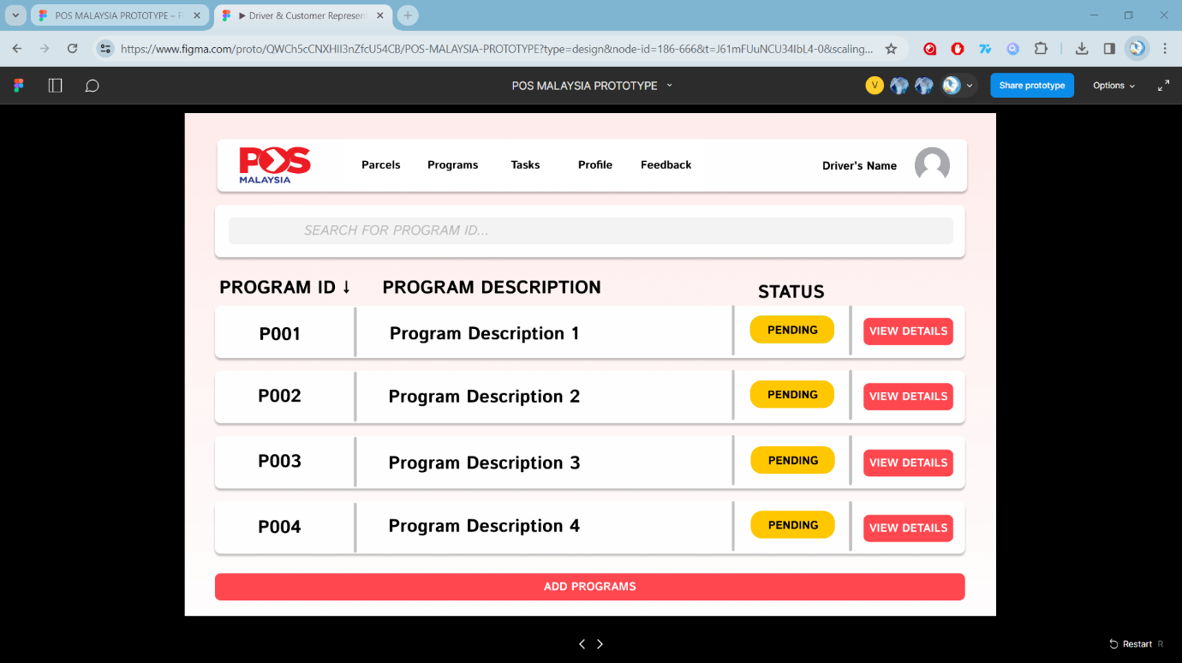
Figure 15:Driver Home Page Programs
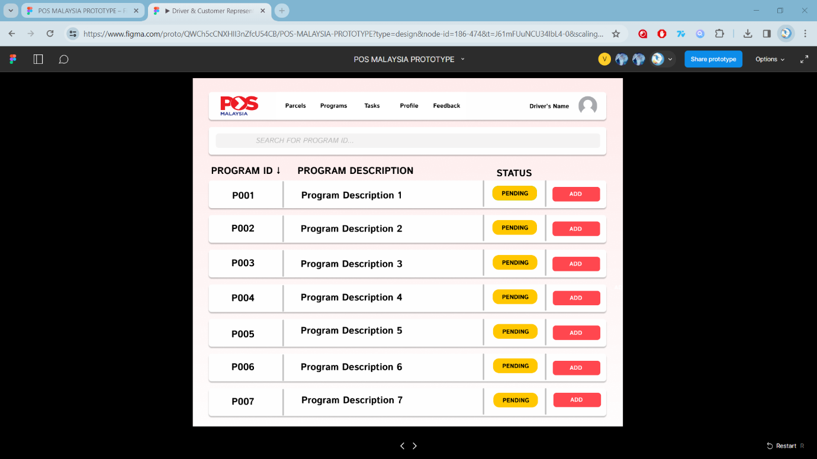
Figure 16:Driver Programs
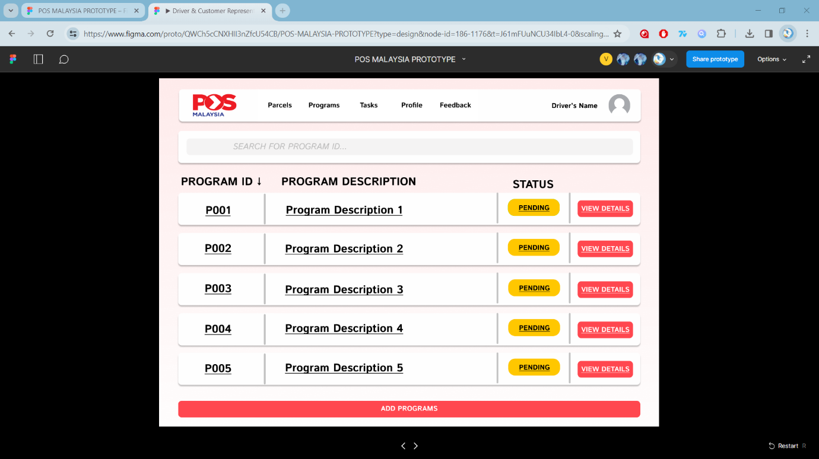
Figure 17:Driver Home Page Program Added
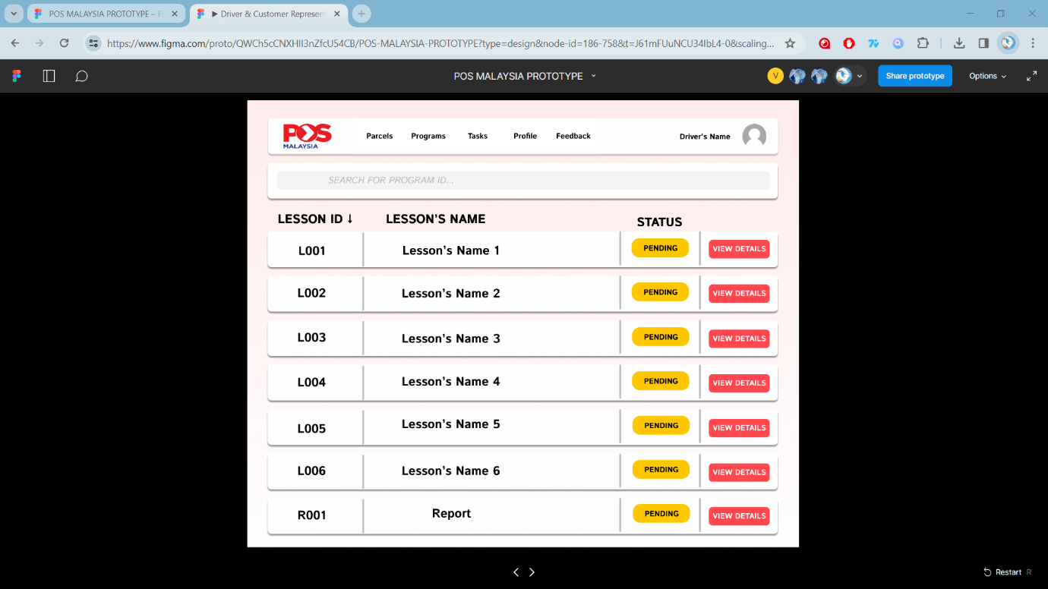
Figure 18:Driver Program's Lessons
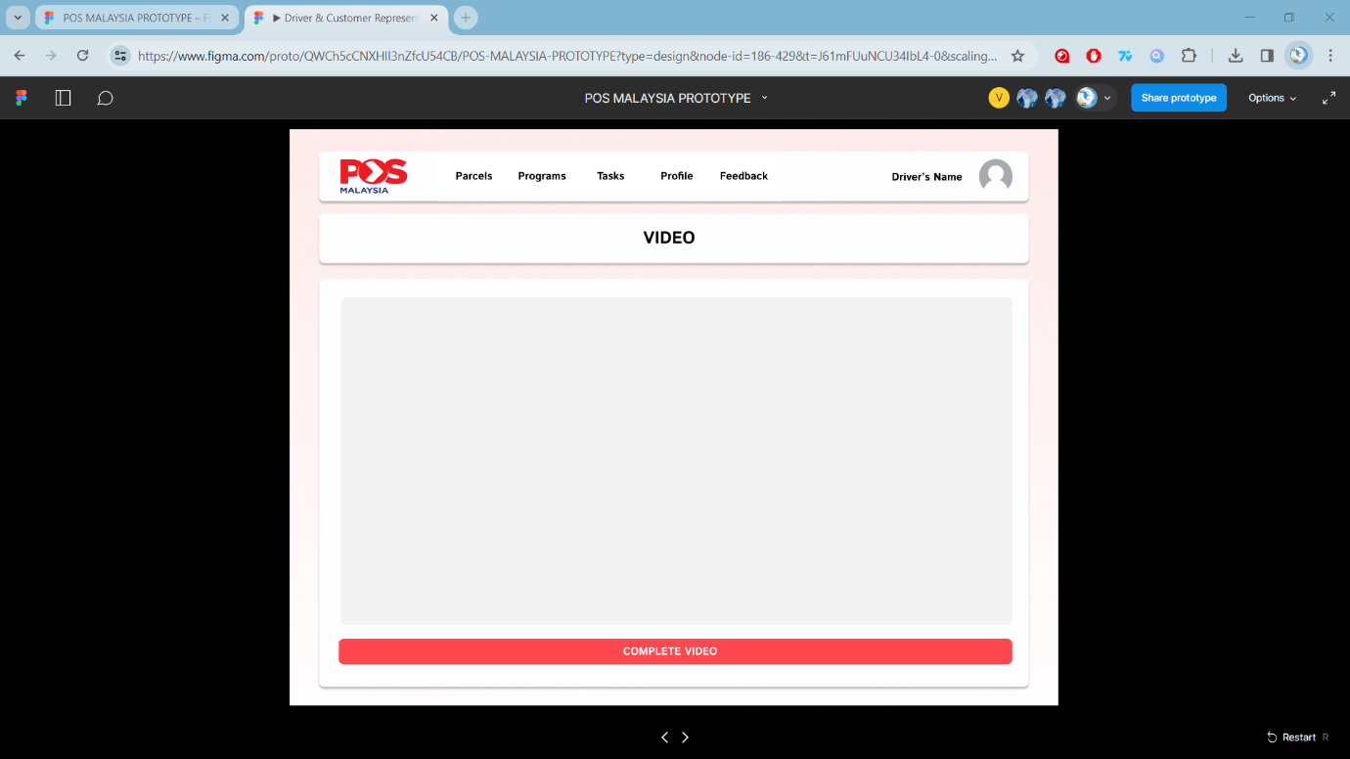
Figure 19:Driver Lesson's Video
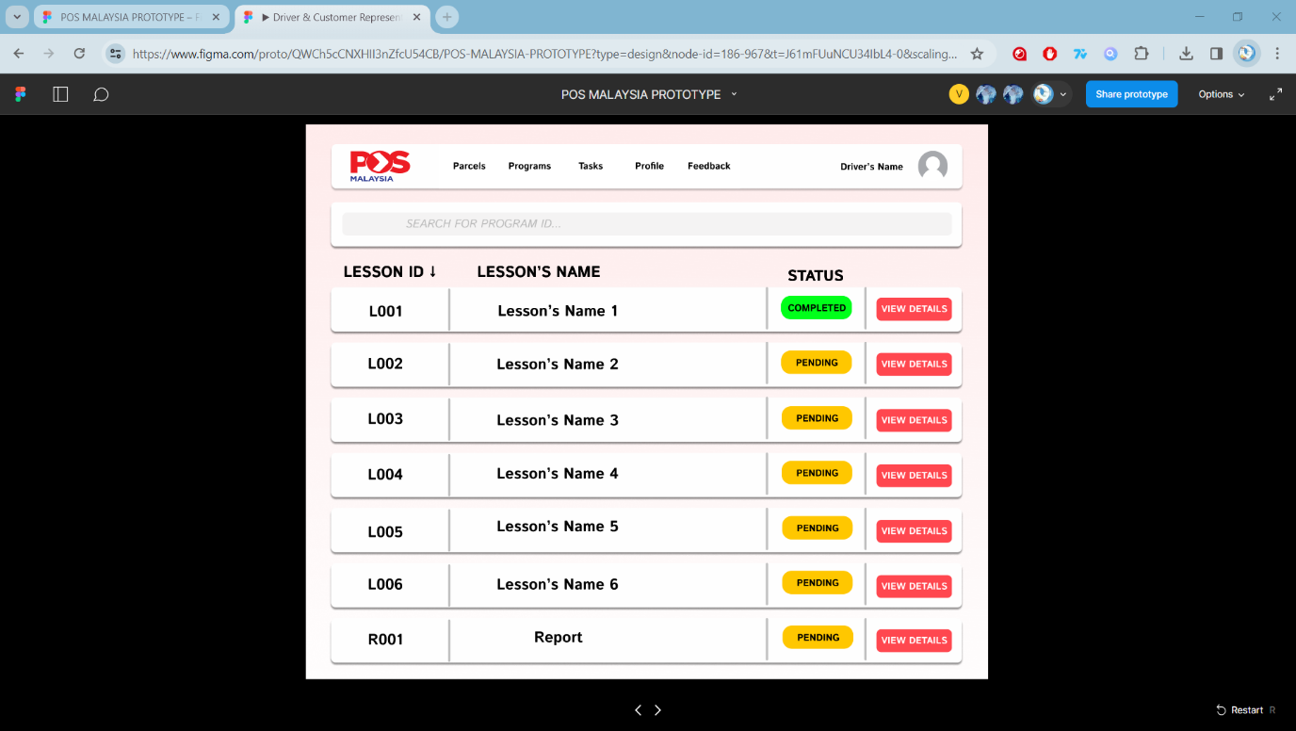
Figure 20:Driver Program's Lessons 2
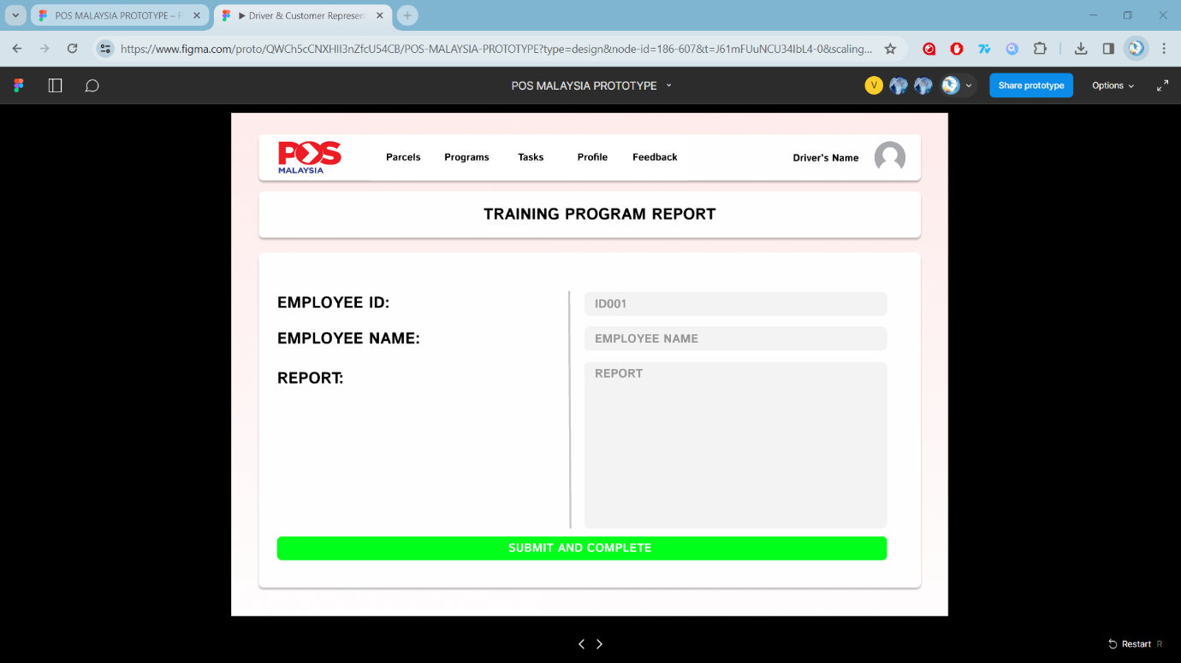
Figure 21:Driver View Report
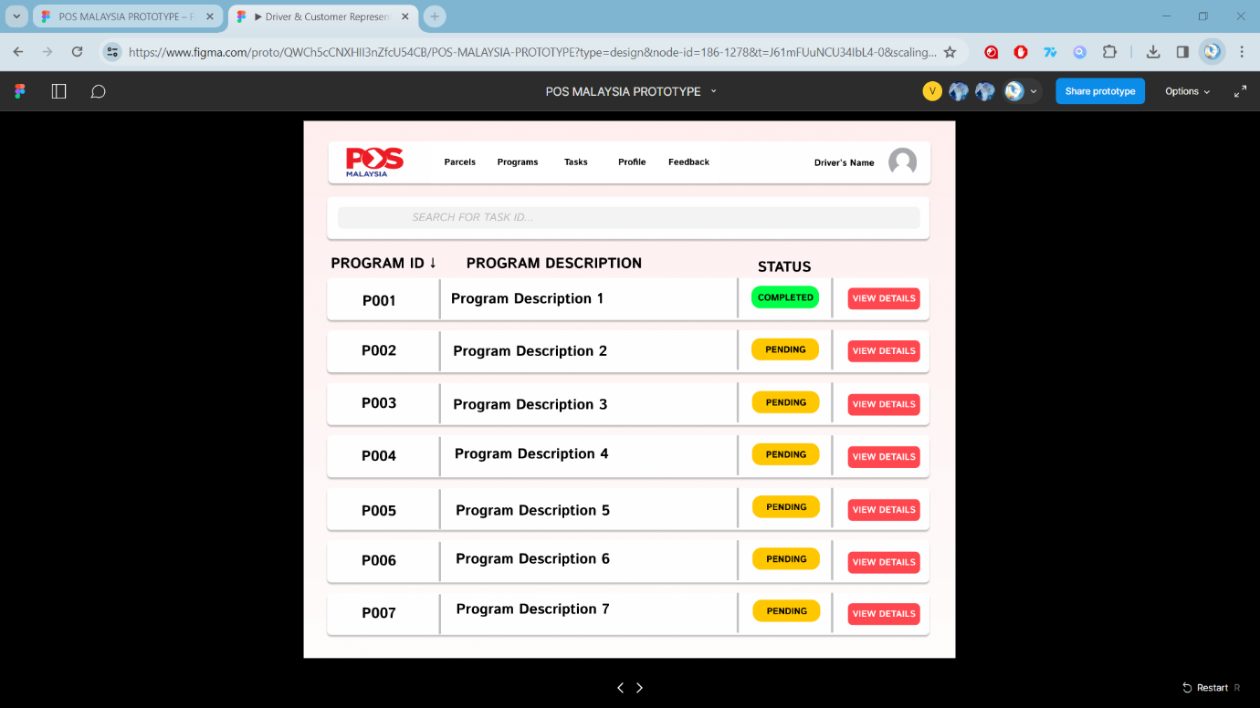
Figure 22:Driver Report Submitted
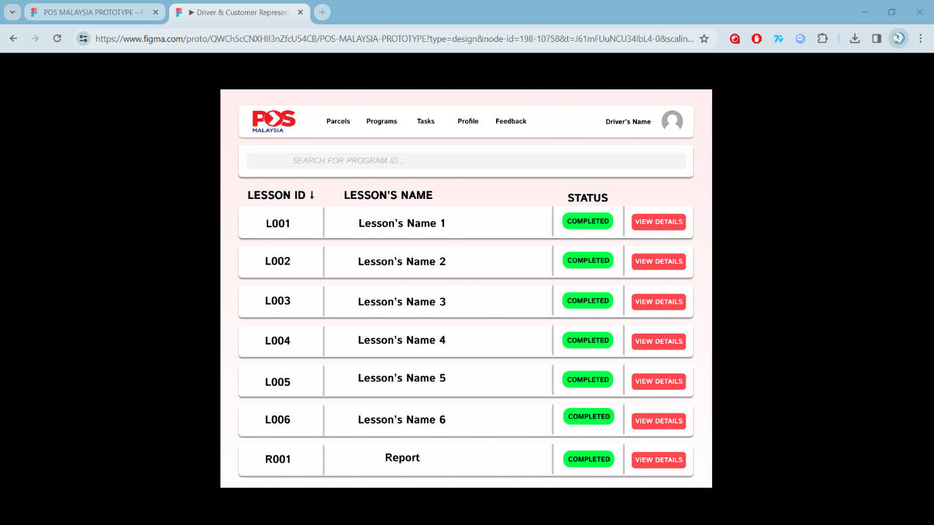
Figure 23:Driver View Completed Lessons

6.1.2.2 Customer Representative
Figure 24: Customer Representative Main Menu

Figure 25: Customer Representative's Login Page

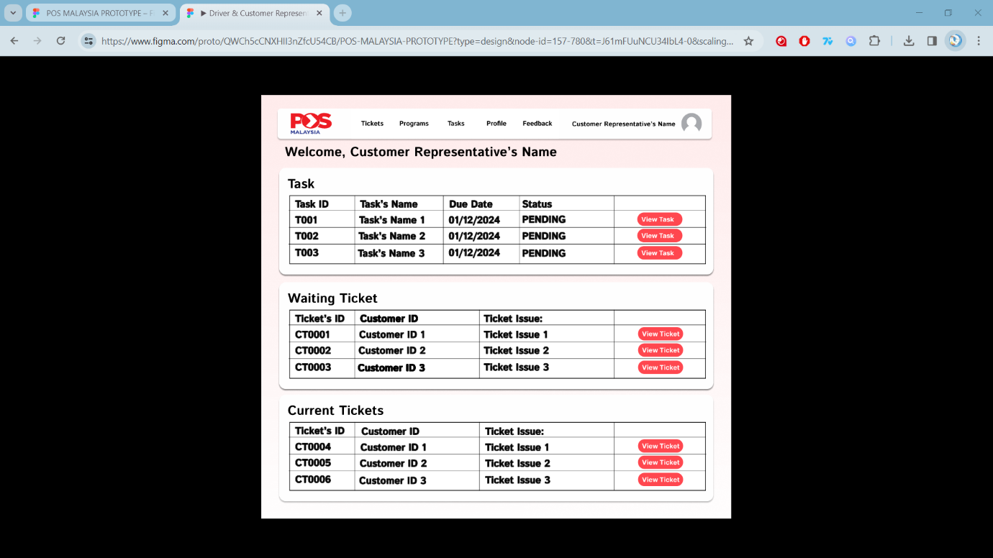
Figure 26: Customer Representative's Home Page
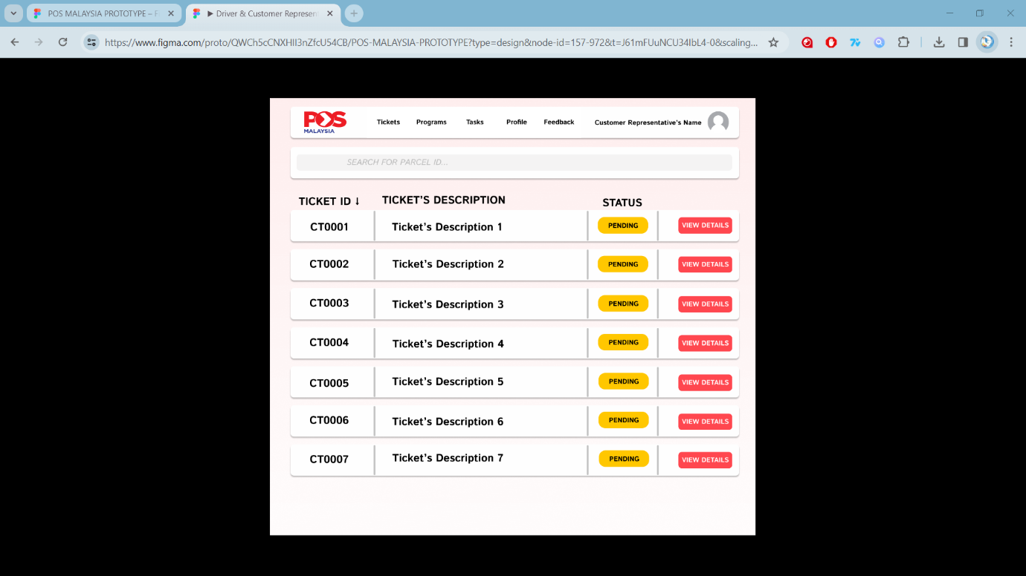
Figure 27: Customer Representative's Ticket List
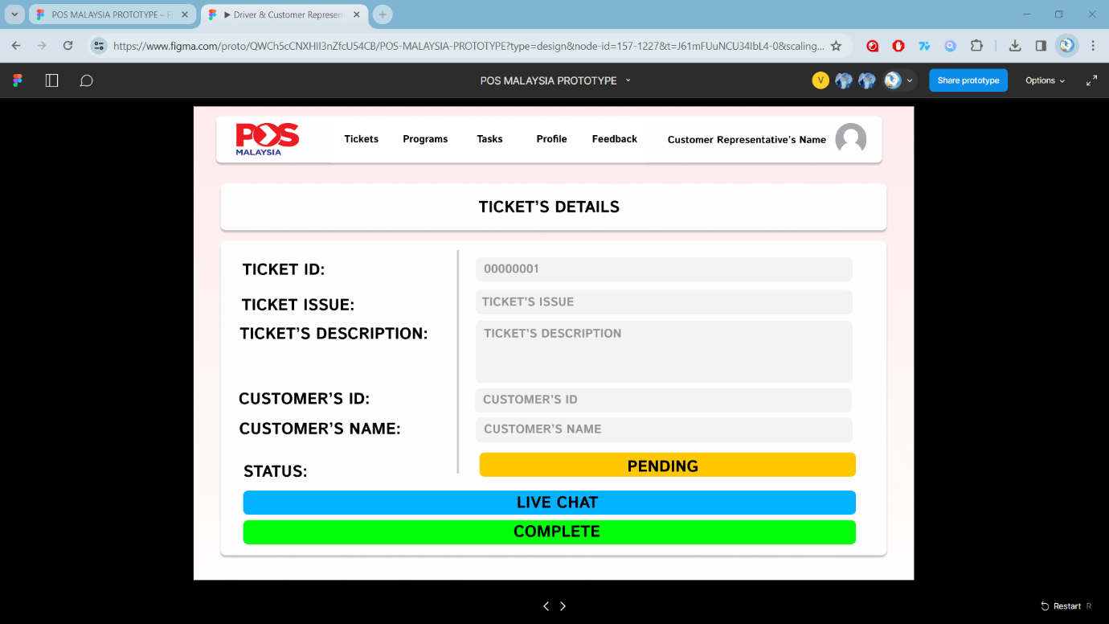
Figure 28: Customer Representative's Ticket Details
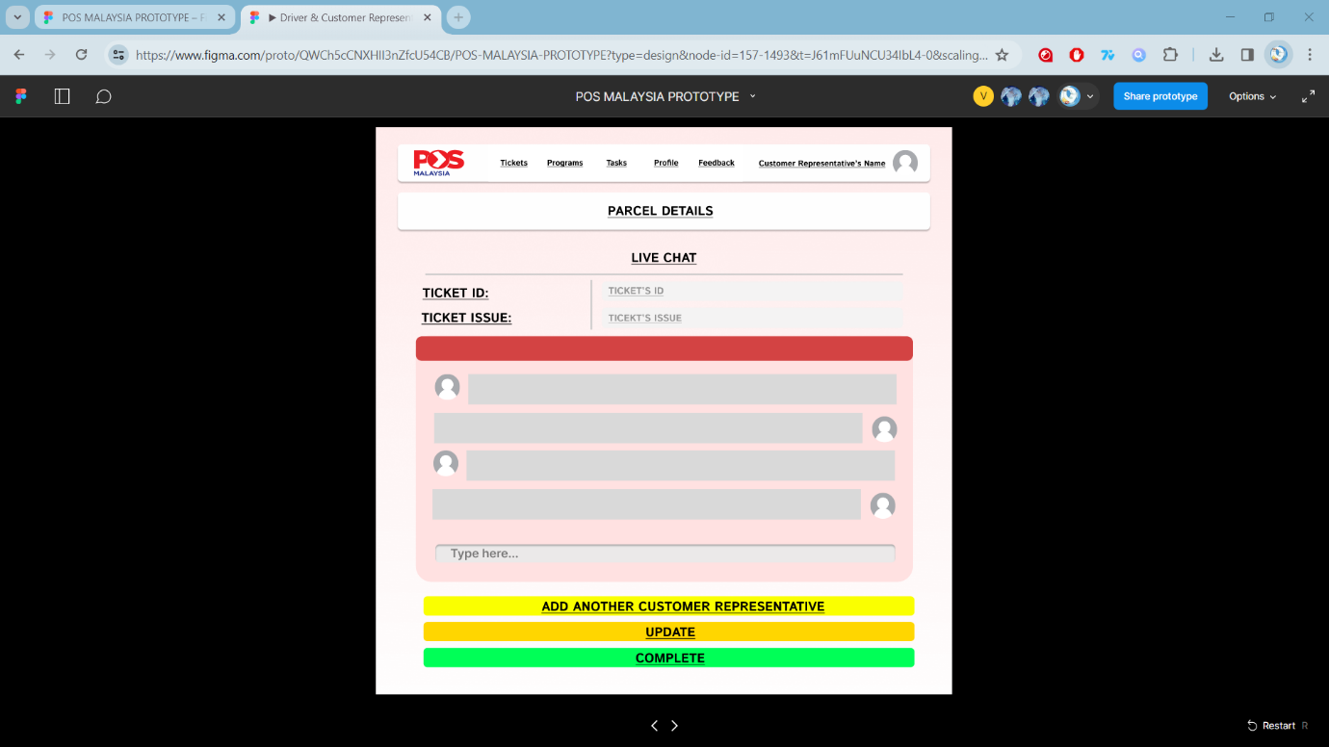
Figure 29: Customer Representative's Live Chat
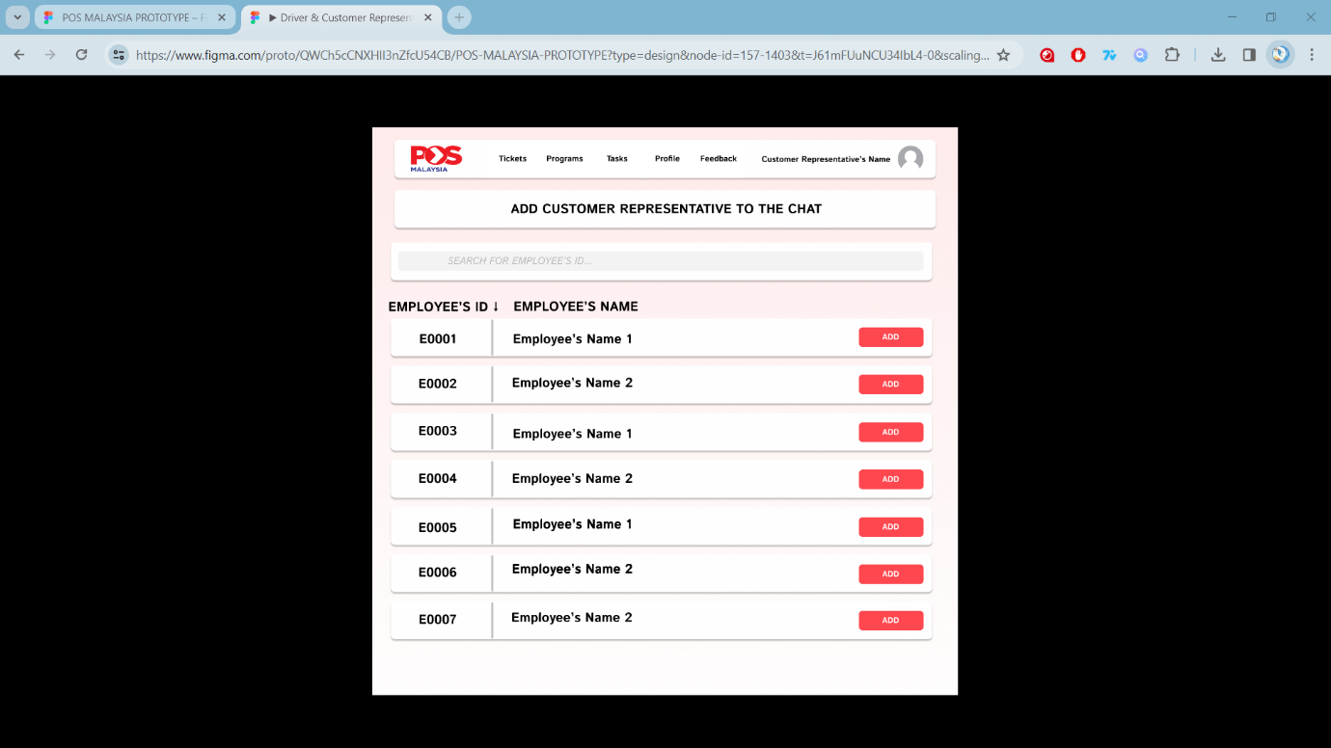
Figure 30: CR's Add Customer Representative to Chat
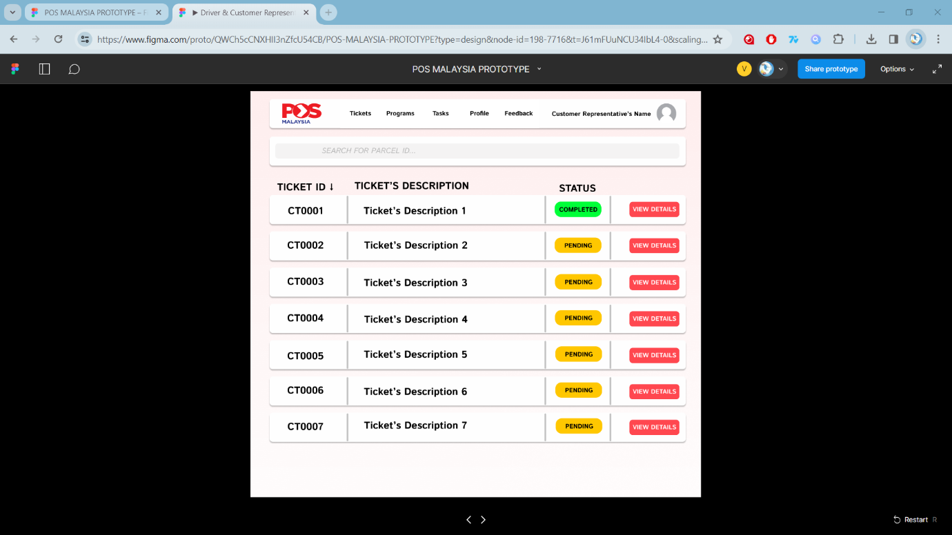
Figure 31: Customer Representative's Ticket List
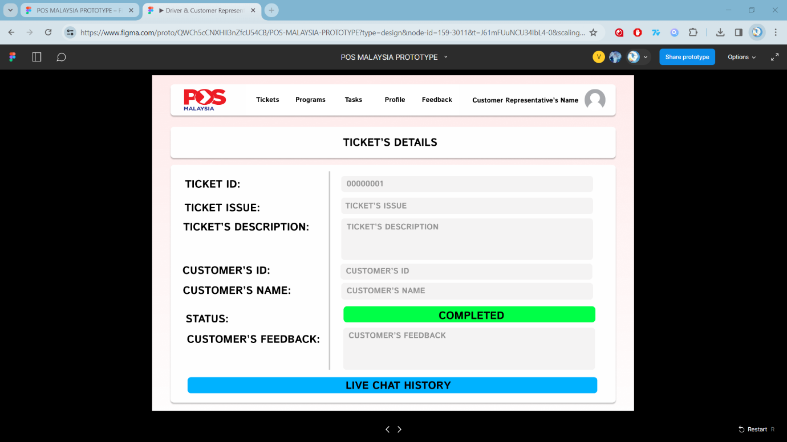
Figure 32: Customer Representative's Ticket Details 2
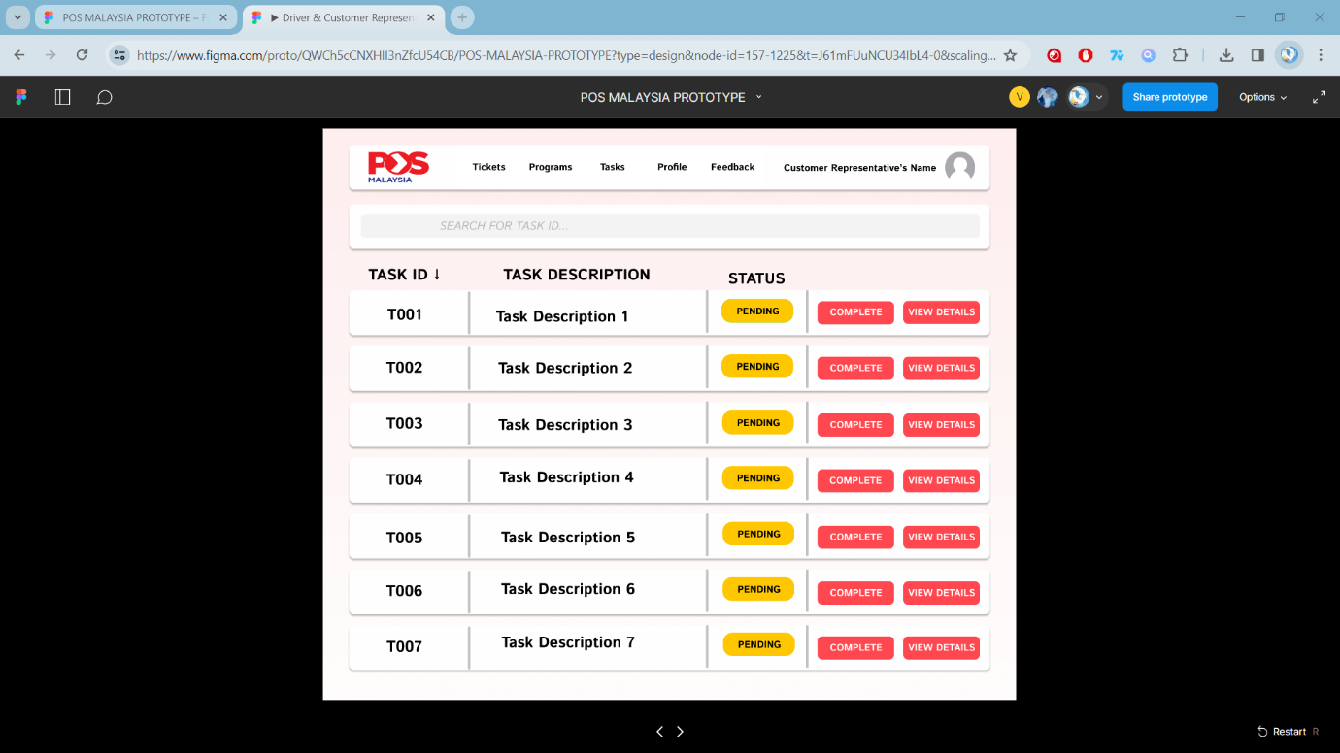
Figure 33: Customer Representative's Task Delegation List
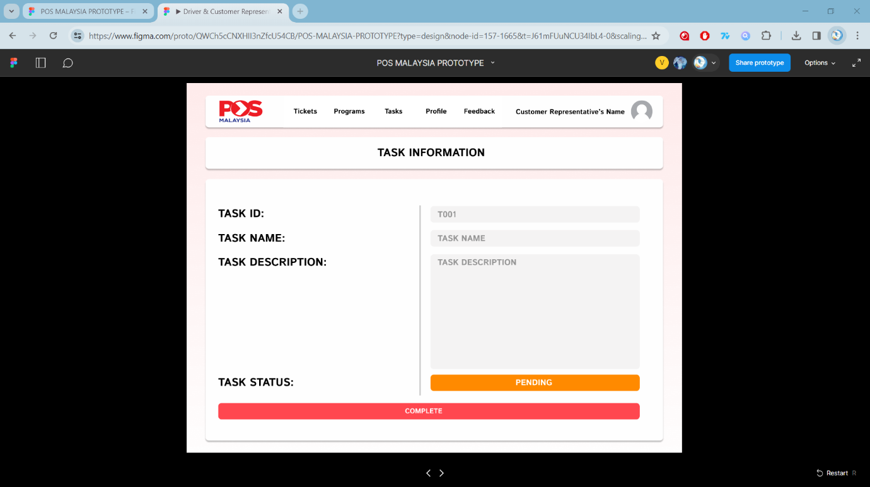
Figure 34: Customer Representative's Task Details 1
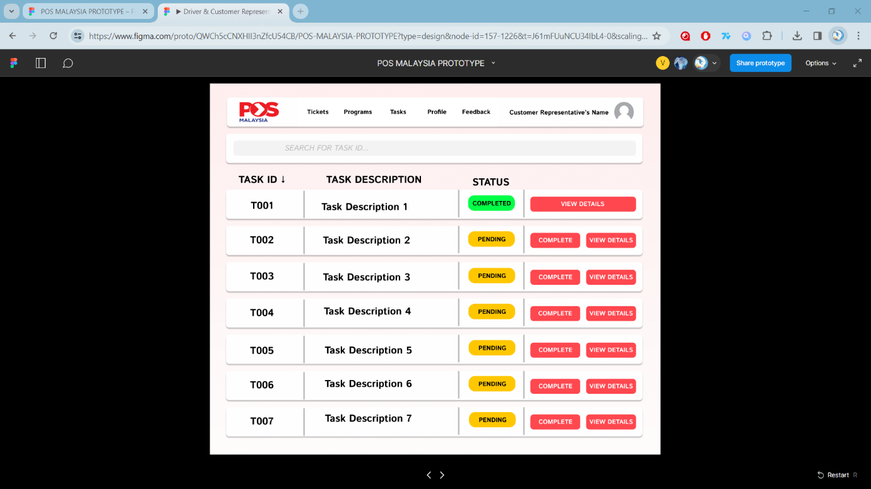
Figure 35: Customer Representative's Task Delegation List 2
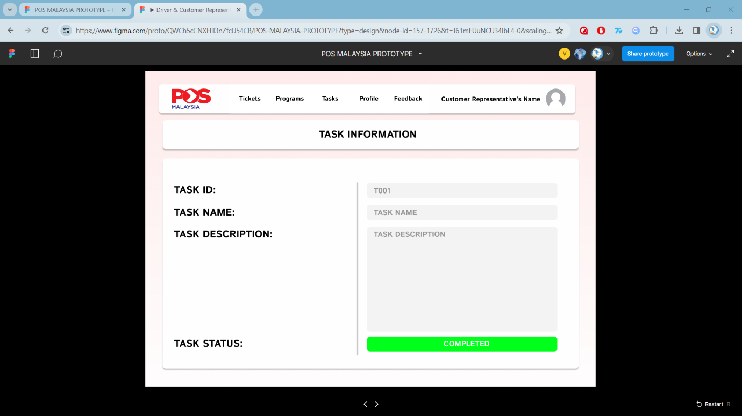
Figure 36: Customer Representative's Task Details 2
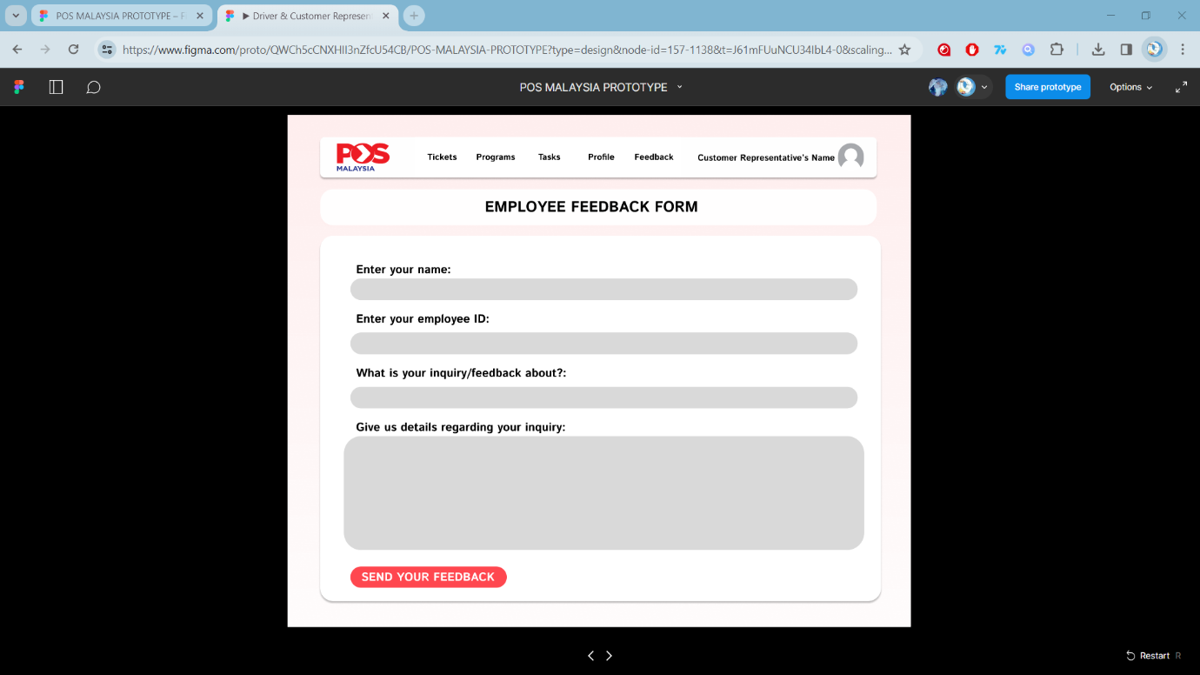
Figure 37: Customer Representative's Employee Feedback Form 1
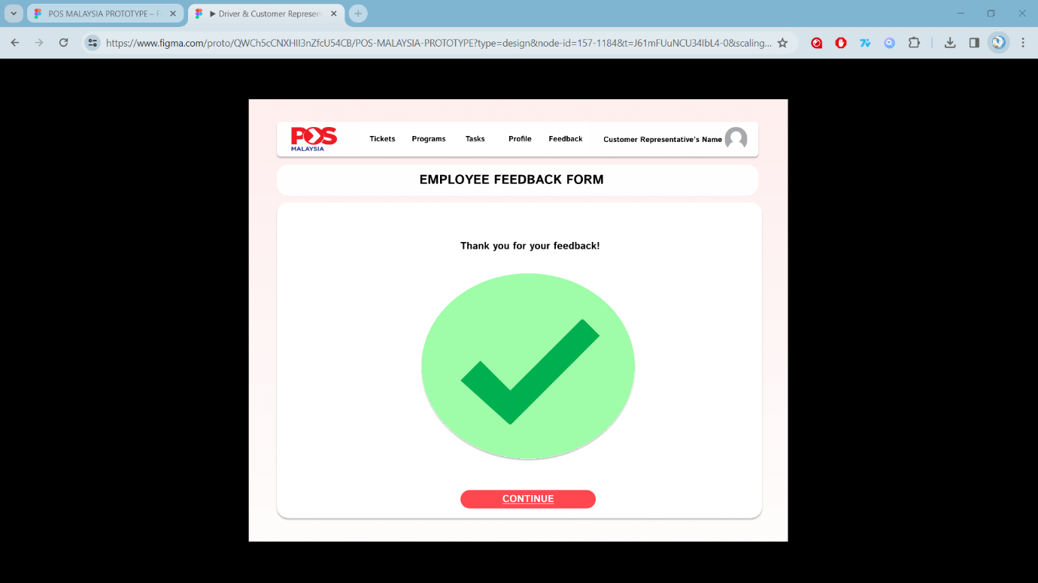
Figure 38: Customer Representative's Employee Feedback Form 2
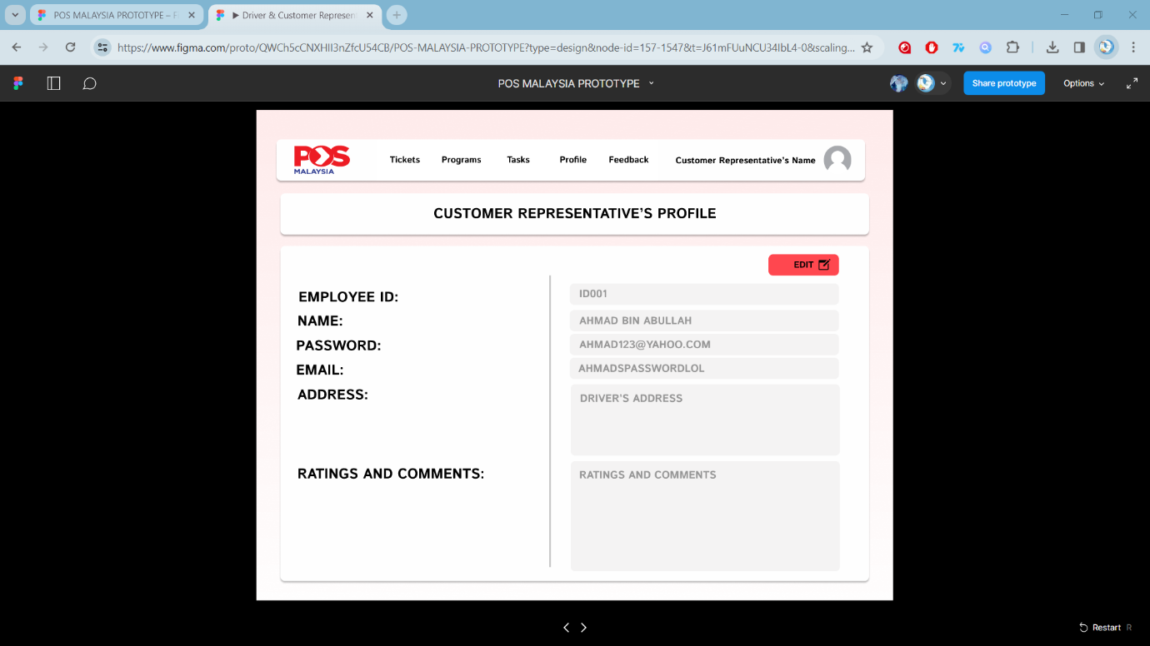
Figure 39: Customer Representative's Profile 1
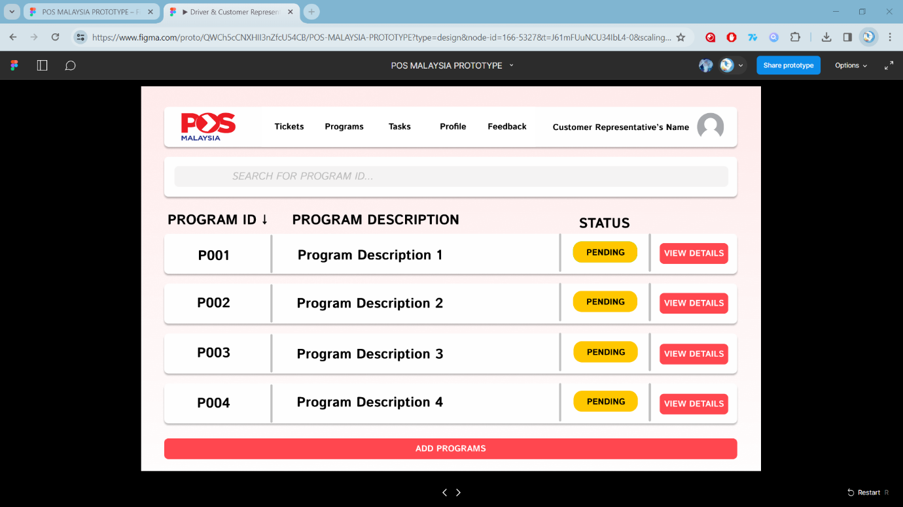
Figure 40: Customer Representative's Program Home Page 1
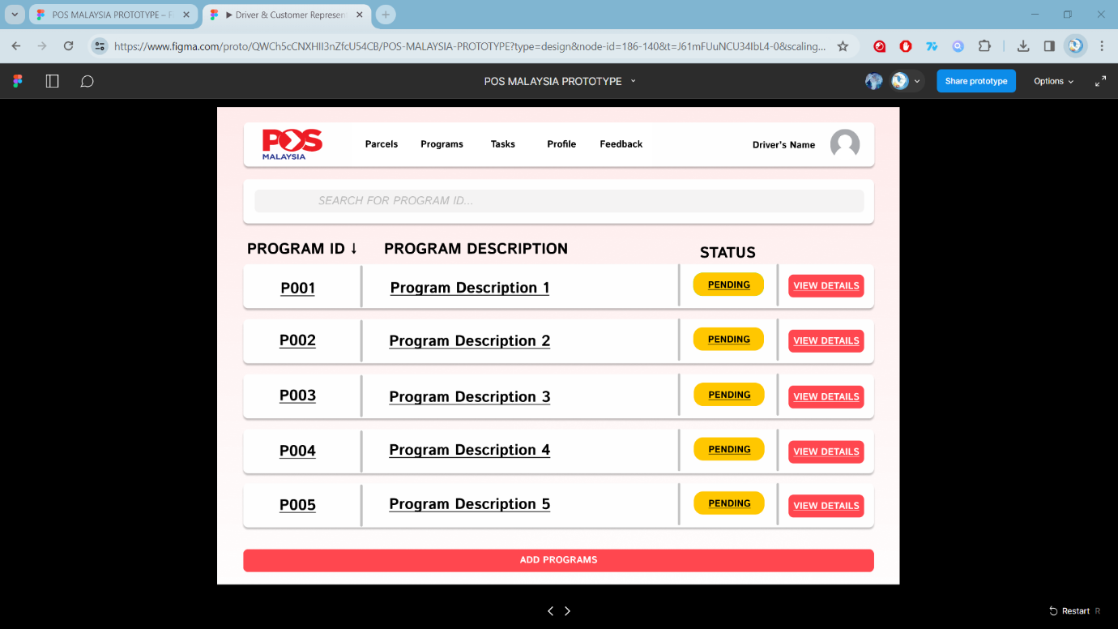
Figure 41 Customer Representative's Program Home Page 2

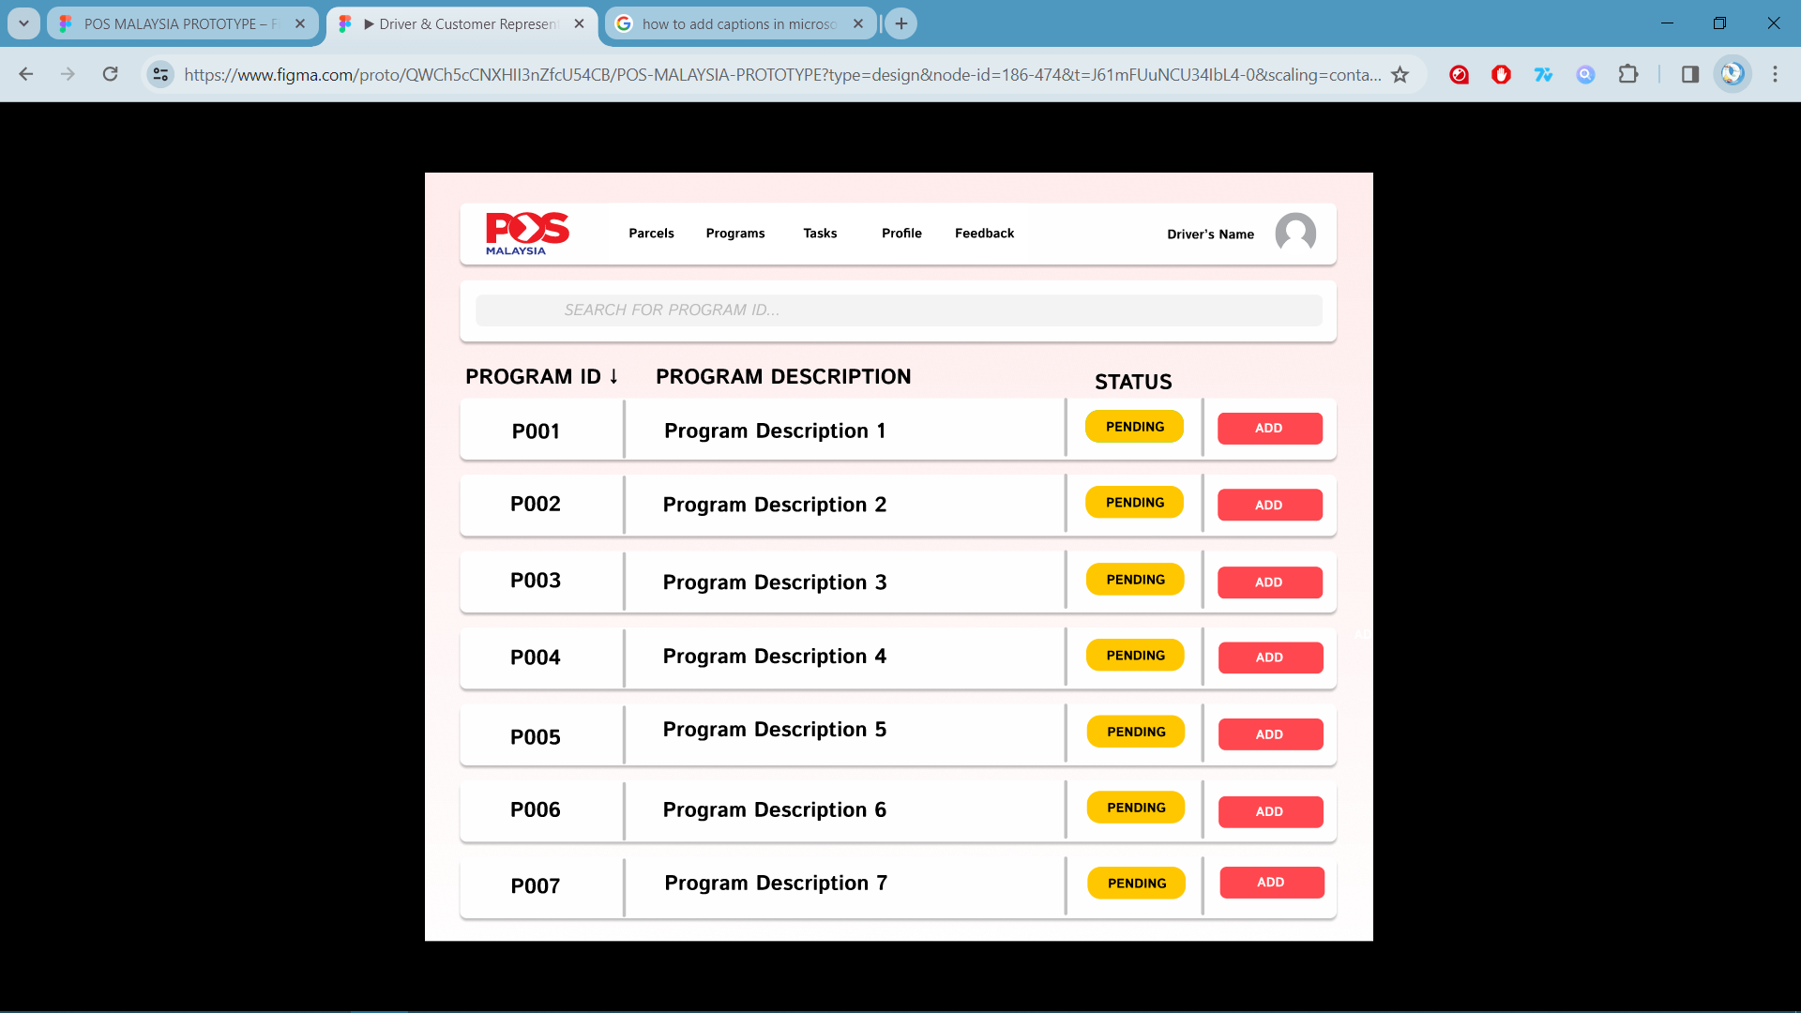
Figure 42 Customer Representative's Programs List 1

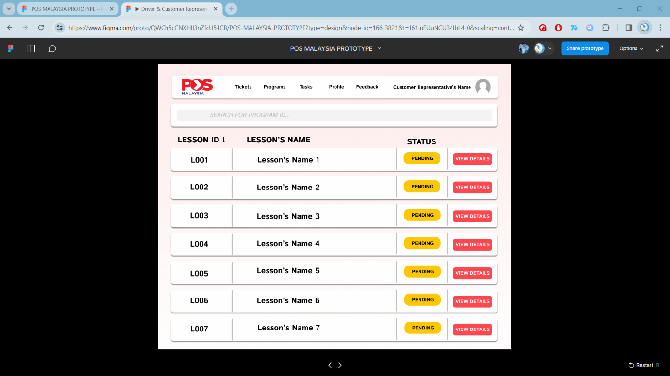
Figure 43 Customer Representative's Lessons List 1

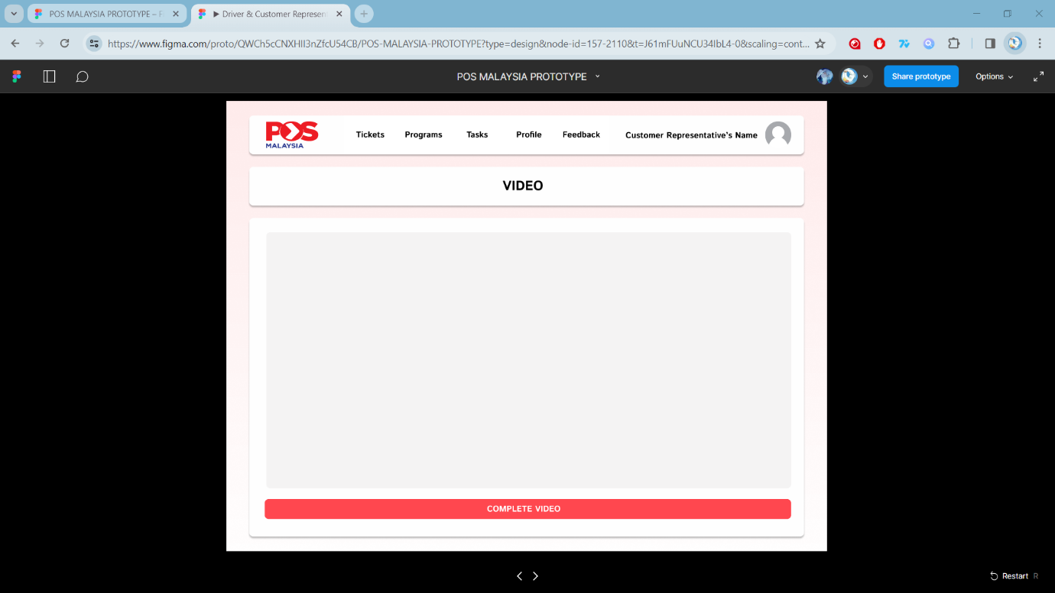
Figure 44 Customer Representative's Video

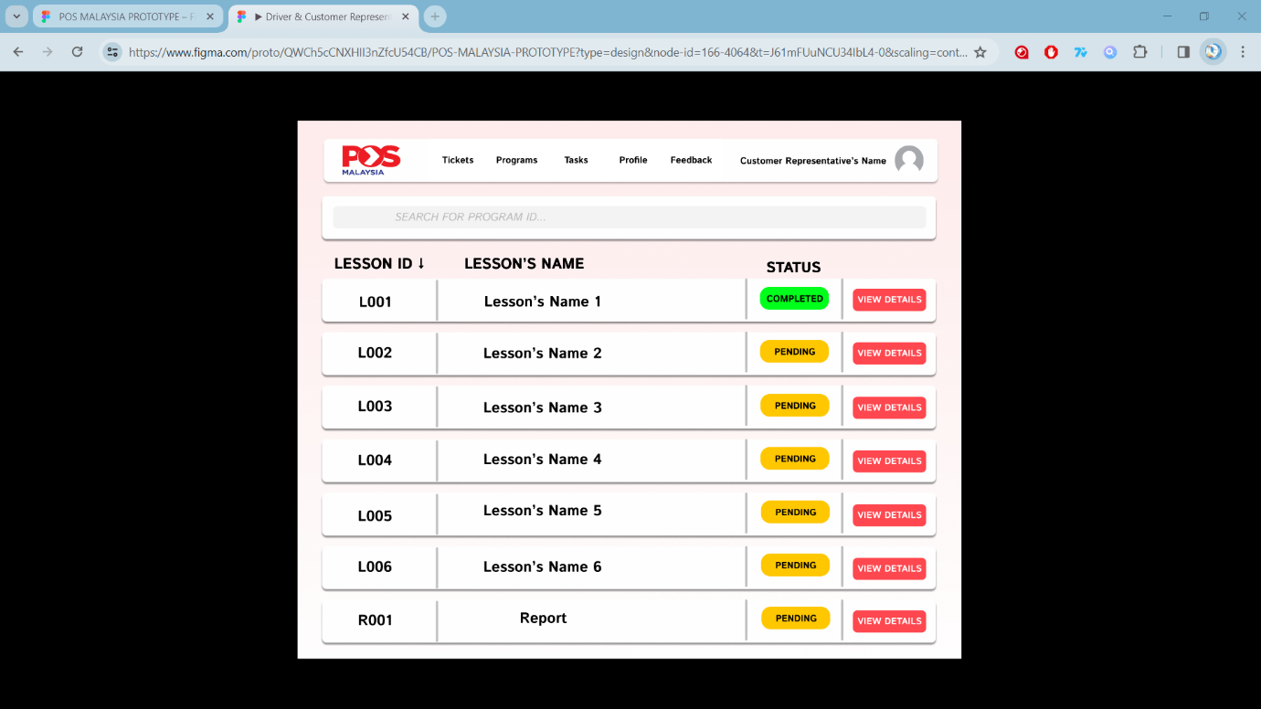
Figure 45 Customer Representative's Lessons List 2

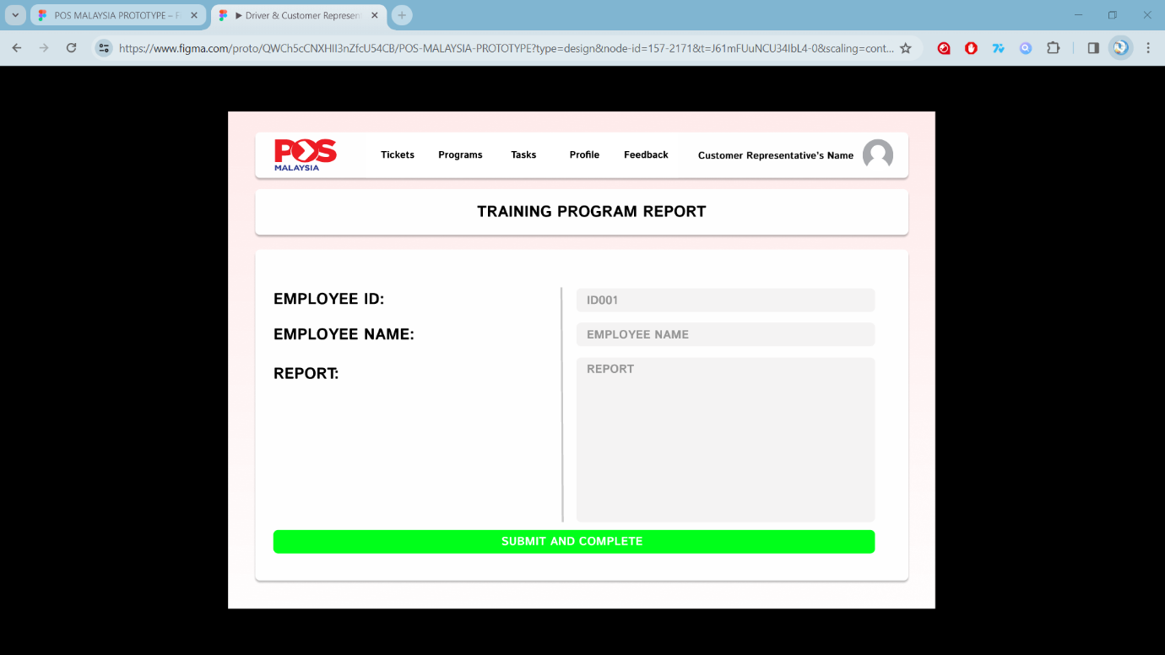
Figure 46 Customer Representative's Training Program Report

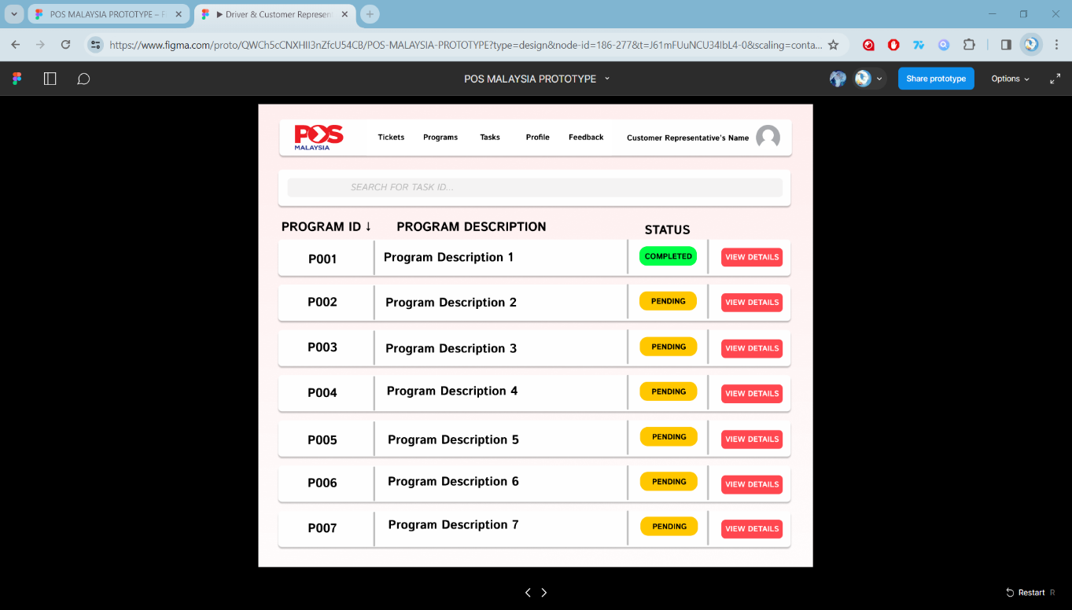
Figure 47 Customer Representative's Programs List 2
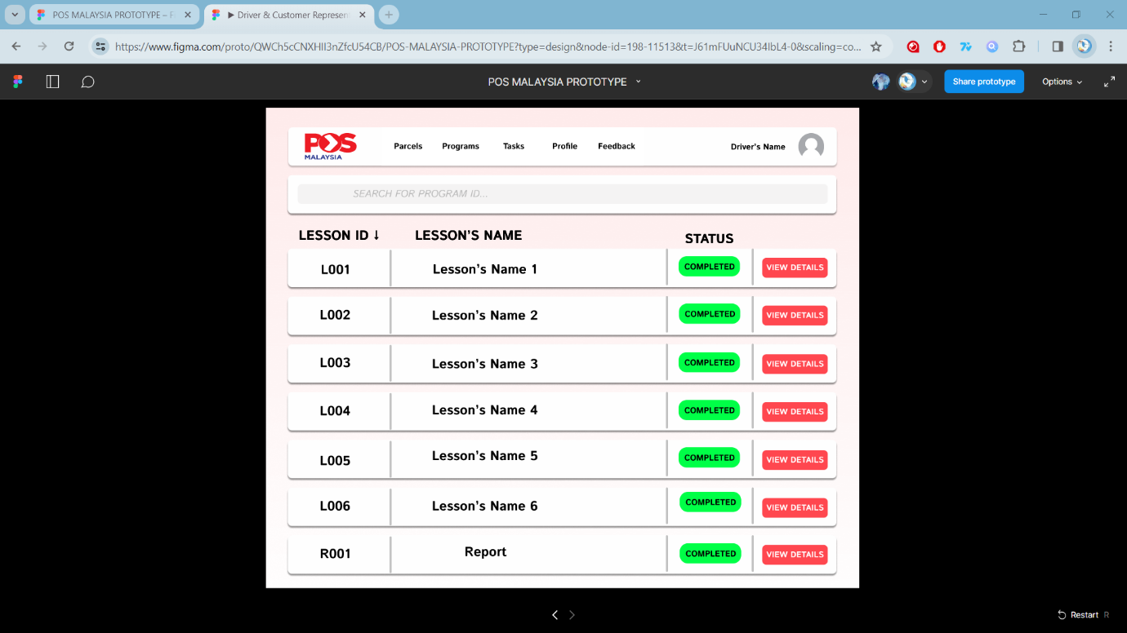
Figure 48 Customer Representative's Lesson List 3
6.1.2.3 Admin
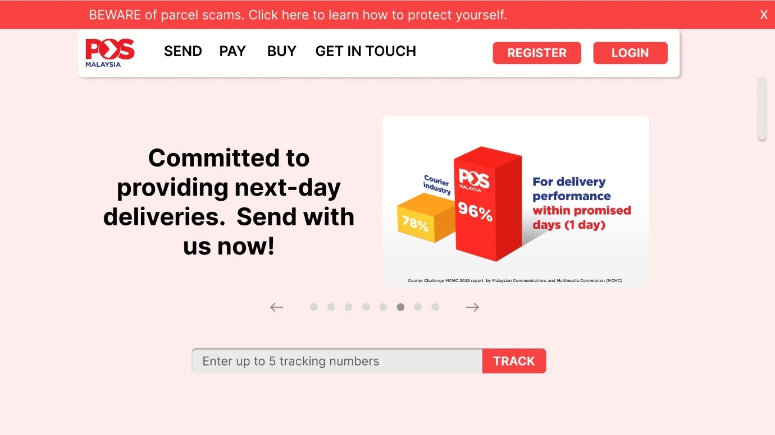
Figure 49 Admin's Main Menu
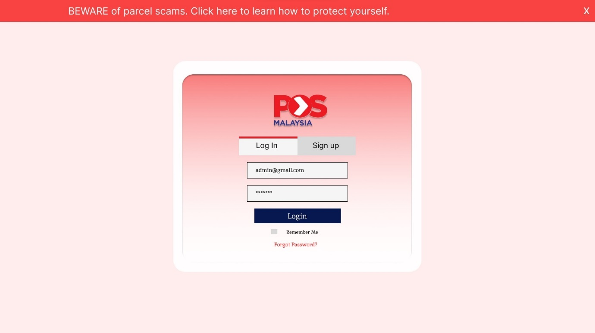
Figure 50 Admin's Login Page

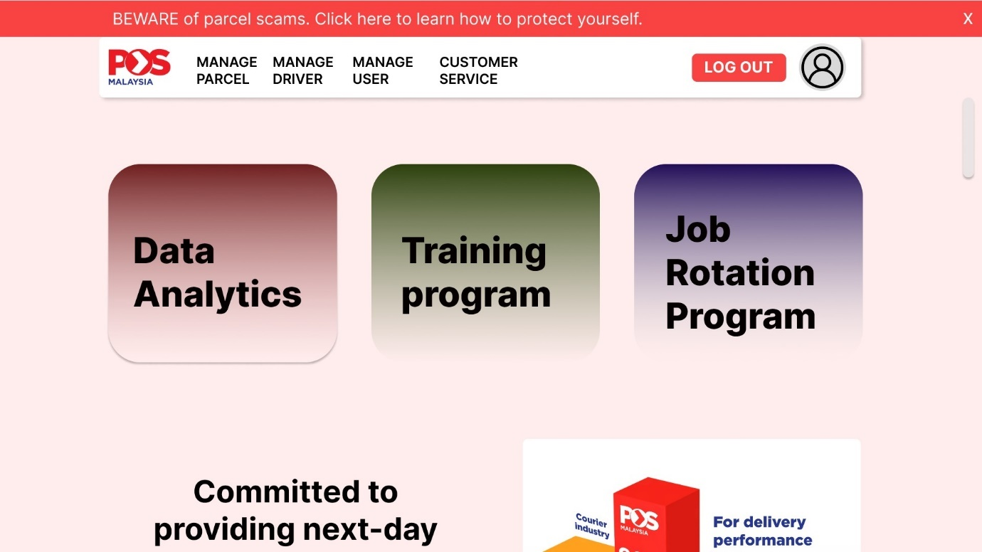
Figure 51 Admin's Home Page
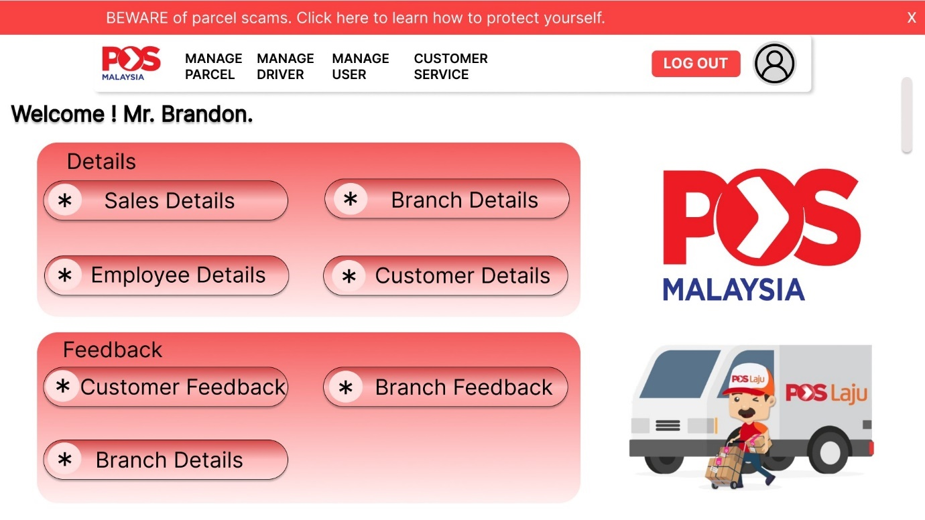
Figure 52 Admin's Data Analytics Page

Figure 53 Admin's Main Page 1
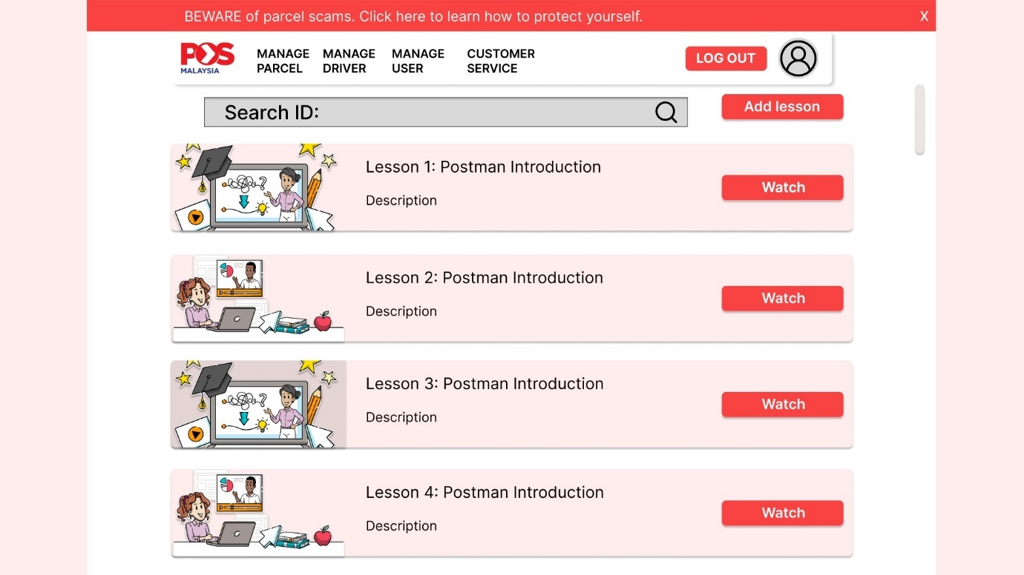
Figure 54 Admin's Training Program Page
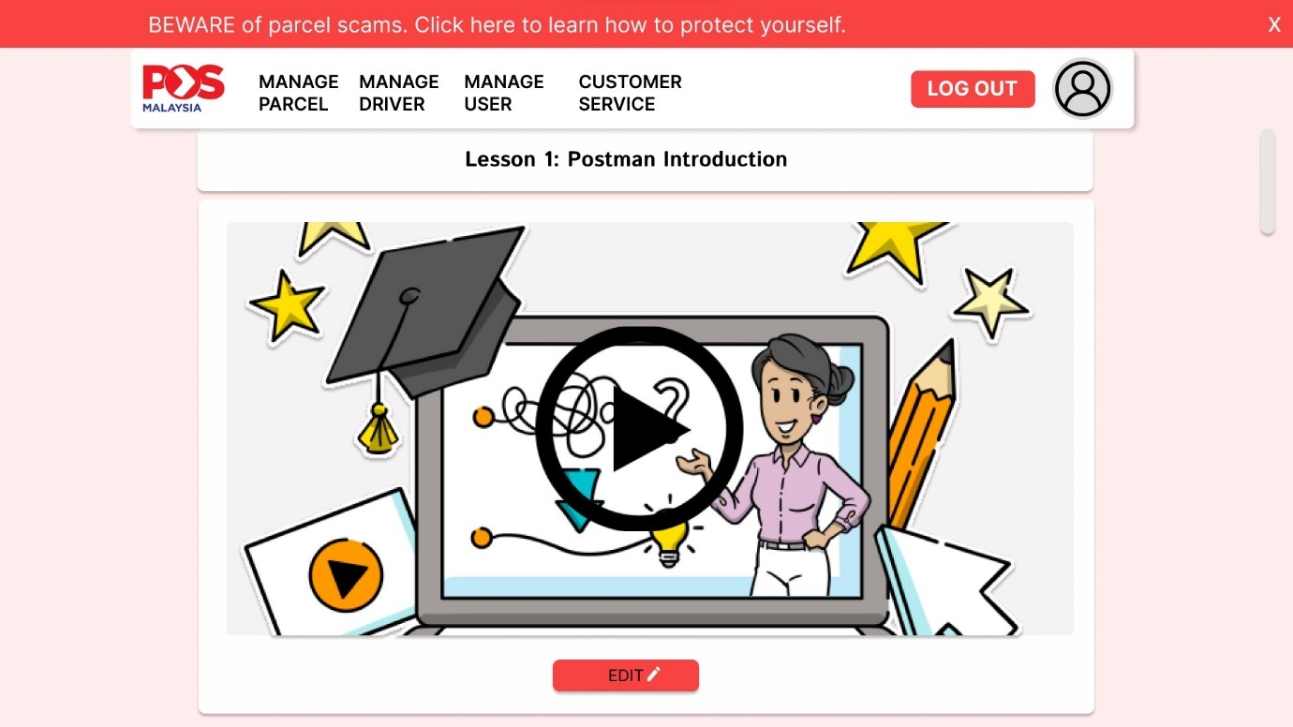
Figure 55 Admin's Lesson Video
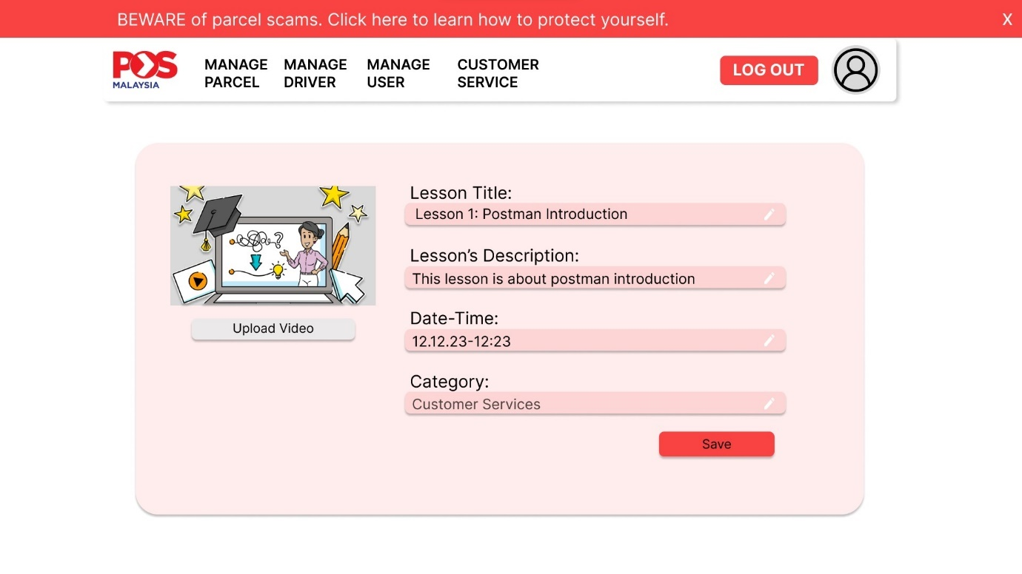
Figure 56 Admin's Video Upload Page
Figure 57 Admin's Main Page 2
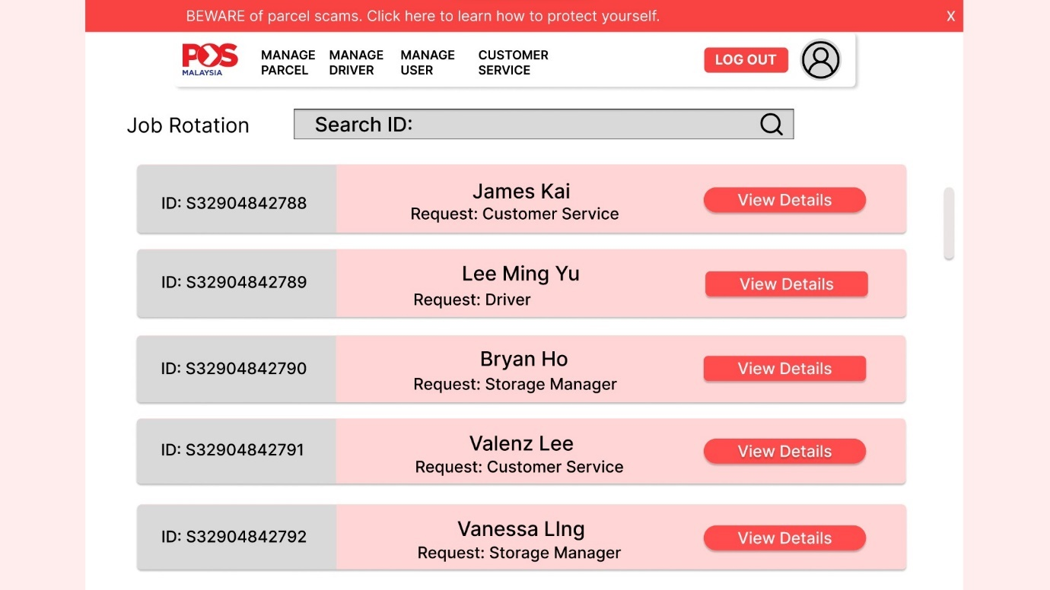
Figure 58 Admin's Job Rotation List

Figure 59 Admin's Homa Page 3
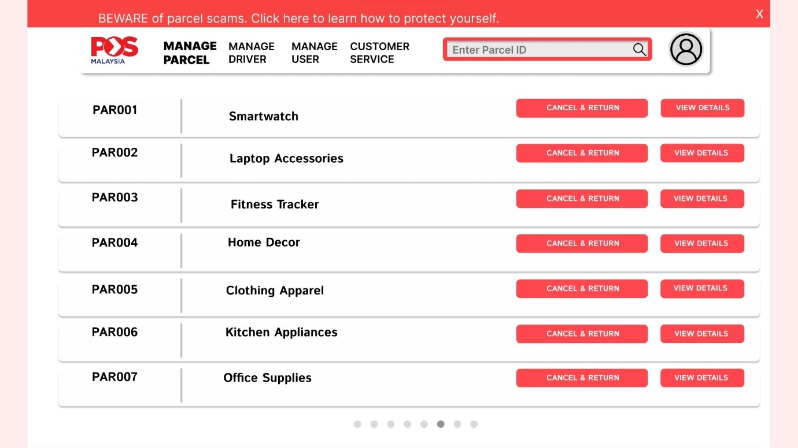
Figure 60 Admin's Manage Parcel List
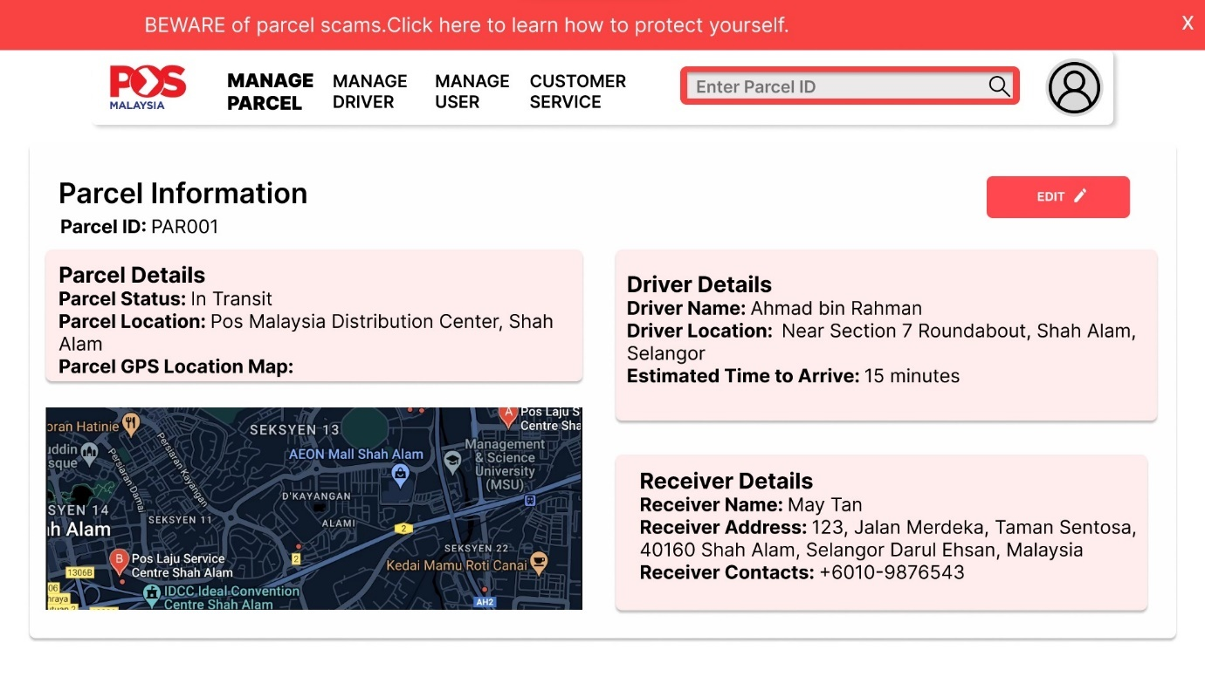
Figure 61 Parcel Information Page
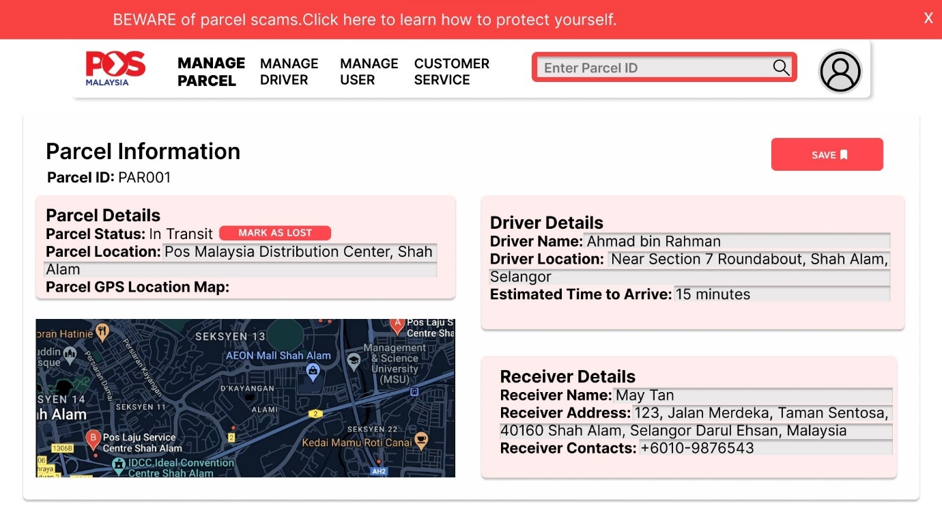
Figure 62 Admin’s Edit Parcel Information Page
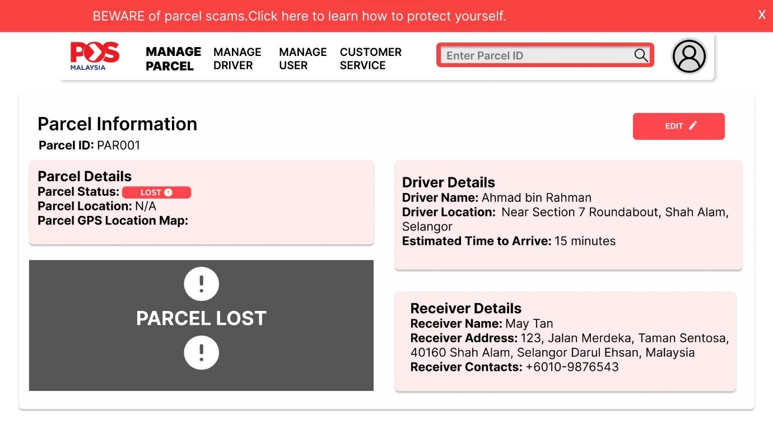
Figure 63 Admin's Parcel Information Lost Page
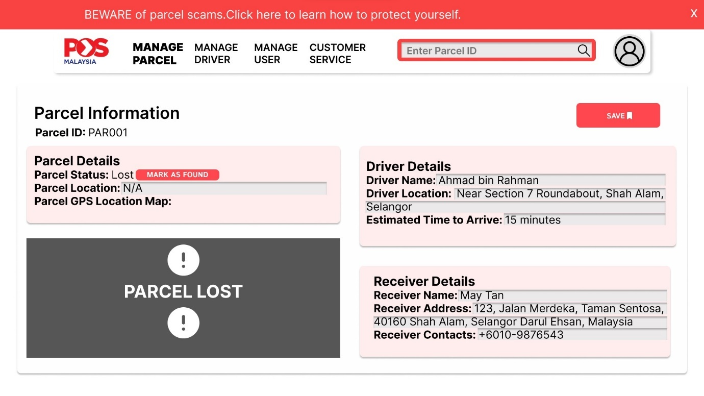
Figure 64 Admin's Edit Parcel Information Lost Page
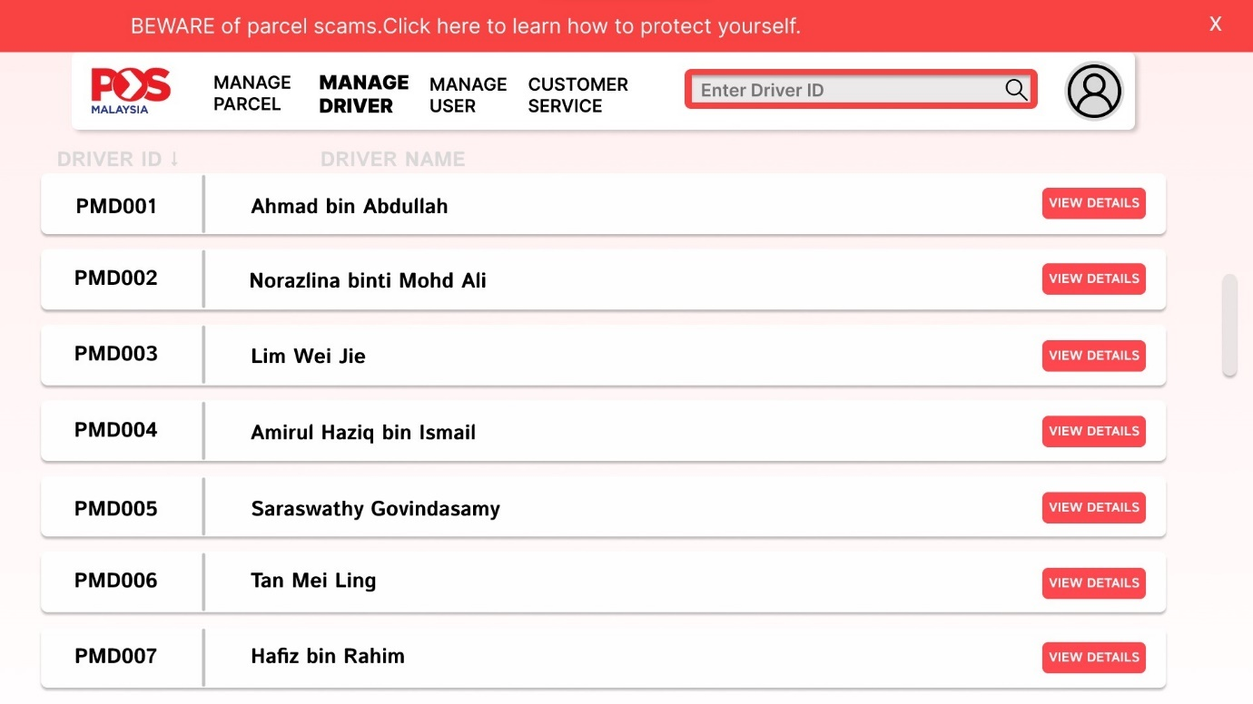
Figure 65 Admin's Manage Driver List
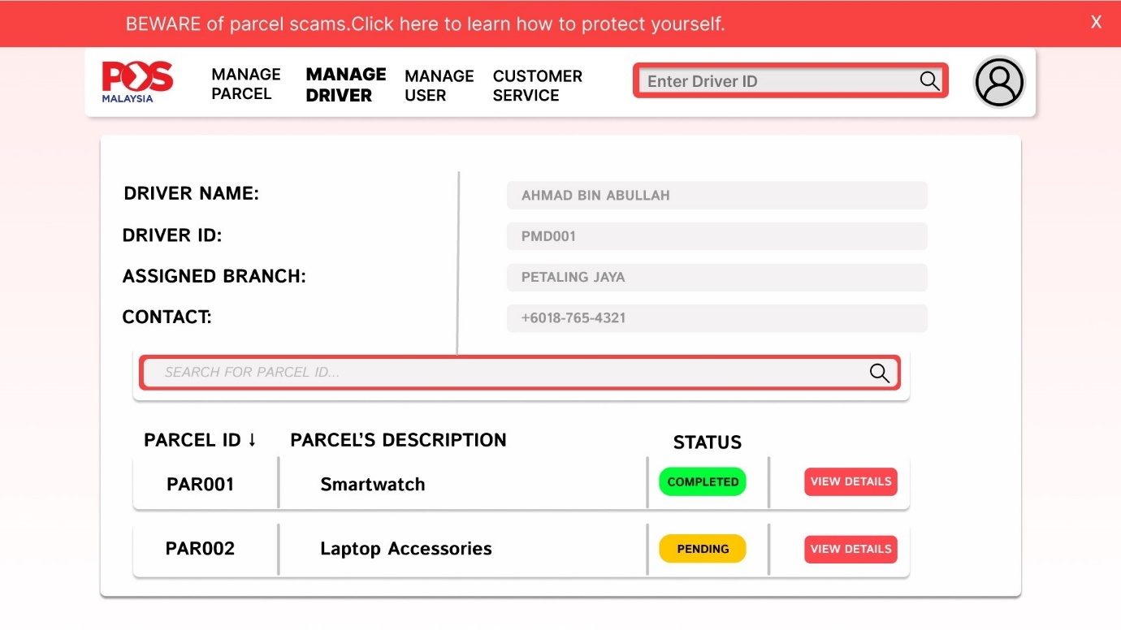
Figure 66 Admin's Manage Driver Details Page
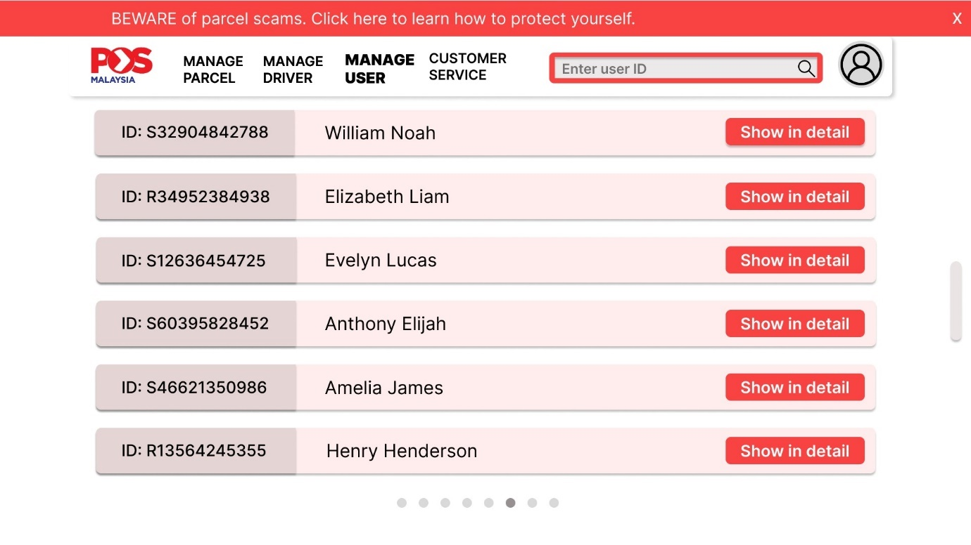
Figure 67 Admin Manage User List
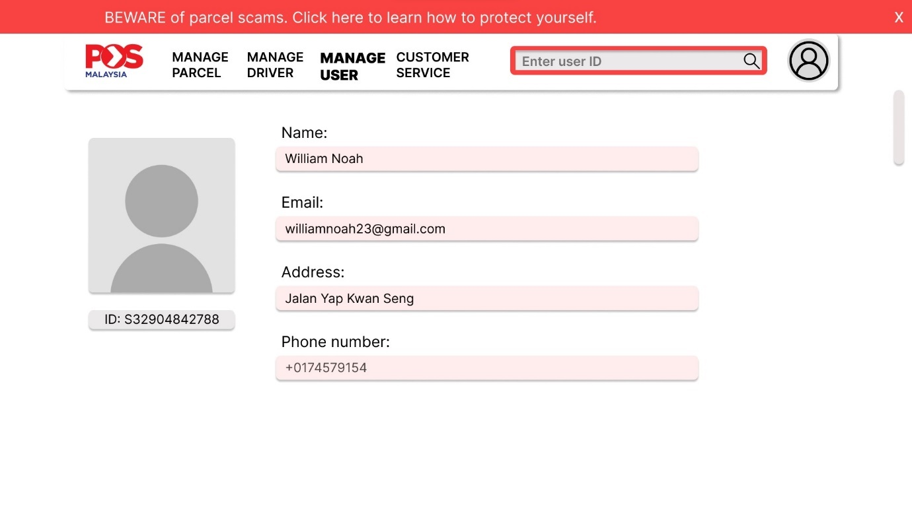
Figure 68 Admin's Manage User Details Page
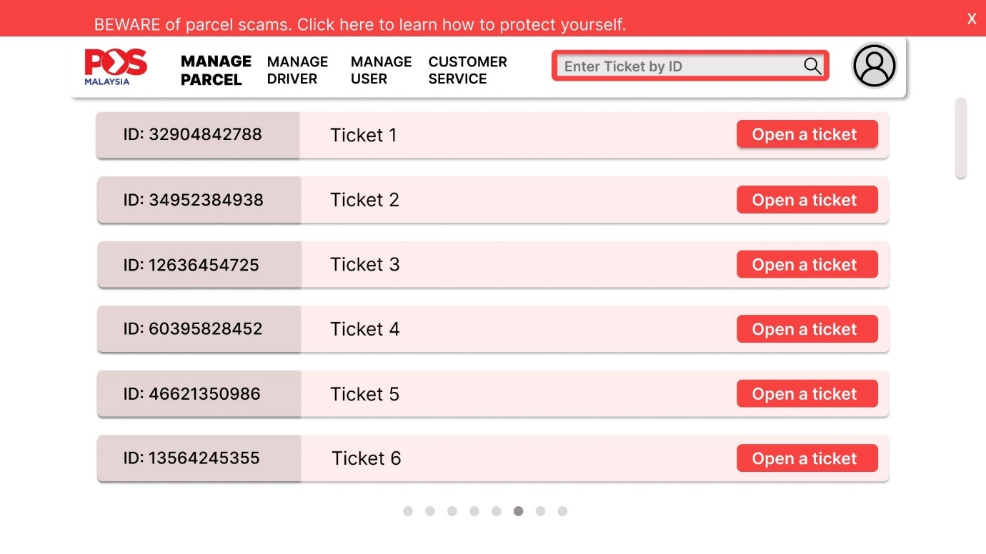
Figure 69 Admin's Customer Service Ticket List
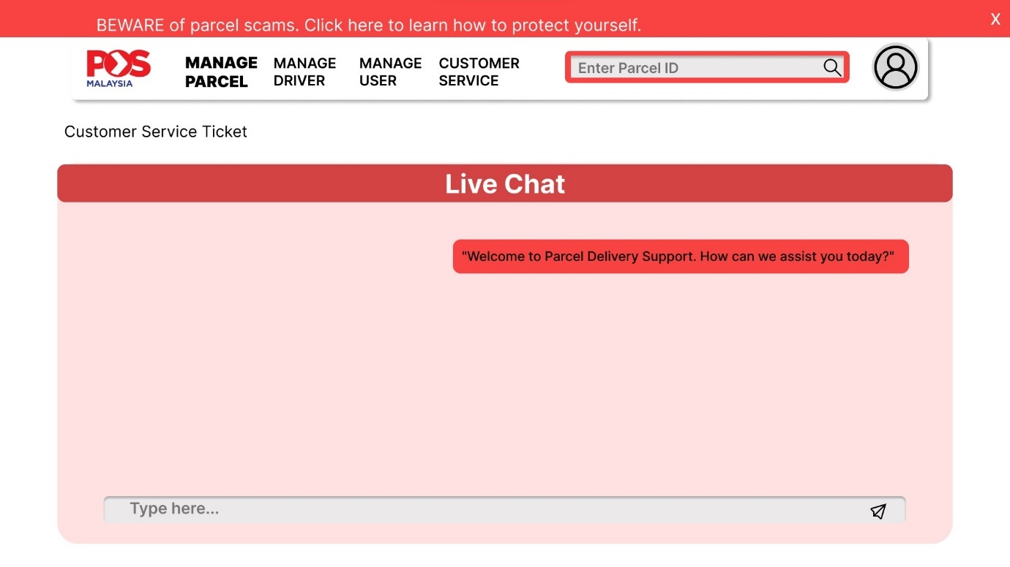
Figure 70 Admin's Customer Service Live Chat Page

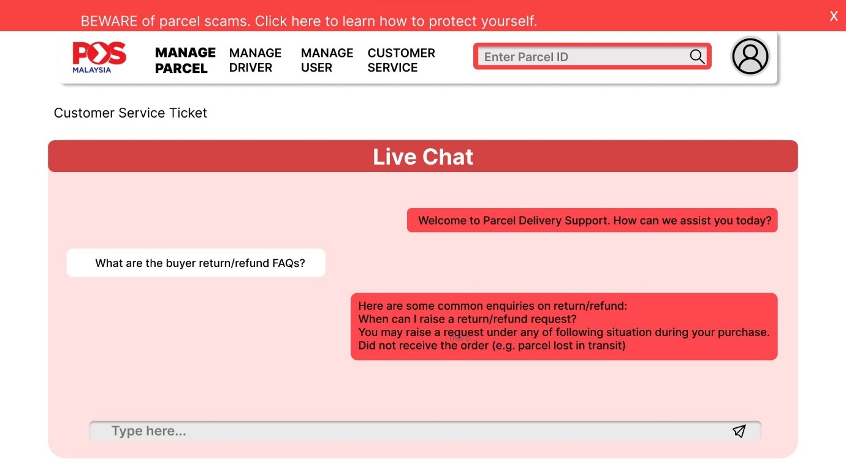
Figure 71 Admin's Customer Service Live Chat Page
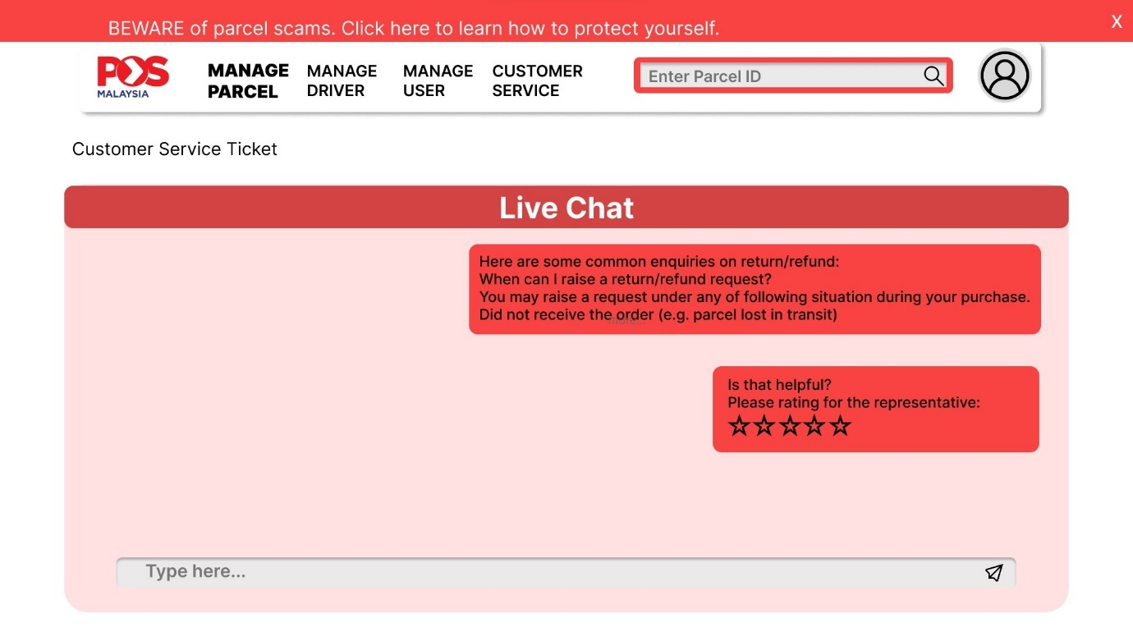
Figure 72 Admin's Customer Service Live Chat Page 2

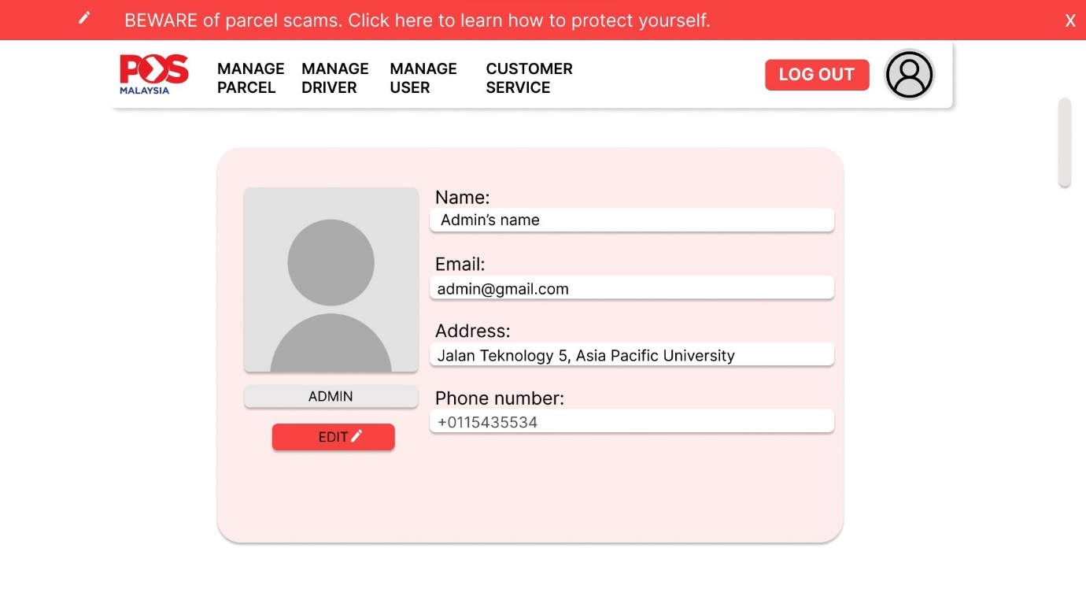
Figure 73 Admin's Profile Page

6.1.2.4 Customer Site
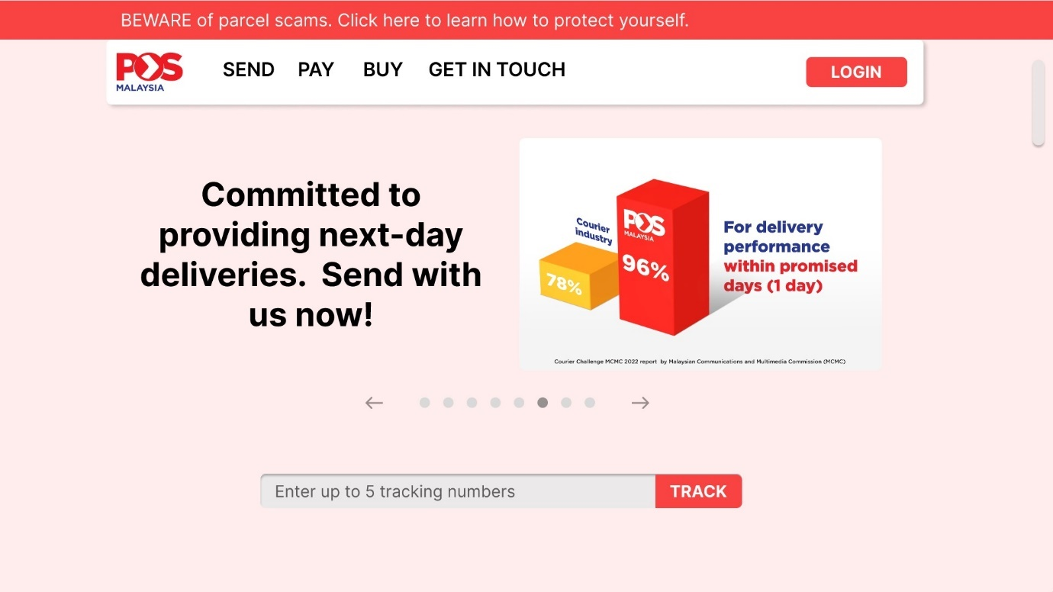
Figure 74 Customer's Main Menu
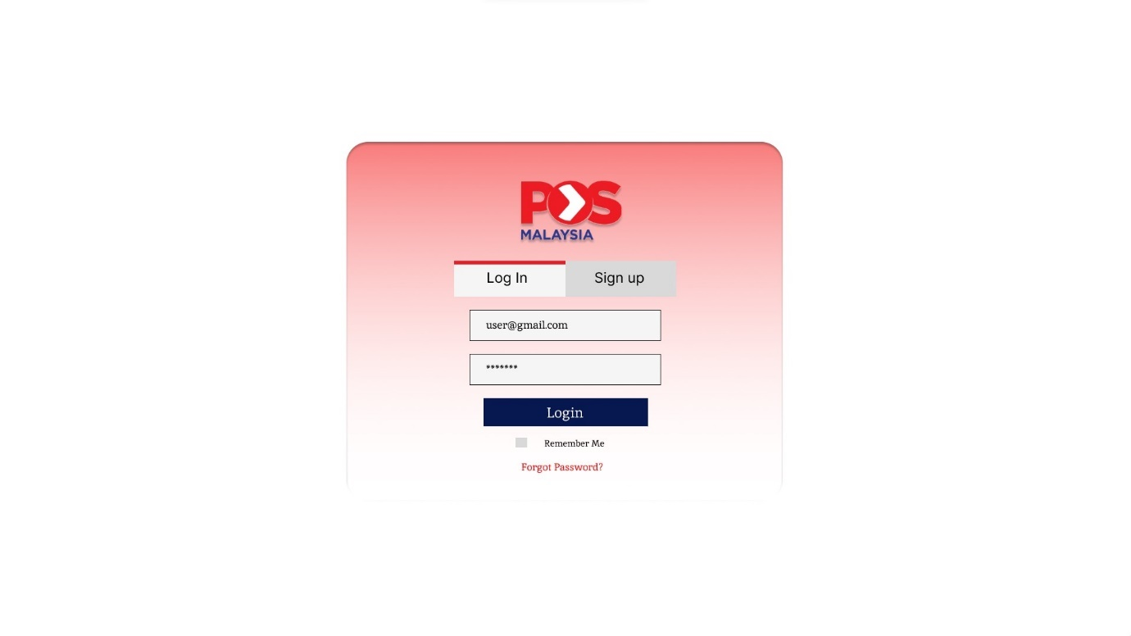
Figure 75 Customer Login Page
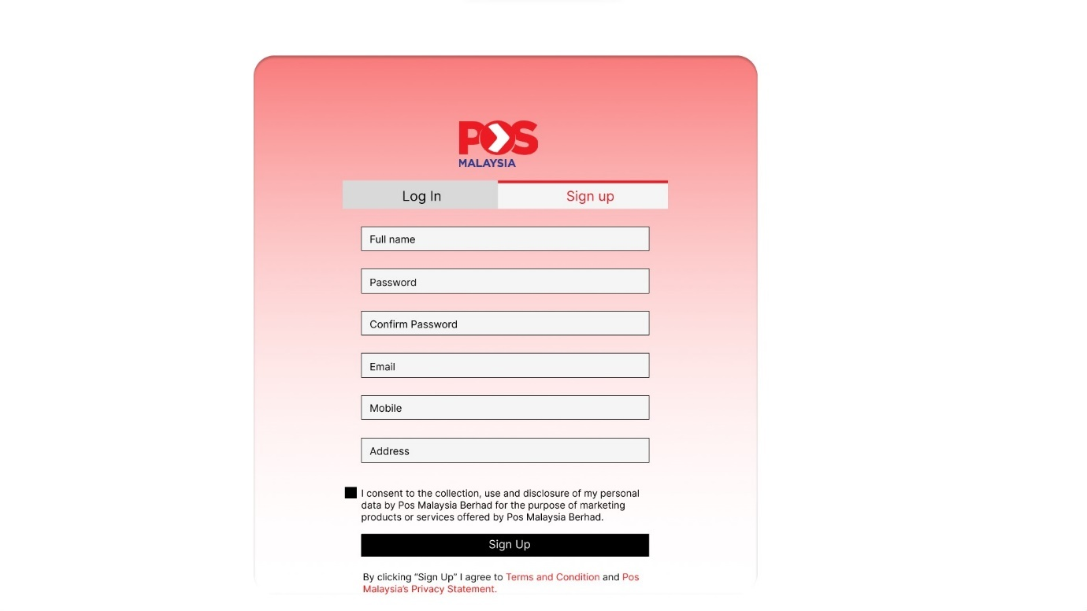
Figure 76 Customer Sign Up Page
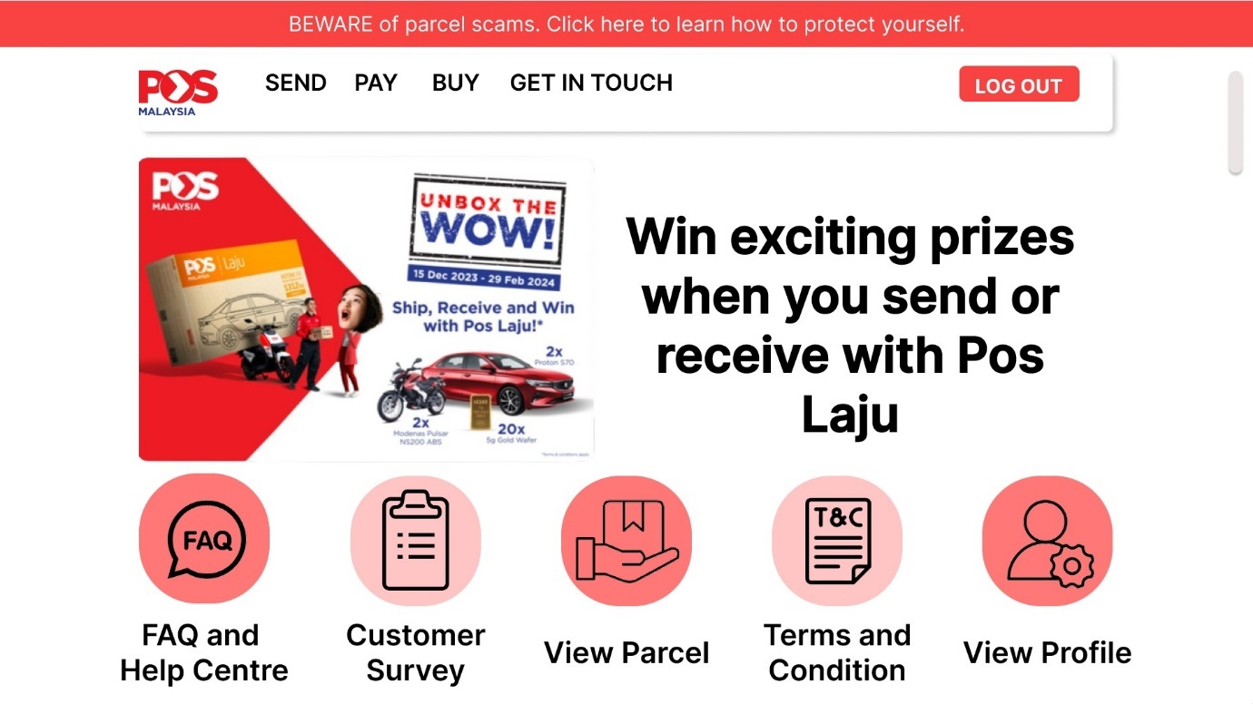
Figure 77 Customer Home Page
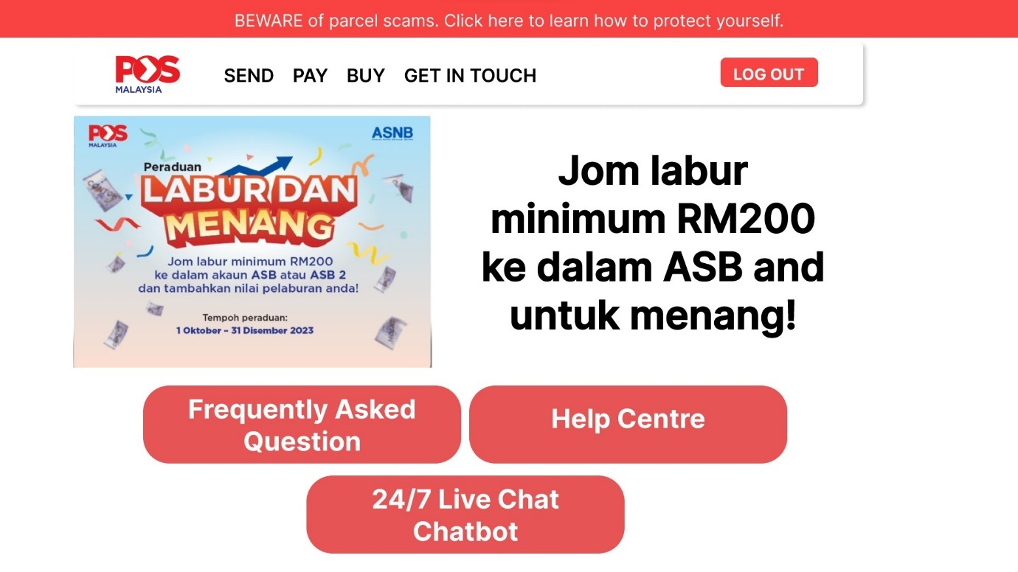
Figure 78 Customer FaQ and Help Center Page
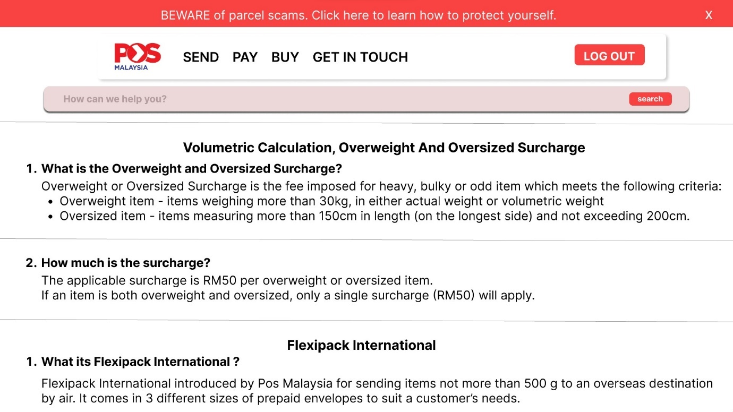
Figure 79 Customer FaQ in detail page
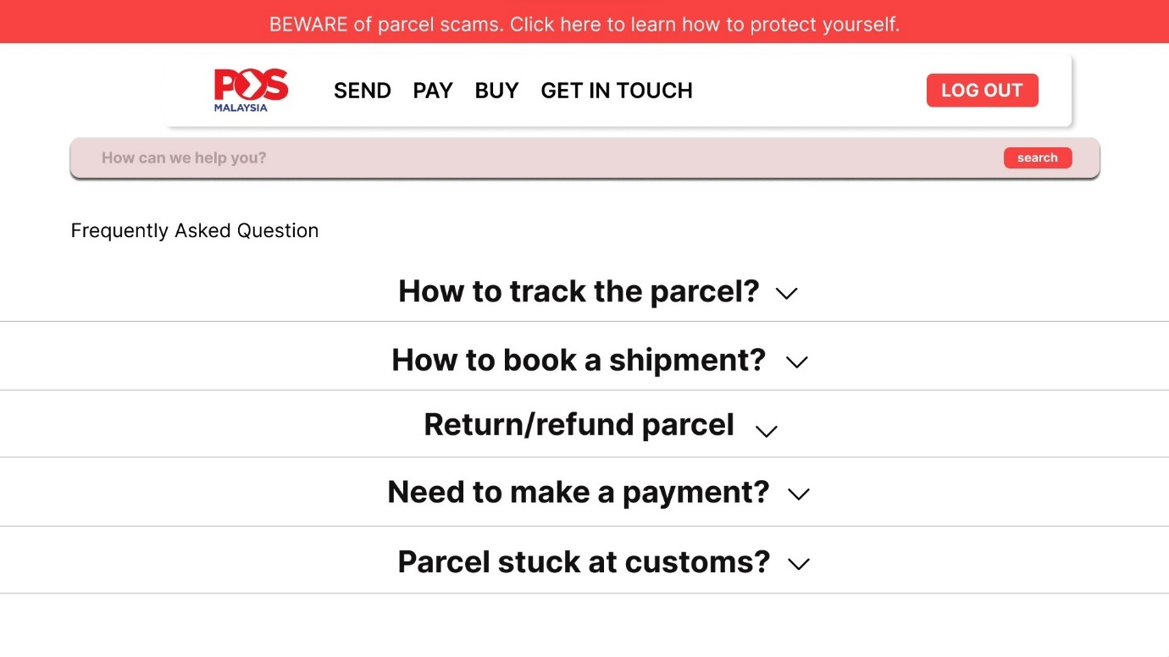
Figure 80 Customer FaQ search question page
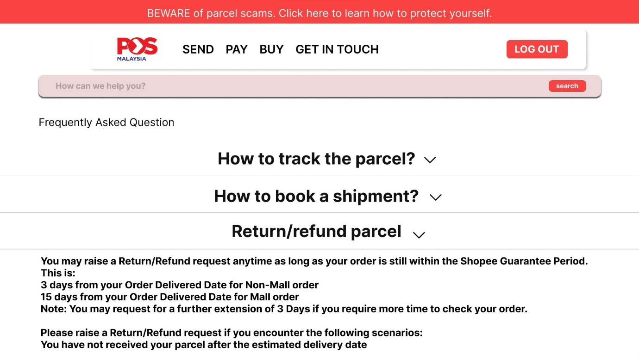
Figure 81 Customer FaQ search question details
Figure 82 Customer Home Page 2

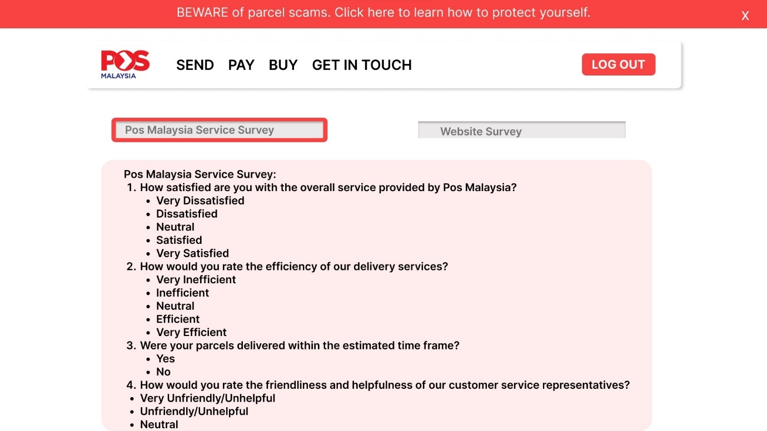
Figure 83 Customer survey page

Figure 84 Customer Home page 3
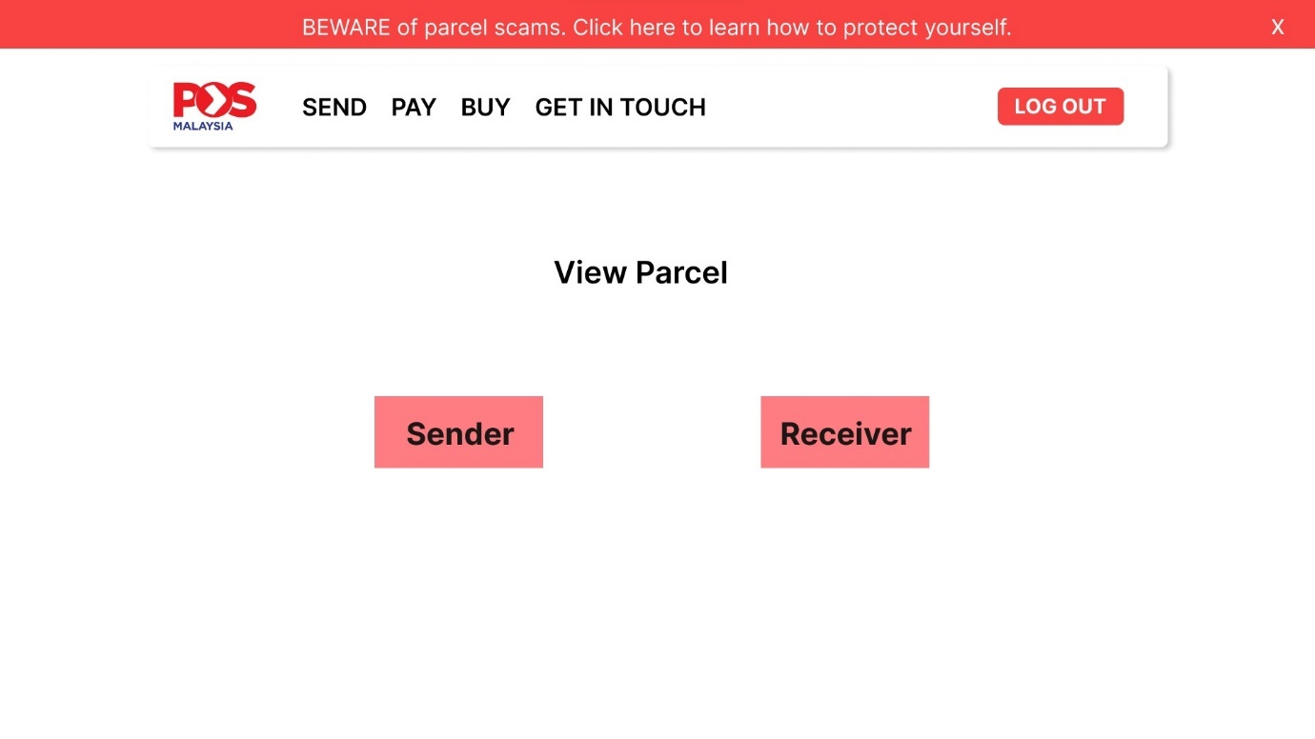
Figure 85 Customer view parcel page
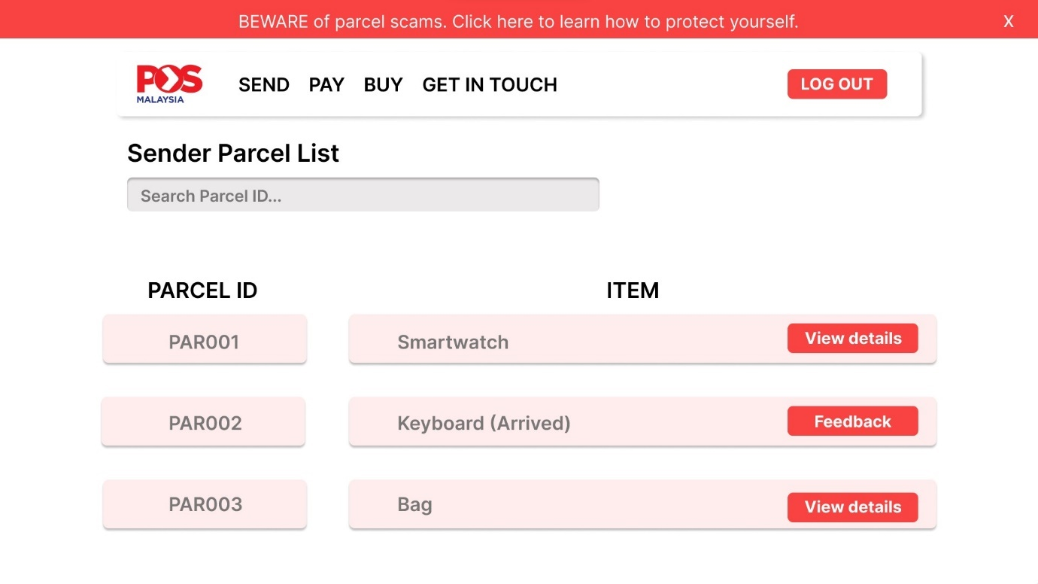
Figure 86 Customer sender list page

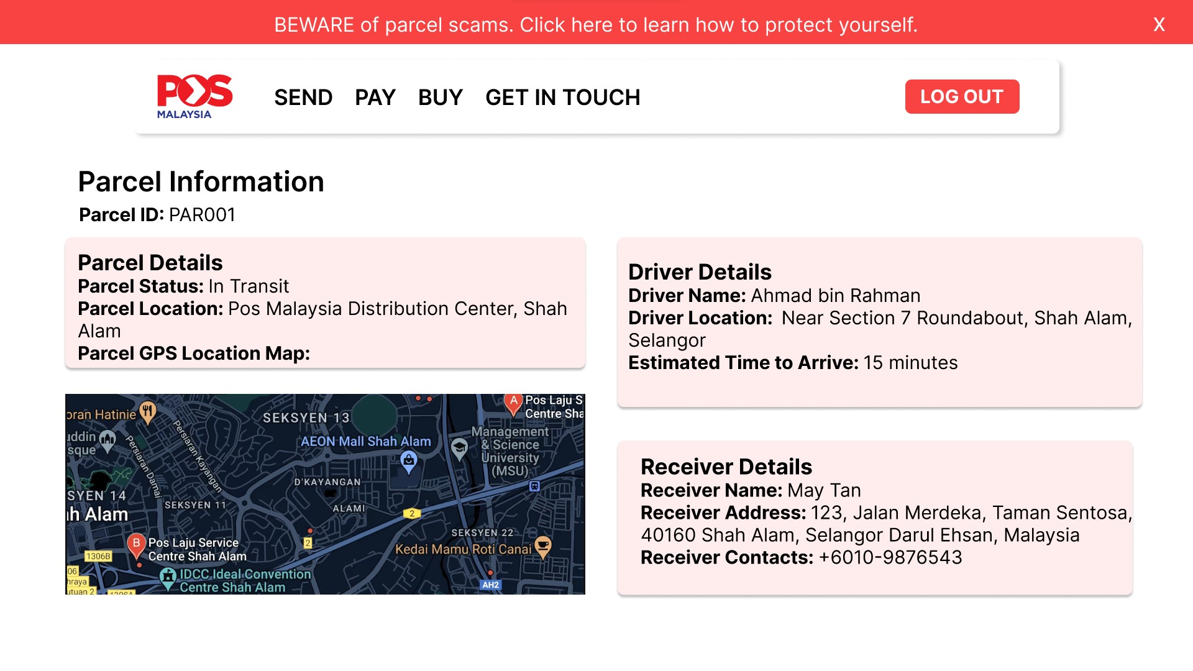
Figure 87 Customer parcel information page
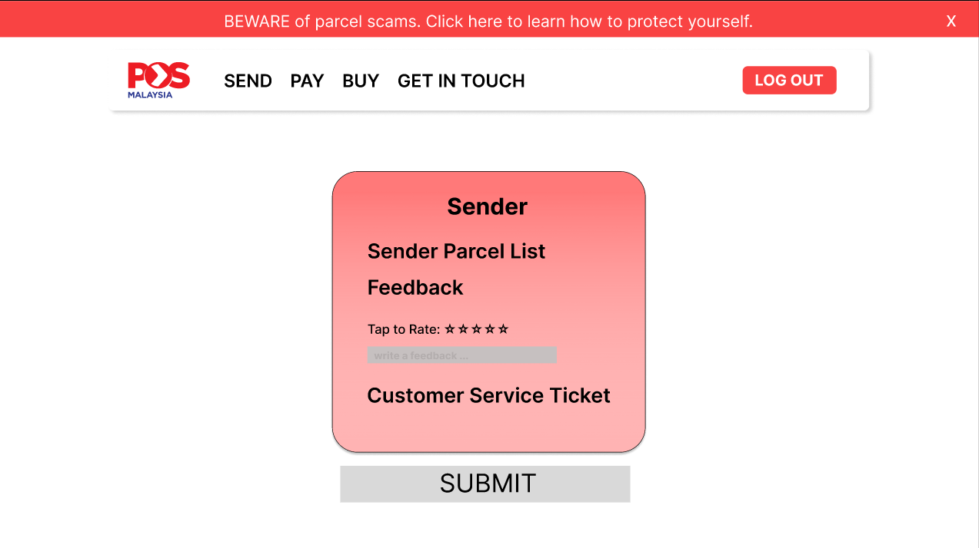
Figure 88 Customer Sender Feedback page
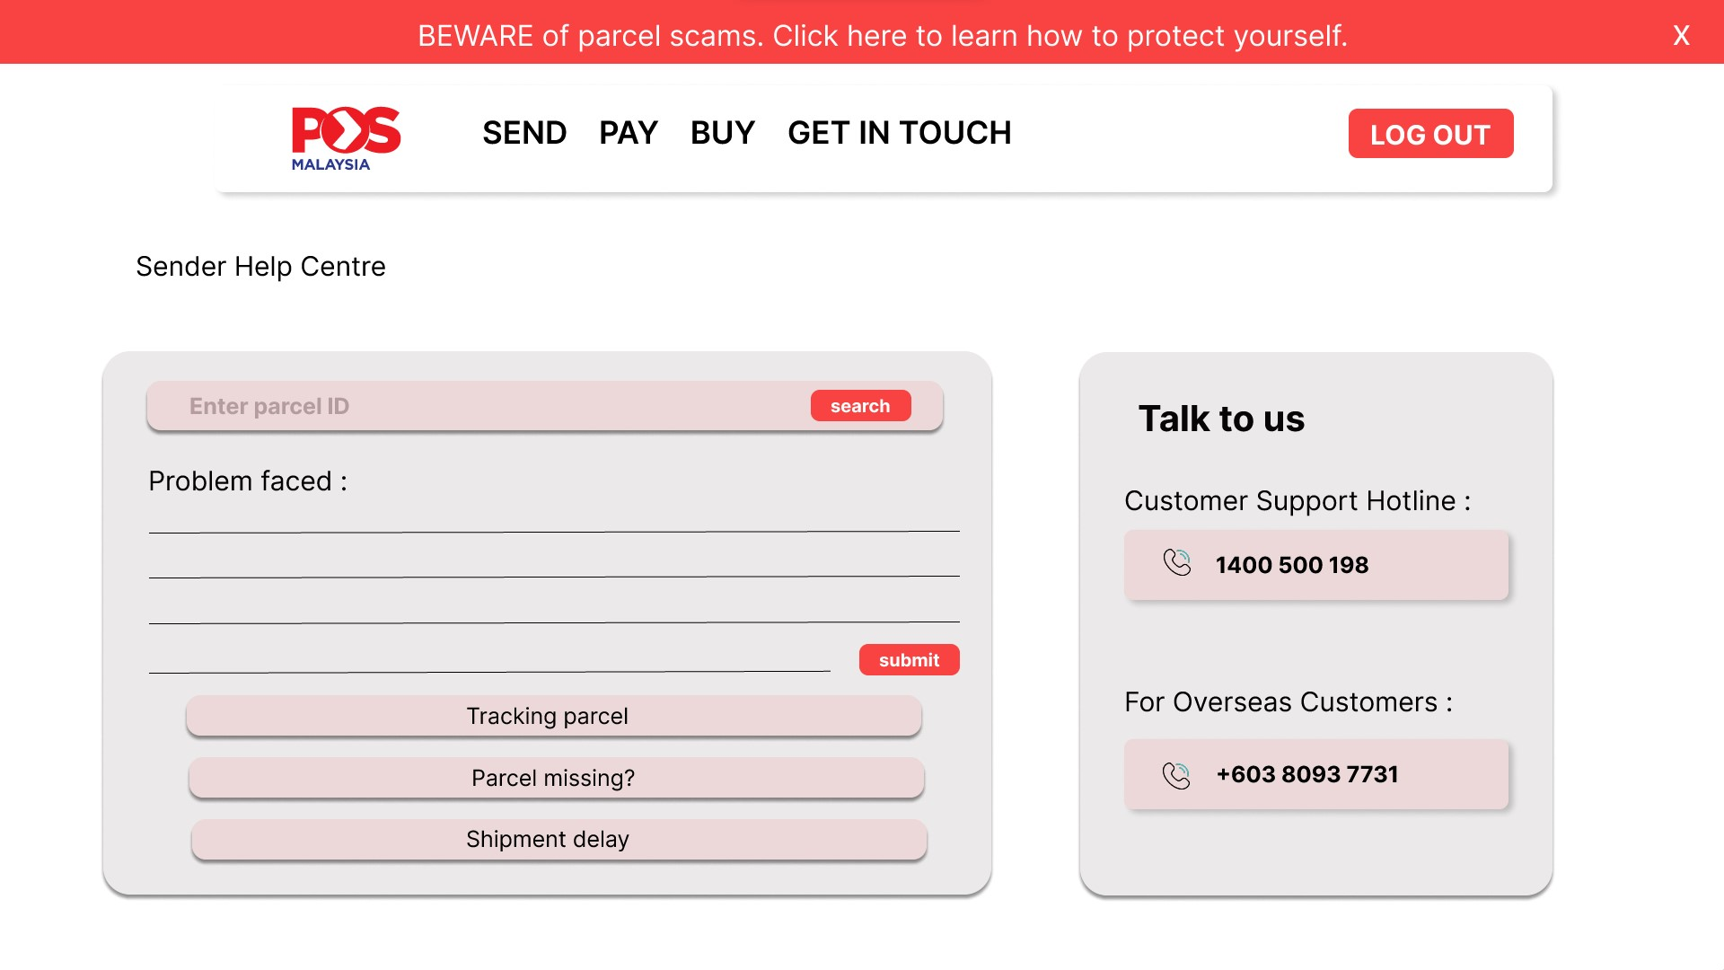
Figure 89 Customer Sender Help Centre page
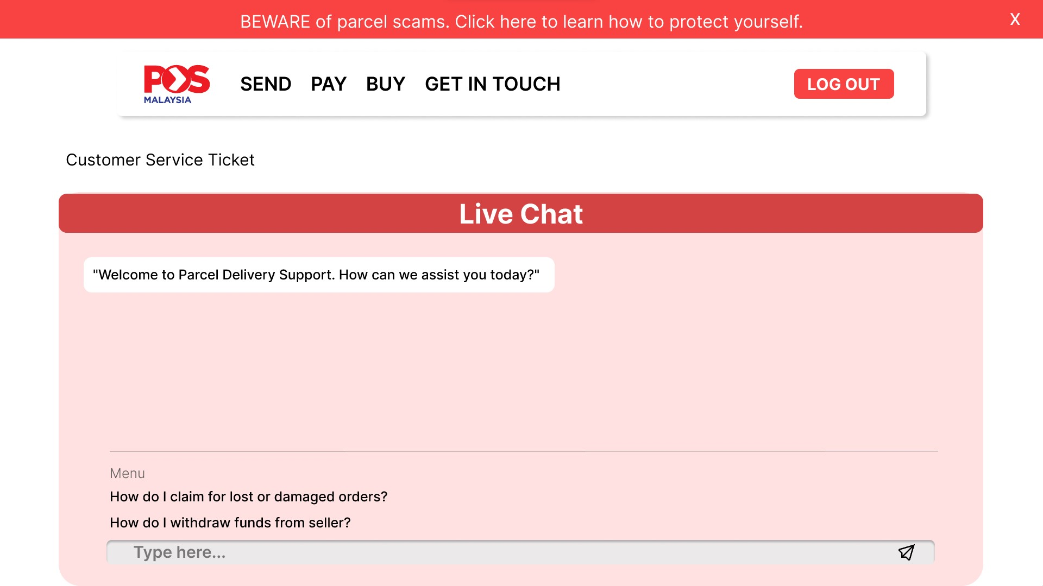
Figure 90 Customer service ticket page
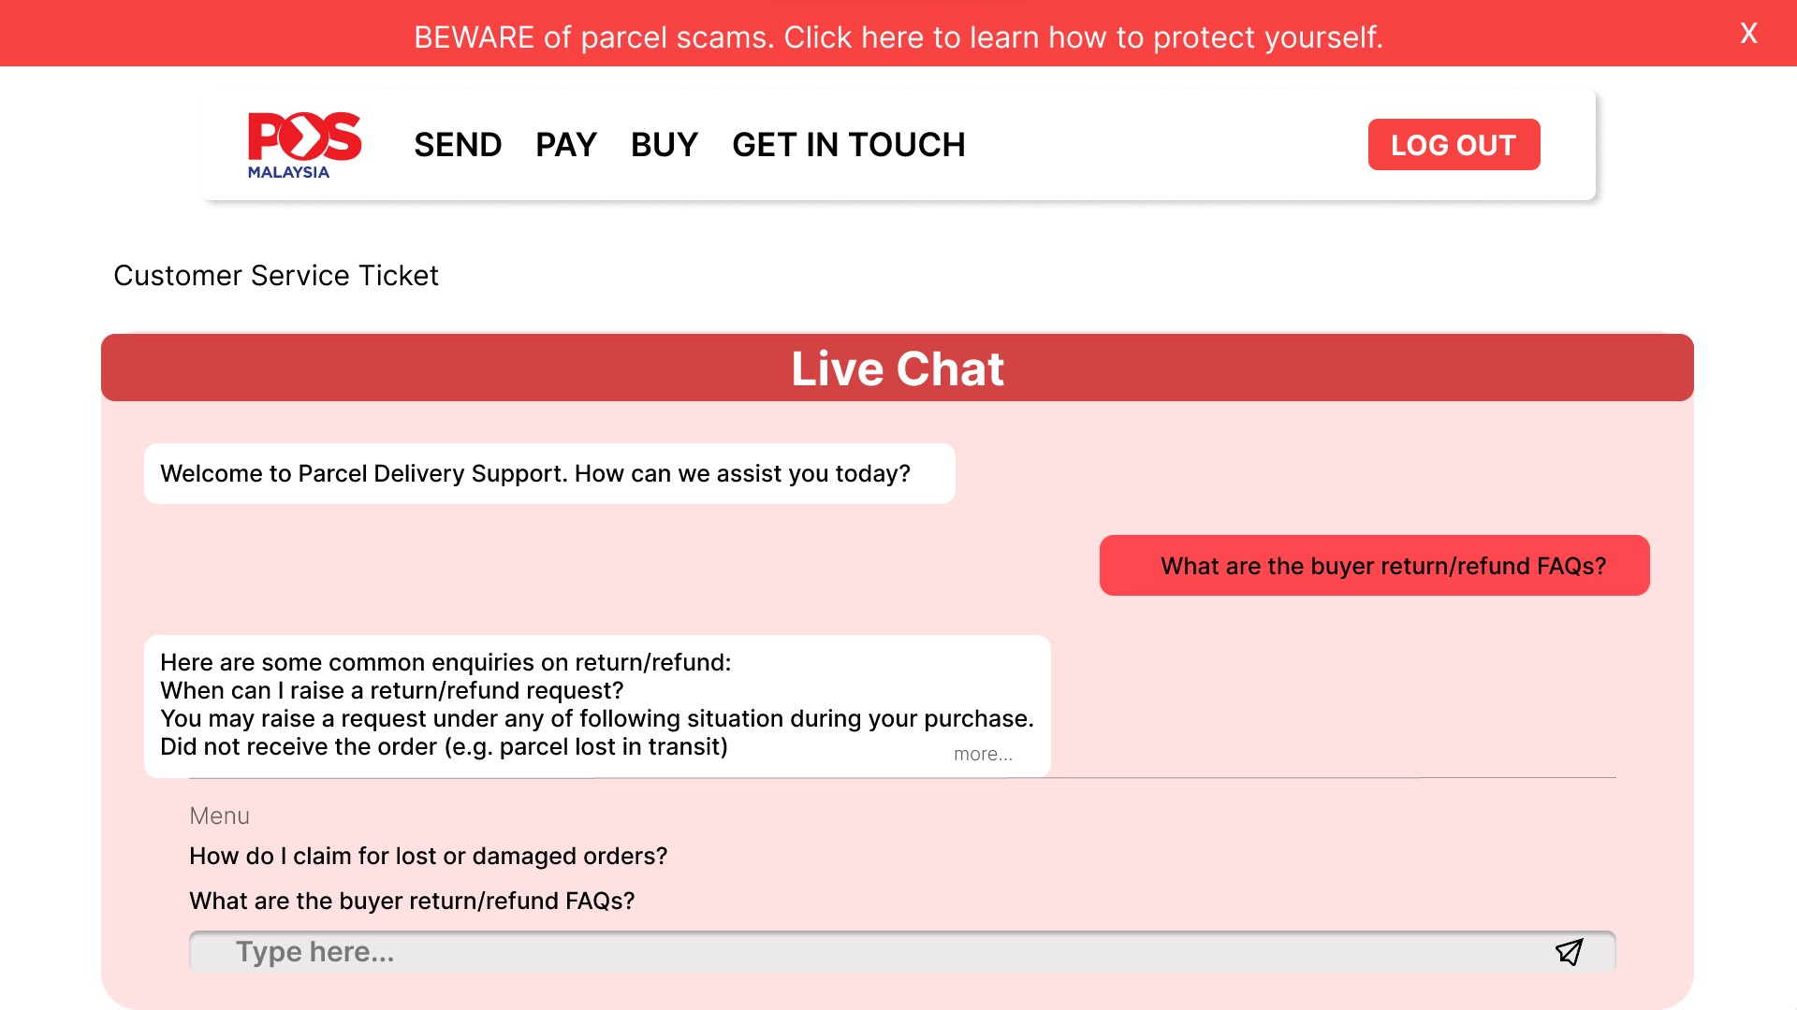
Figure 91 Customer Service Ticket 2
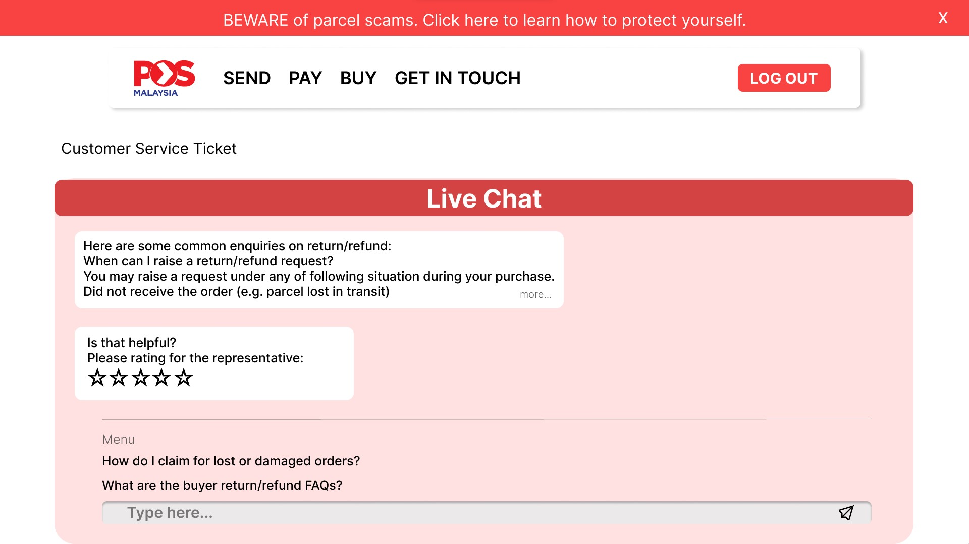
Figure 92 Customer sender live chat page 3
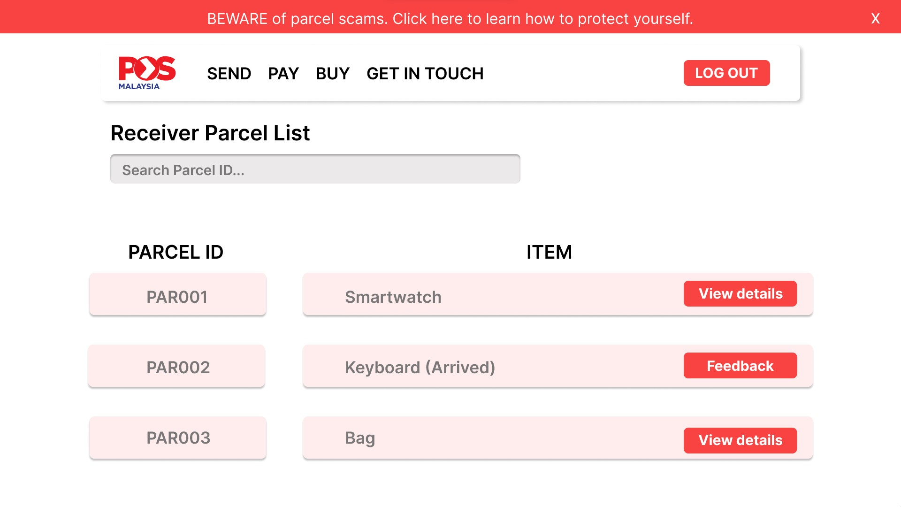
Figure 93 Customer receiver parcel list page
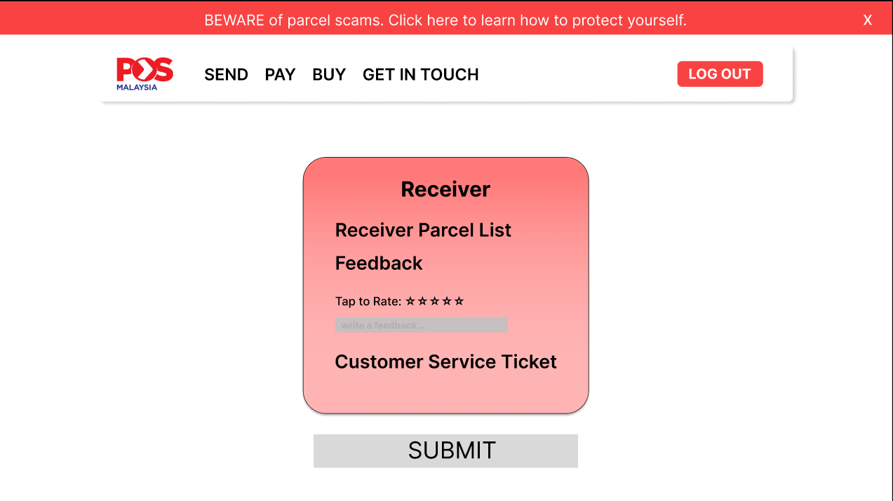
Figure 94 Customer receiver feedback page
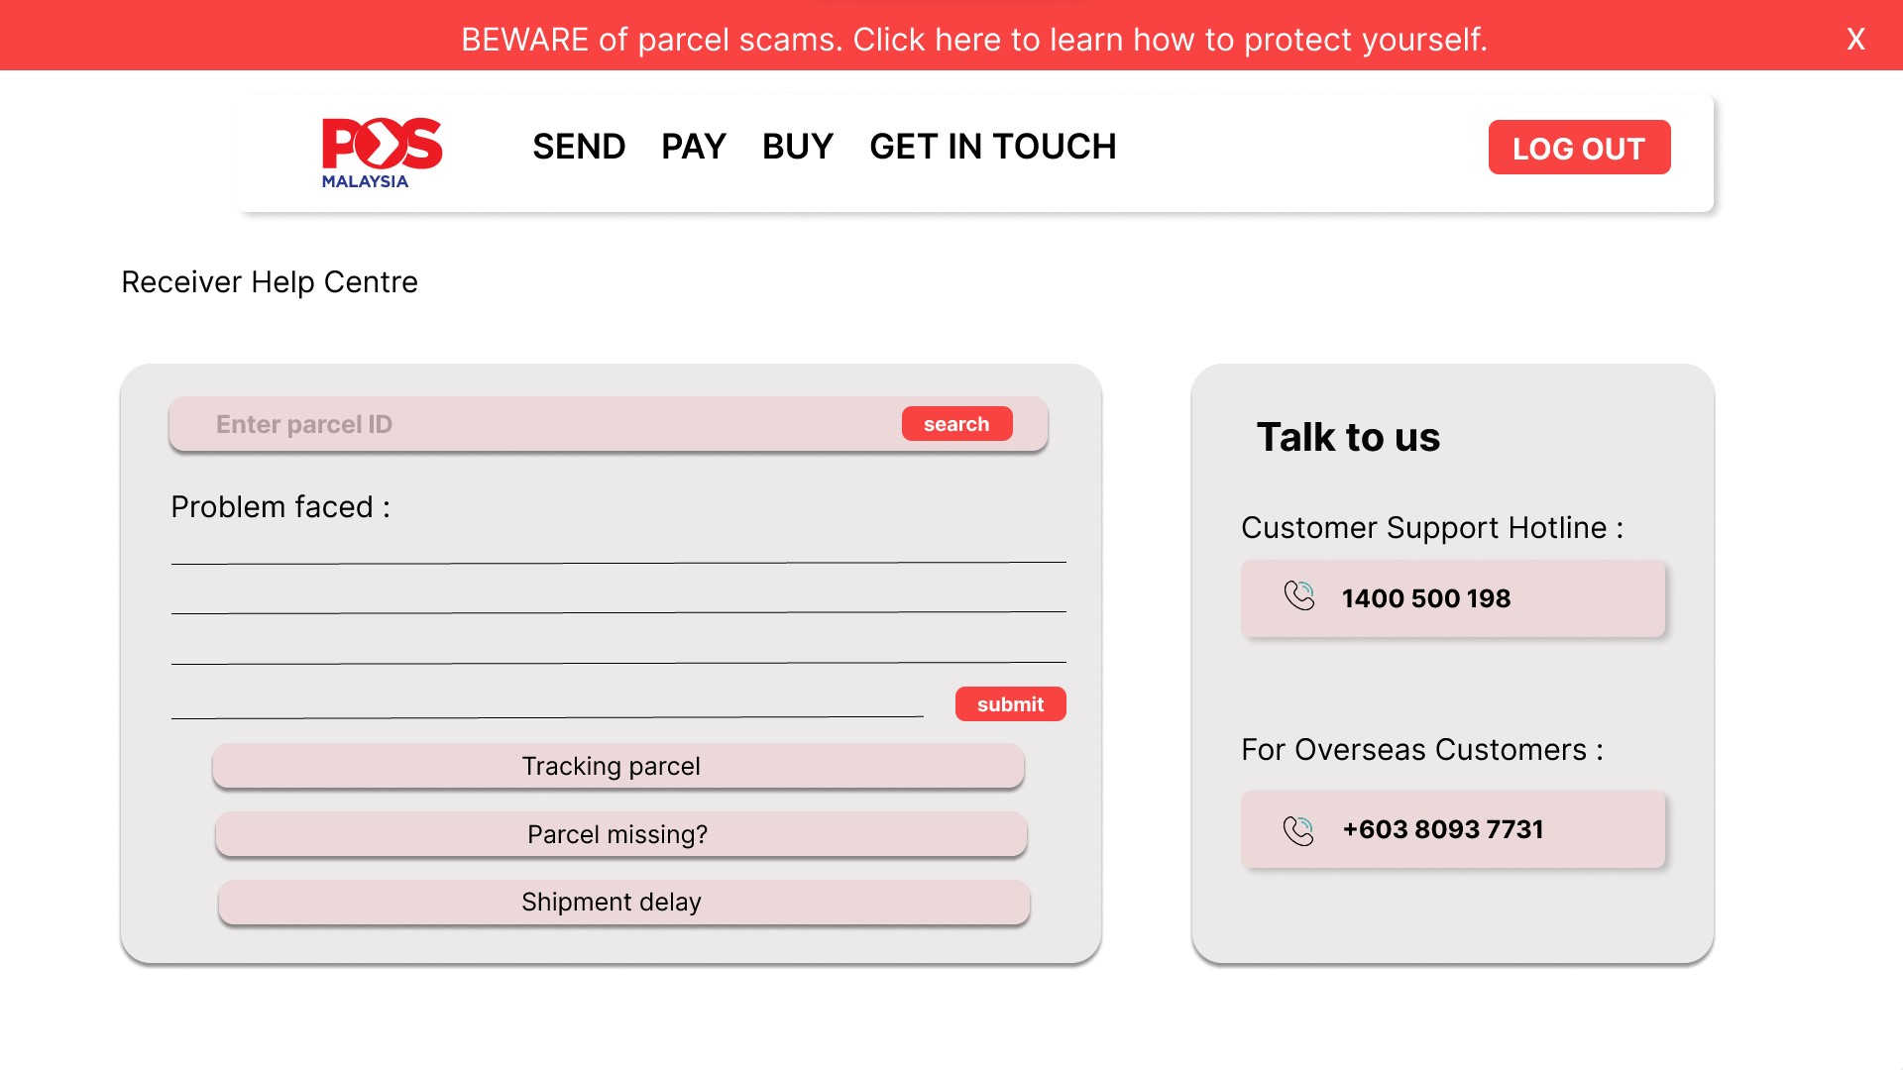
Figure 95 Customer Receiver Help Centre page
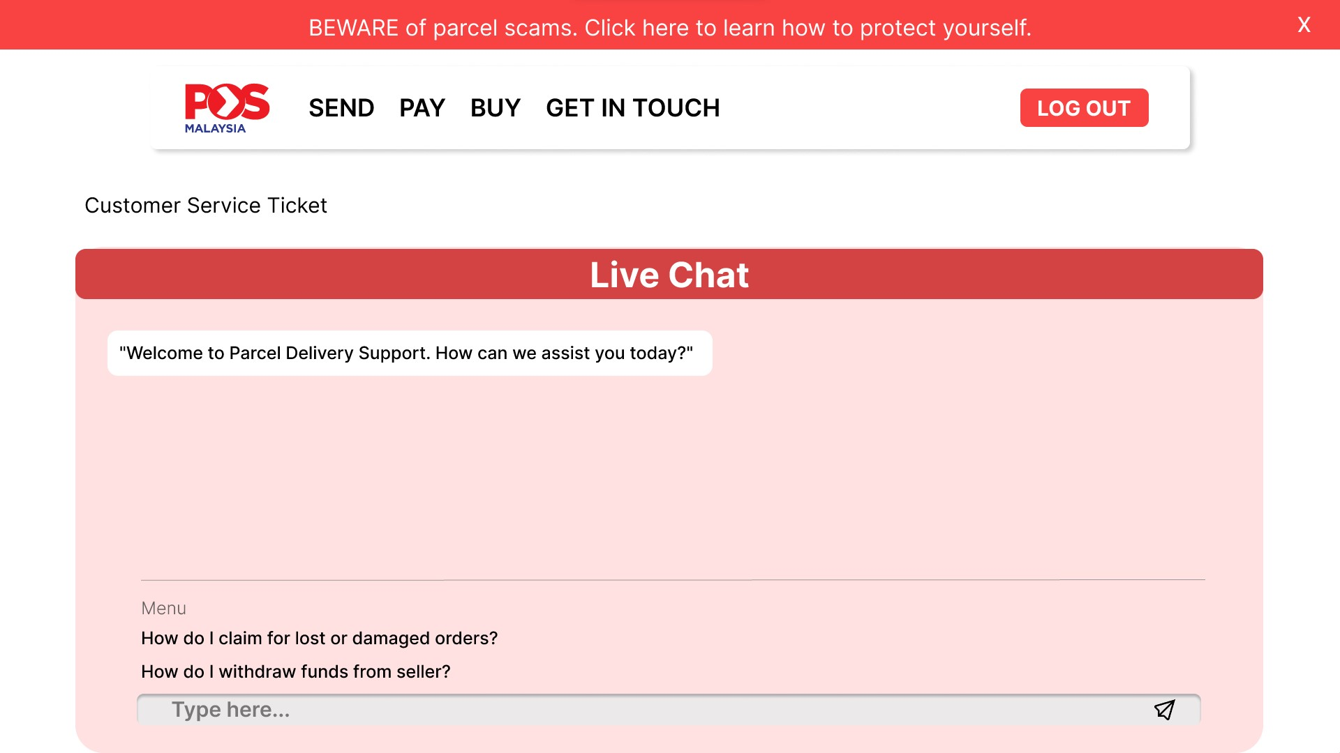
Figure 96 Customer receiver live chat page
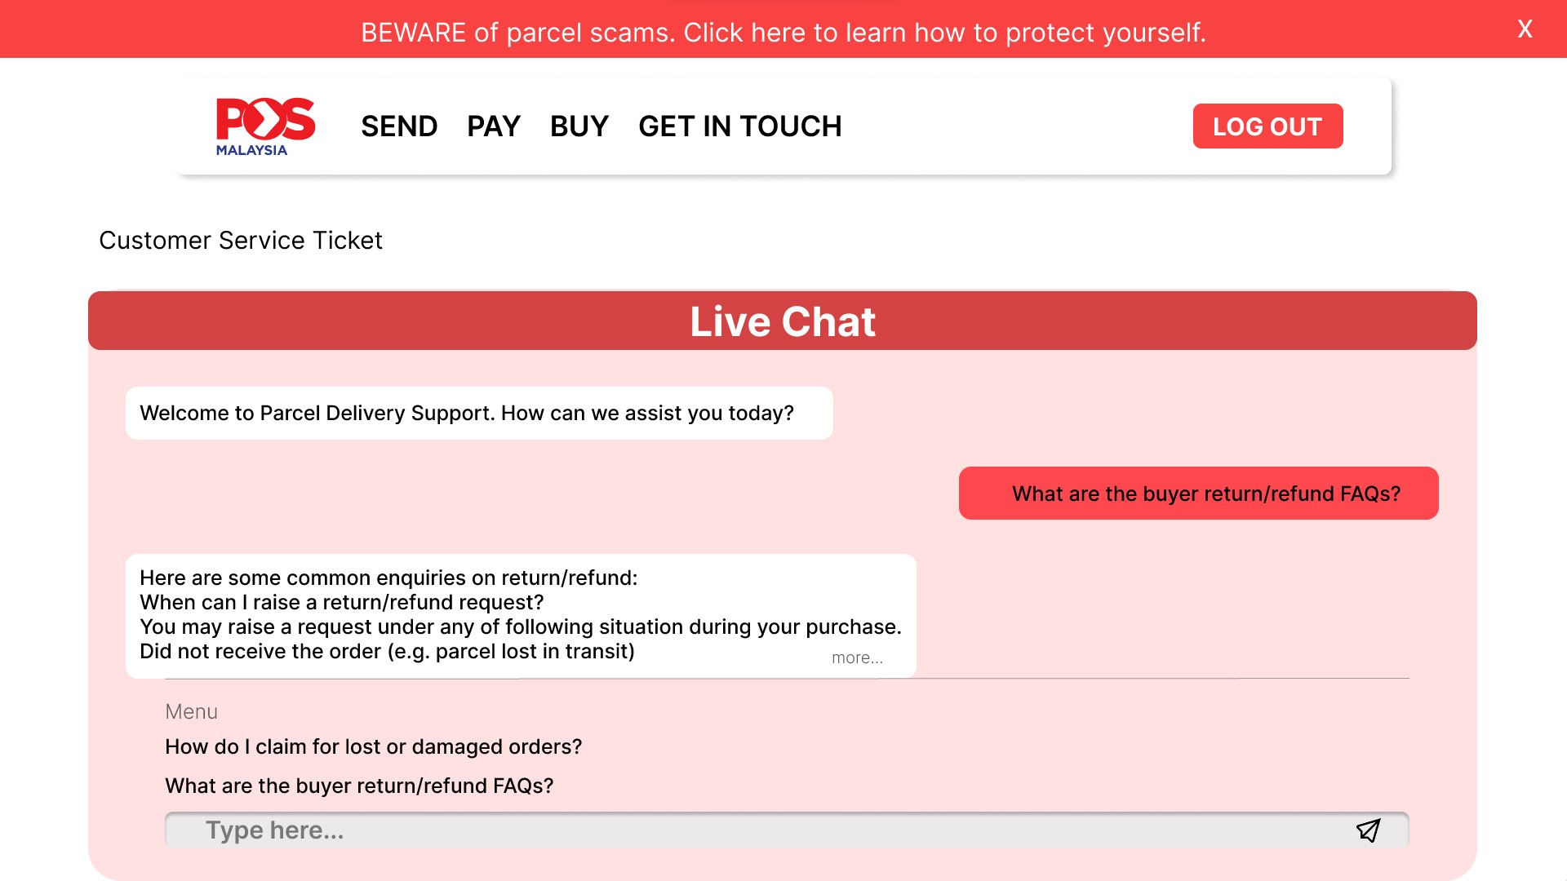
Figure 97 Customer receiver live chat page 2
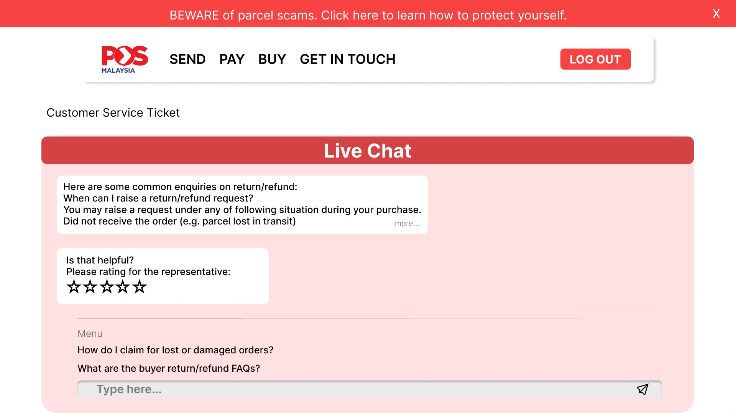
Figure 98 Customer receiver live chat page 3
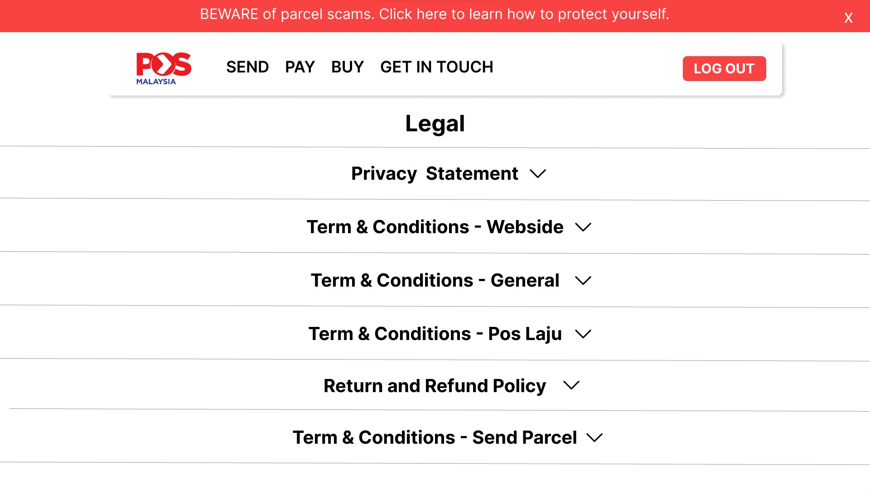
Figure 98 Customer Terms and Condition page
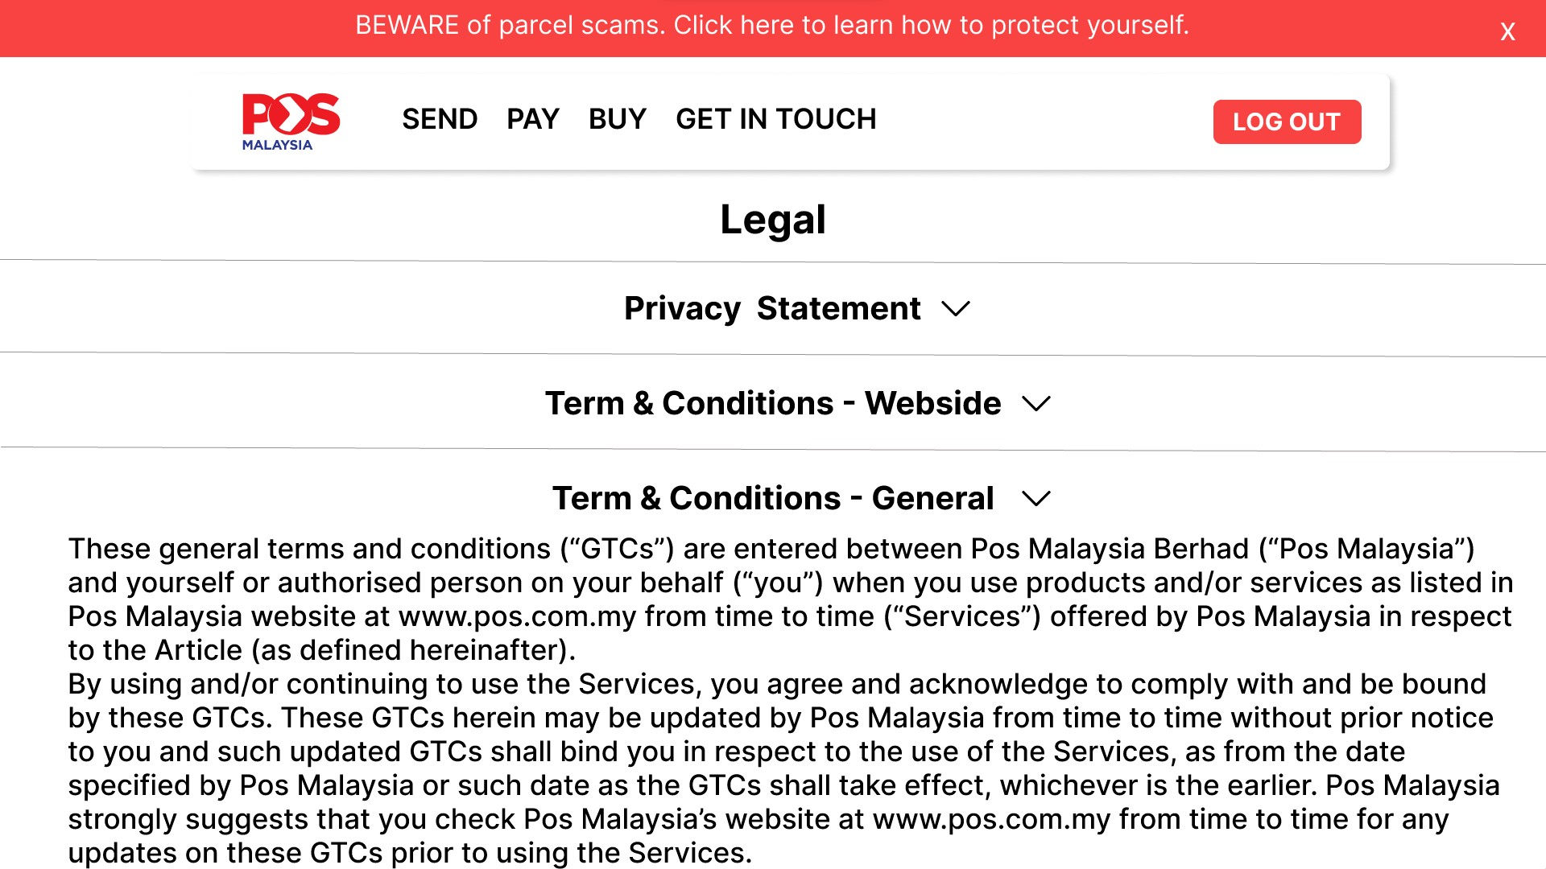
Figure 99 Customer Terms and Condition details page
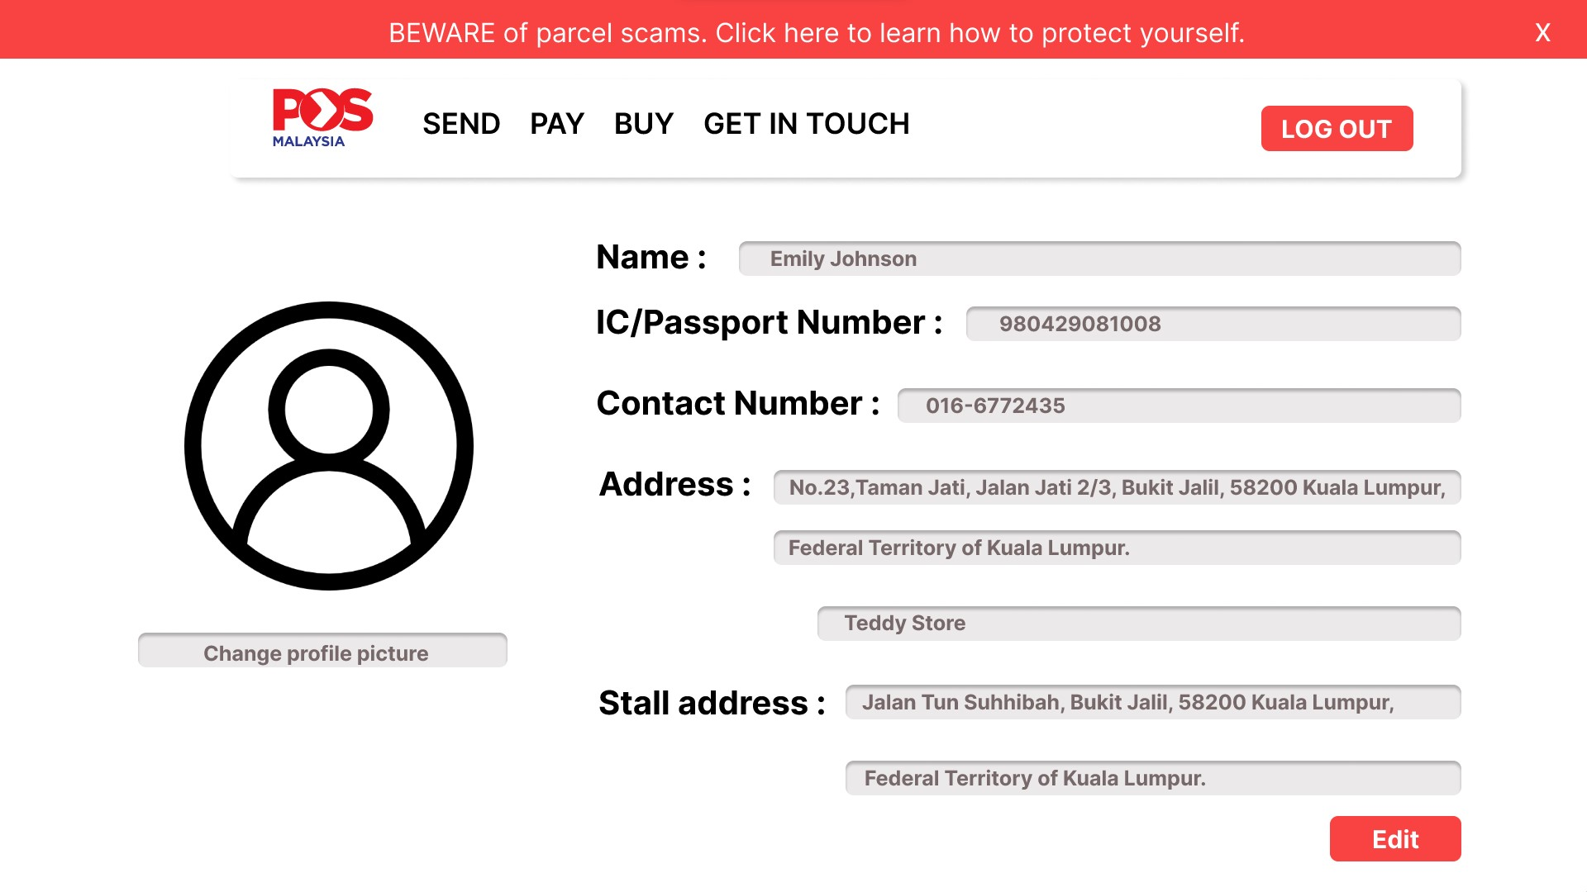
Figure 100 Customer view profile page
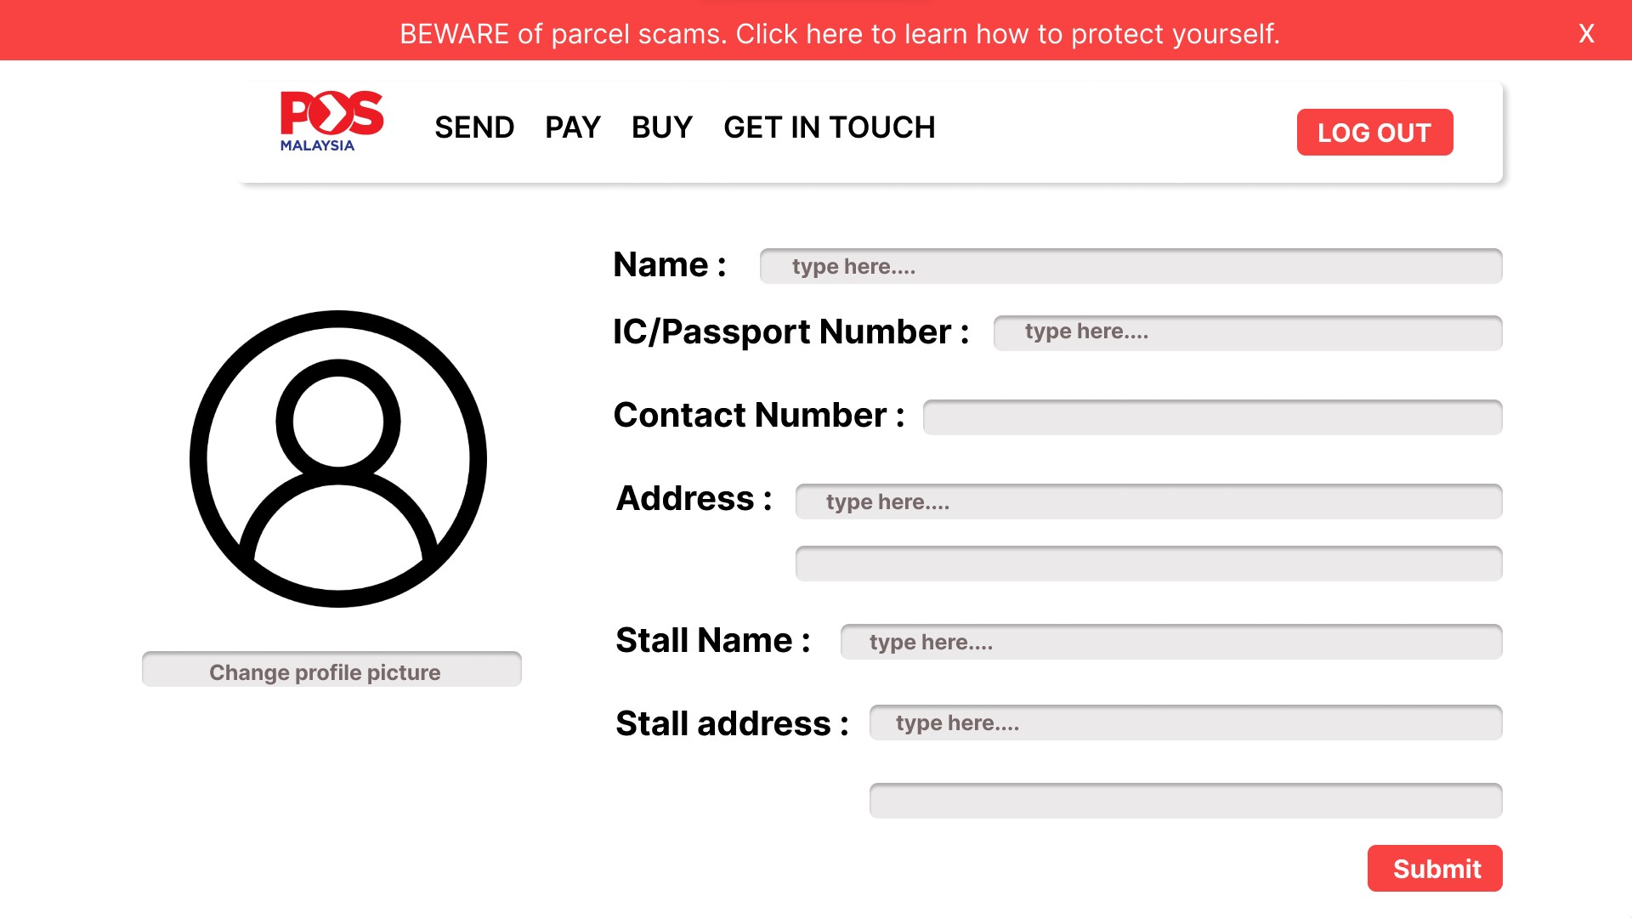
Figure 101 Customer edit profile page

6.2 Appendix B: Work Breakdown Structure
Name | Task / Description / Responsibility | Signature
Wong Lik Hong | Bad management System  Flowchart Creation  Admin Prototype Creation | WLH
Valerie Annabella | Introduction  Bad Customer Service  Existing System Review  Flowchart Creation  Driver Prototype Creation  Customer Representative Prototype Creation
Lee Wan Chien | Bad aftercare  Prototype Development  Customer Prototype Creation | LWC
Tan Qiao Qian | Insufficient information on Delivery  Prototype Development | TQQ
Yap Huey Shin | Insufficient information on Delivery  Prototype Development
Tan Kien Hwa | Conclusion  Bad aftercare  Flowchart Creation  Customer Prototype Creation
Lee Ka Shing | Bad management System  Flowchart Creation  Driver Prototype Creation  Customer Representative Prototype Creation | 
Rakhmatullayeva Amina Maratovna | Bad Customer Service  Prototype Development  Flowchart Creation  Admin Prototype Creation | 
Yee Ka Hoe | Low Quality Control  Flowchart Creation  Admin Prototype Creation | YKH  
Abhay Rana Pratap Beedasee | Low Quality Control  Admin Prototype Creation

